
Grammar Lessons

for Aleph with Beth

Contents

Contents
Lesson 1 - First nouns and adjectives
1.1 Interrogative pronouns
1.2 The definite article
1.3 Adjectives
Lesson 2 - Plural nouns and adjectives
2.1 מְאֹד ‘very’
2.2 Plural demonstrative ‘these’
2.3 Plural forms
2.4 Irregular plurals
Lesson 3 - Conjunction and gender
3.1 The conjunction -וְ
3.2 Letters with two pronunciations
3.3 Gender and epicene nouns
Lesson 4 - Subject Pronouns
4.1 Subject pronouns
4.2 Verbless clauses
Lesson 5 - Family terms
5.1 Possessive pronoun suffixes
5.2 Construct forms
5.3 Letters with two pronunciations
5.4 Maqqef
Lesson 6 - Prepositions and Location
6.1 Prepositions
6.2 Imperative verb שִׂים
6.3 אֶת־ marks definite direct objects
Lesson 7 - Alphabet part 1
7.1 Consonants
7.2 Vowels
7.3 Definite article variants
Lesson 8 - Parts of the Body
8.1 Dual forms
8.2 Nouns with plural form only
8.3 Nouns in construct form
Lesson 9 - Things good and bad
9.1 Possessive suffixes review
9.2 The word דָּבָר
9.3 Adjectives ‘good’ and ‘bad’
9.4 The yes-no question marker prefix
9.5 Hinneh הִנֵּה
Lesson 10 - Alphabet part 2
10.1 Consonants
10.2 Vowels
10.3 Maqqef (review from 5.4)
Lesson 11 - Construct Forms
11.1 Plural forms of son and daughter
11.2 Construct forms
11.3 Good or bad in the eyes of...
Lesson 12 - Numbers 1-5
12.1 Numbers 1-5
12.2 Imperative verb קַח
12.3 All - כָּל־ / כֹּל
Lesson 13 - Alphabet part 3
13.1 Consonants
13.2 Vowels
13.3 Letters with two pronunciations
Lesson 14 - Nature and existence clauses
14.1 Nouns with plural form only
14.2 Metaphorical uses of body parts
14.3 Day and night adverbs
14.4 Collective nouns
14.5 Existence clauses
Lesson 15 - Geography and more
15.1 Much/many
15.2 Collective nouns
15.3 Rivers and wadis
Lesson 16 - Alphabet part 4
16.1 Consonants
Lesson 17 - Lamed and Possession
17.1 Expressing possession
17.2 Adjectives as nouns
Lesson 18 - Children and Elders
18.1 Vocabulary Notes
Lesson 19 - Alphabet part 5
19.1 Consonants
19.2 Reduced pataħ
19.3 Furtive pataħ
Lesson 20 - Asher & Relative Clauses
20.1 Morphology of prepositions
20.2 Inseparable prepositions with the definite article
20.3 When -וְ (vǝ-) becomes -וּ (u-) (Review from 3.1)
20.4 Relative Pronoun אֲשֶׁר ’asher
Lesson 20b - Writing the Hebrew Alphabet
20b.1 The Hebrew Alphabet or Aleph-Bet
Lesson 21- Verbs come & go (qatal singular)
21.1 Introduction to the Hebrew Verb
21.2 Aspect
21.3 Weak & Strong Verbs
21.4 Binyanim & Qal
Lesson 22 - Say & Imperatives
22.1 אָמַר - He Said
22.2 Imperatives
22.3 The vayyiqtol or vav-consecutive-imperfect
Lesson 23 - Possessive Suffixes part 1 & Body Parts
23.1 Possessive Suffixes
Lesson 24 - Possessive Suffixes part 2 & Family Terms
24.1 Family Terms
Lesson 25 - Hear & Obey
25.1 Voice/Sound - קוֺל
25.2 Hear & Obey
25.3 The Name of God
Lesson 26 - Be & Beauty
26.1 To Be - הָיָה
26.2 Beauty - יָפֶה and יָפָה
Lesson 27 - Give & Take, Silver & Gold
27.1 Give נָתַן & Take לָקַח
27.2 Conjugating more verbs in the plural
Lesson 28 - Marriage
28.1 New Vocabulary
28.2 Vayyiqtol Review
28.3 Taking & Giving Wives
Lesson 29 - More Prepositions
29.1 City - עִיר
29.2 To Say - לֵאמֹר
29.3 The מִן Preposition
29.4 More Prepositions
Lesson 30 - Possessive Suffixes 3 - plural masc. nouns with suffixes
Lesson 31 - Numbers 6-10
31.1 Numbers 6-10
Lesson 32 - Prophets & More Verbs
32.1 New Vocabulary
32.2 דִּבֶּר & Piel
32.3 רָאָה
Lesson 33 - אֶת־ with definite direct objects
33.1 Review of definiteness & examples
Lesson 34 - Truth, Lies & Imperative forms
34.1 He’s not, I’m not, but rather
34.2 Truth & Lie
34.3 Imperative forms
Lesson 35 - Fruit & Prepositions with Suffixes
35.1 Adding suffixes to prepositions
35.2 מַעֲשֶׂה
Lesson 36 - Flesh & Blood, Altars & Anointing
36.1 New vocabulary
Lesson 37 - Dead & Alive
37.1 בָּנָה - “build”
37.2 Dead & Alive
37.3 וַיֵּרַע
37.4 יִהְיֶה - he will be
Lesson 38 - Israel asks for a king
Lesson 39 - Strength & Wisdom: Comparisons
39.1 New Vocabulary
39.2 Comparative מִן
Lesson 40 - Noah & the Ark: Categories of Creatures
40.1 Creature Categories
40.2 More vocabulary
Lesson 41 - Kaf & Similarities
41.1 New Vocabulary
41.2 The כְּ Preposition
41.3 כַּאֲשֶׁר
Lesson 42 - Light & Darkness, Morning & Evening
42.1 New Vocabulary
Lesson 43 - Creation (no new grammar to discuss)
Lesson 44 - Go out & lift up
44.1 New Vocabulary
44.2 More Conjugations of רָאָה
44.3 אֵת “with”
44.4 Sof Pasuq ׃
Lesson 45 - Verb Sequences: Vayyiqtol Forms 1
45.1 Vayyiqtol
45.2 Qamets Hatuf
45.3 Review Weak Verbs
Lesson 46 - Send, Messenger & Object Pronouns
46.1 More on Both Kinds of אֵת
46.2 New Vocabulary
Lesson 47 - Food & Drink
47.1 New Vocabulary
Lesson 48 - 40 Days & 40 Nights
48.1 זָב - flowing, gushing
48.2 Qamets hatuf review
48.3 More Vayyiqtol Forms
48.4 Singular nouns with plural numbers
Lesson 49 - Return & Fear
49.1 New Vocabulary
49.2 שָׁב and Hollow Verbs
Lesson 50 - Places: Here & There
50.1 New Vocabulary
50.2 The Imperative שֵׁב
Lesson 51 - The Twelve Spies
51.1 New Vocabulary
Lesson 52 - Vayyiqtol Forms 2: First Person
52.1 First Person Vayyiqtol Forms
Lesson 53 - Going Up & Down
53.1 New Vocabulary
Lesson 53b - King Josiah reads the Book of the Covenant
Lesson 54 - David’s Dilemma
54.1 New Vocabulary
54.2 שָׁכַב - lie down
Lesson 55 - Cross Over to the Other Side
55.1 New Vocabulary
55.2 Infinitive Construct
Lesson 56 - Weapons & Warfare
56.1 New Vocabulary
56.2 כְּלִי
56.3 צָבָא
Lesson 57 - Strike & Fall
57.1 New Vocabulary
57.2 First Nun Verbs or Pe Nun Verbs
Lesson 58 - Directional Words
58.1 New Vocabulary
58.2 Directional Questions
50.3 Directional Ending Qamets He ה ָ
Lesson 59 - Run to Meet & Bow Down
59.1 New Vocabulary
59.2 הִשְׁתַּחֲוָה
Lesson 60 - A Tense Reunion
60.1 New Vocabulary
60.2 Counting by Hundreds
60.3 Collective Use of אִישׁ
60.4 Describing Order
60.5 Dual Form for פַּעַם
Lesson 61 - Flee & Chase
61.1 New Vocabulary
61.2 Hollow Verb Patterns
Lesson 62 - David & Goliath
62.1 New Vocabulary
Lesson 63 - Vayyiqtol Forms 3: Second Person
63.1 New Vocabulary
63.2 More Vayyiqtol
Lesson 63b - Sihon & Og
63b.1 New Vocabulary
63b.2 וַנַּכֵּם
Lesson 64 - Chariots & Horsemen
64.1 New Vocabulary
64.2 Review of We and Y’all Verbs
64.3 רֶ֫כֶב
Lesson 65 - Thus says יהוה - a brief history of Israel
65.1 New Vocabulary
65.2 עוֺלָם
Lesson 66 - Captains & Enemies
66.1 New Vocabulary
66.2 צַר
Lesson 67 - Between Eglon & Zedekiah
67.1 New Vocabulary
67.2 בֵּין
Lesson 67b - Peace & War in the Land
67b.1 New Vocabulary
Lesson 68 - Killing in the Camp
68.1 New Vocabulary
Lesson 69 - The woman who killed Sisera
69.1 New Vocabulary
Lesson 70 - Covenant & Seed
70.1 New Vocabulary
Lesson 71 - Vayyiqtol forms 4: feminine plural
71.1 New Vocabulary
71.2 More Vayyiqtol Forms and Morphology
Lesson 71b - Verb Forms Summary: Qatal & Vayyiqtol
71b.1 Verbal Patterns
Lesson 72 - Naomi & Ruth
72.1 New Vocabulary
Lesson 73 - More Parts of the Body
73.1 New Vocabulary
Lesson 74 - Lev: mind, will, emotions
74.1 New Vocabulary
74.2 לֵב
Lesson 75 - Participles 1: singular
75.1 New Vocabulary
75.2 Participles
Lesson 76 - Participles 2: in context
76.1 New Vocabulary
Lesson 77 - Participles 3: Plural
77.1 New Vocabulary
77.2 Plural Participles
Lesson 78 - Stand, Pillars & Gifts
78.1 New Vocabulary
78.2 More Practice with Participles
Lesson 79 - Participles 4: 3-ה verbs & 2-ו verbs
79.1 Participles Ending with ה
79.2 Second-Vav Participles
Lesson 80 - אַבְרָם וְהַלֶּחֶם - Avram & the Bread
80.1 Practice What You’ve Learned
Appendix 1 - The Hebrew Names of the Books of the Bible
Appendix 2 - Grammatical and Other Terms Used in Hebrew

Lesson 1 - First nouns and adjectives

1.1 Interrogative pronouns
In Biblical Hebrew, there is no question mark (?). You can identify questions by their interrogative pronouns "what?" "where?" etc. In these lessons, all sentences, including questions, will end with this symbol (׃) called a sof pasuq.

where? | אַיֵּה ʾayyeh | what? | מָה/מַה mah

What (is)  this?  This (is) a… | זֹאת אִשָּׁה׃ zoʾt ʾishshah  This (is) a woman. | מַה־זֹּאת׃ mah-zoʾt  What (is) this? | זֶה אִישׁ׃ zeh ʾish  This (is) a man. | מַה־זֶּה׃ mah-zeh  What (is) this?
 | זֹאת פָּרָה׃ zoʾt parah  This (is) a cow. | מַה־זֹּאת׃ mah-zoʾt  What (is) this? | זֶה פַּר׃ zeh par  This (is) a bull. | מַה־זֶּה׃ mah-zeh  What (is) this?

1.2 The definite article
The definite article ‘the’ is a prefix attached to the beginning of the word: ha- (-הַ or -הָ). There is no indefinite article like ‘a’ or ‘an’; instead, an indefinite noun will have no article. Compare אִישׁ ʾish (‘a man’) with הָאִישׁ haʾish (‘the man’). The definite article occurs on nouns, and also on any adjectives and demonstratives (zeh זֶה ‘this masc.’ or zo’t זֹאת ‘this fem.’) that modify them. This helps us to pair an adjective or demonstrative with the noun it modifies in the same phrase.

definite article ‘the’ | הַ-/הָ- ha
the big bull | הַפָּר הַגָּדוֹל happar haggadol
this bull | הַפָּר הַזֶּה happar hazzeh

1.3 Adjectives
An adjective describes a property or characteristic of a noun and follows the noun it modifies. In Hebrew, the adjectives agree in gender (masculine or feminine) and number (singular or plural) with the nouns they modify. That is, an adjective has four possible forms: masculine singular, feminine singular, masculine plural and feminine plural. A masc. sg. noun will take a masc. sg. adjective, and a fem. sg. noun will take a fem. sg. adjective, as in the table below.

פָּרָה גְדוֹלָה  gǝdolah parah  fem. sg. fem. sg.  a big cow   | פַּר גָּדוֹל  gadol par  masc. sg. masc. sg.  a big bull  

When an adjective directly modifies a noun in the same phrase, it also agrees in definiteness, and takes the definite article prefix -הַ, as in the previous examples in 1.2 and below right. If an adjective or demonstrative occurs with a definite noun but does not have -הַ, then it must form a sentence with an implied equivalence “is” or “are,” as in the example below left.

הָאִישׁ גָּדוֹל haʾish gadol | הָאִישׁ הַגָּדוֹל haʾish haggadol
‘The man (is) big.’ | ‘the big man’

Notice that we know that the adjectives and demonstratives in row 1 below form part of the same phrase as the noun they modify because they are all marked with -הַ. By contrast, the demonstratives in row 2 and the adjectives in row 3 do not have -הַ, and therefore they must be on one side or another of an implied verb “is,” forming complete sentences.

This big man... | הָאִישׁ הַגָּדוֹל הַזֶּה  haʾish haggadol hazzeh | This small woman... | הָאִשָּׁה הַקְּטַנָּה הַזֹּאת  haʾishshah haqqǝṭannah hazzoʾt | 1
This (is) the big man. | זֶה הָאִישׁ הַגָּדוֹל׃  zeh haʾish haggadol | This (is) the small woman. | זֹאת הָאִשָּׁה הַקְּטַנָּה׃  zoʾt haʾishshah haqqǝṭannah | 2
This man (is) big. | הָאִישׁ הַזֶּה גָּדוֹל׃  haʾish hazzeh gadol | This woman (is) small. | הָאִשָּׁה הַזֹּאת קְטַנָּה׃  haʾishshah hazzoʾt qǝṭannah | 3

Lesson 2 - Plural nouns and adjectives

2.1 מְאֹד ‘very’
The word mə’od מְאֹד intensifies the adjective it modifies, like the word “very.”

good ṭov טוֹב | small qaton קָטֹן
טוֹב מְאֹד very good ṭov mǝʾod | very small qaton mǝʾod קָטֹן מְאֹד

2.2 Plural demonstrative ‘these’
For the singular demonstrative ‘this,’ there is a masculine form zeh זֶה and a feminine form zo’t זֹאת. The plural demonstrative ‘these’ is the same for both genders: ’elleh אֵלֶּה.

 | Masculine | Feminine
Singular | זֶה | זֹאת
Plural | אֵלֶּה

Just like זֶה and זֹאת, when אֵלֶּה directly modifies a plural noun in the same phrase, it follows the noun and takes the definite article to match the noun (below left). It can also be the subject of the sentence (below right).

These horses... | הַסּוּסִים הָאֵלֶּה | These (are) horses. | אֵלֶּה סוּסִים

2.3 Plural forms
Masculine nouns take the plural ending -im ים◌ִ -, while feminine nouns take the plural ending -ot וֹת-. An adjective that modifies a noun will agree with it in gender and number, taking the same ending that the noun takes.

bull | פַּר | cow | פָּרָה
bulls | פָּרִים | cows | פָּרוֹת
a big bull | פַּר גָּדוֹל | a big cow | פָּרָה גְדוֹלָה
big bulls | פָּרִים גְּדֹלִים | big cows | פָּרוֹת גְּדֹלוֹת

2.4 Irregular plurals
Some nouns are irregular and take the plural suffix that is associated with the opposite gender. Two of these nouns are אִשָּׁה and עֵז, which take the masculine plural ending ים◌ִ - even though they are actually feminine. We can see their true gender by the fact that adjectives that modify them take the feminine plural ending וֹת-.

woman | אִשָּׁה | goat | עֵז
women | נָשִׁים | goats | עִזִּים
big women | נָשִׁים גְּדֹלוֹת | small goats | עִזִּים קְטַנּוֹת

We will see irregular masculine nouns that take the feminine plural ending -ot וֹת- in future lessons.

Lesson 3 - Conjunction and gender

3.1 The conjunction -וְ
The conjunction prefix vǝ-, -וְ, can join many types of phrases and clauses. It is most often translated “and,” but may be translated as “but” or other conjunctions, depending on the context. It is written attached to the following word.
אִישׁ וְאִשָּׁה
“a man and a woman”

In some contexts, -וְ (vǝ-) becomes -וּ (u-), depending on the word it is attached to. This sound change happens:
- before the labial (involving the lips) letters פ , ב , מ , ו
- before a shewa vowel ְ
In this lesson, we encounter -וּ before the labial letter פ, as in וּפַר ,וּפָרוֹת etc. and before a word with the shewa vowel ְ at the beginning, as in וּגְמַלִּים, וּנְעָרוֹת etc. We will see more examples of this sound change in later lessons.

3.2 Letters with two pronunciations
Some letters (often called the begadkefat letters to help remember them) become fricativized in certain contexts (the airstream is constricted but keeps flowing instead of being cut off completely). In the pronunciation you hear in the videos, only three letters ב ,פ , and כ, undergo this sound change, and it is always marked by the absence of dagesh (a dot in the center of the letter):

- When they are marked with a dagesh, they are pronounced as stops (airstream cut off completely, like in b, p, and k).
- When they have no dagesh, they are pronounced as fricatives (airstream keeps flowing, like in v, f, and χ).

k | כּ | p | פּ | b | בּ | Stops with dagesh
χ | כ | f | פ | v | ב | Fricatives without dagesh
This is why you will hear some letters change their sounds in certain contexts, such as after -וְ or -וּ. In this lesson you hear p change to f, and k change to χ (a uvular trill like in German “Bach”), as in the examples below. In future lessons you will also hear b change to v.

וּכְבָשִׂים | כְּבָשִׂים | וּפַר | פַּר
u-χǝvasim | kǝvasim | u-far | par
and sheep (pl.) | sheep (pl.) | and a bull | bull

(In the videos, the other begadkefat letters ד,ג and ת will always be pronounced ɡ, d and t respectively, with or without a dagesh.)

3.3 Gender and epicene nouns
Nouns in Hebrew belong to one of two genders, masculine (זָכָר zaχar) or feminine (נְקֵבָה nəqevah). In this video we sort all the nouns we’ve learned so far according to their gender. Feminine nouns often end in ה◌ָ – or ת–, but not always.

A few animate nouns in Hebrew have just one form for both male and female sexes. These are called “epicene nouns,” and the word for camel, גָּמָל, is one of these. The form גָּמָל could refer to a male camel or a female camel. An adjective or demonstrative modifying an epicene noun would signal if it is a male or female in that context, as in the examples below.

This small (male) camel | הַגָּמָל הַקָּטֹן הַזֶּה  haggamal haqqaṭon hazzeh
This small (female) camel | הַגָּמָל הַקְּטַנָּה הַזֹּאת  haggamal haqqǝṭannah hazzoʾt

Key helps
Why? ← לָמָּה
I don’t know ← אֵינֶנִּי יֹדַעַת
Such is Hebrew! ← כָּכָה עִבְרית

Lesson 4 - Subject Pronouns

4.1 Subject pronouns
Subject pronouns have singular and plural forms, and distinguish between masculine and feminine in the second and third persons. For example, אַתָּה ʾattah is ‘you’ when speaking with a man, and אַתְּ ʾat is ‘you’ when speaking with a woman. Likewise, אַתֶּם ʾattem is ‘you’ when speaking with a group of men or a mixed group, and אַתֶּן ʾatten is ‘you’ when speaking to a group of women. The first-person pronouns ‘I’ and ‘we’ are the same regardless of the gender of the speaker. There are two versions of the pronoun ‘I’ that appear in the Hebrew Bible: the most common is אֲנִי ʾani, but אָנֹכִי ʾanoχi also appears frequently. There’s no clear difference in meaning between these two 1sg. pronouns.

Singular |  |  | Plural
Masculine | Feminine |  | Masculine | Feminine
אֲנִי / אָנֹכִי ʾanoχi / ʾani |  | I | אֲנַחְנוּ ʾanaħnu |  | we
אַתָּה ʾattah | אַתְּ ʾatt | you | אַתֶּם ʾattem | אַתֶּן ʾatten | you
הוּא huʾ | הִיא hiʾ | he/she | הֵם hem | הֵנָּה hennah | they

4.2 Verbless clauses
Just like the sentences in the previous lessons, the sentences in this lesson are verbless. In Hebrew, a simple clause can be formed by juxtaposing the subject and the complement that describes it, with no verb necessary. The complement may be a noun (as in 1) or an adjective (as in 2). In later lessons we will also see prepositional phrases in verbless clauses to describe the location of the subject.

You (are) (a) donkey. | אַתָּה חֲמוֹר׃ ʾattah ħamor | 1
You (are) small. | ʾattah qaṭon אַתָּה קָטֹן׃ | 2

In some contexts, we may also see the complement come first and the subject afterward.

What (is) she? | מַה־הִיא׃ mah-hiʾ | 1
A small woman (is) she. | ʾishshah qǝṭannah hiʾ אִשָּׁה קְטַנָּה הִיא׃ | 2

Key helps
Conjunction כִּי. It has many translations in different contexts, but here
it marks a counter-statement after a negative statement, like saying “No, on the
contrary … ” or “No, but rather...”

Lesson 5 - Family terms

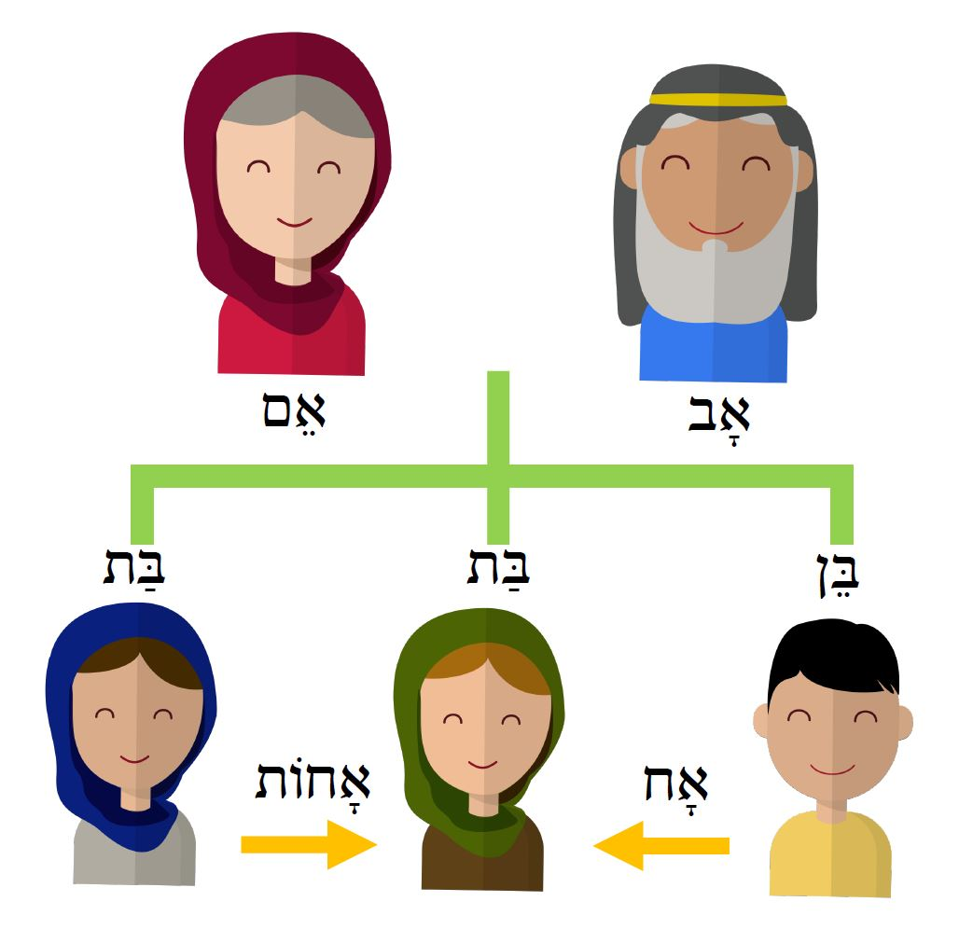

5.1 Possessive pronoun suffixes
Hebrew marks possession with pronominal suffixes on nouns. In this lesson we encounter three of those suffixes: the first person singular ‘my’ י ִ - and the third person singular masculine ‘his’ וֹ- and feminine ‘her’ הּ◌ָ-. Often when these suffixes are added to a word, the vowels of the noun stem contract or are shortened. Here שְׁמ- → שֵׁם.

שְׁמָהּ | שְׁמוֹ | שְׁמִי | שֵׁם
her name | his name | my name | name

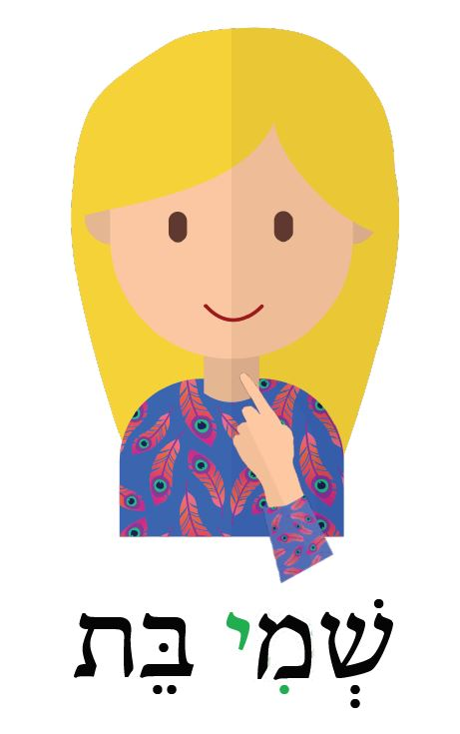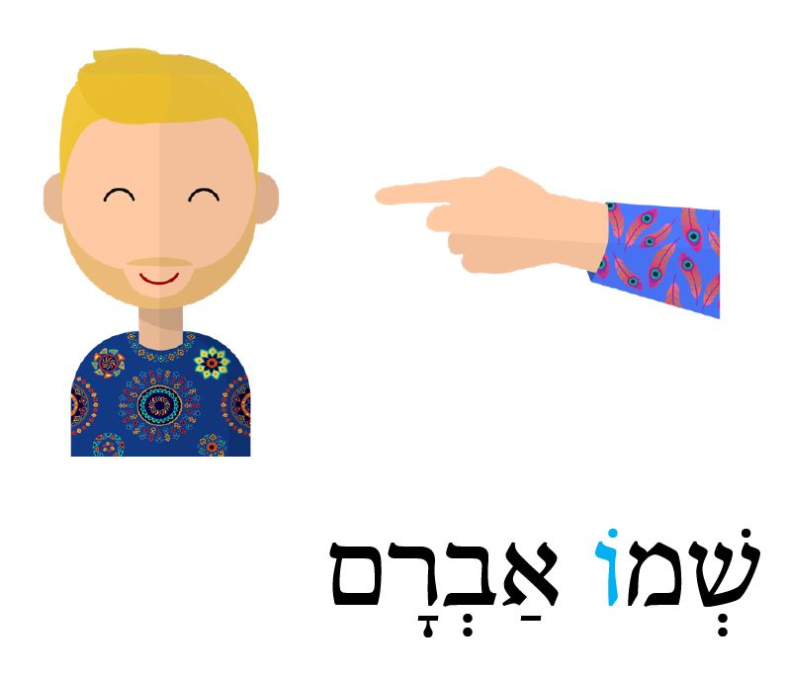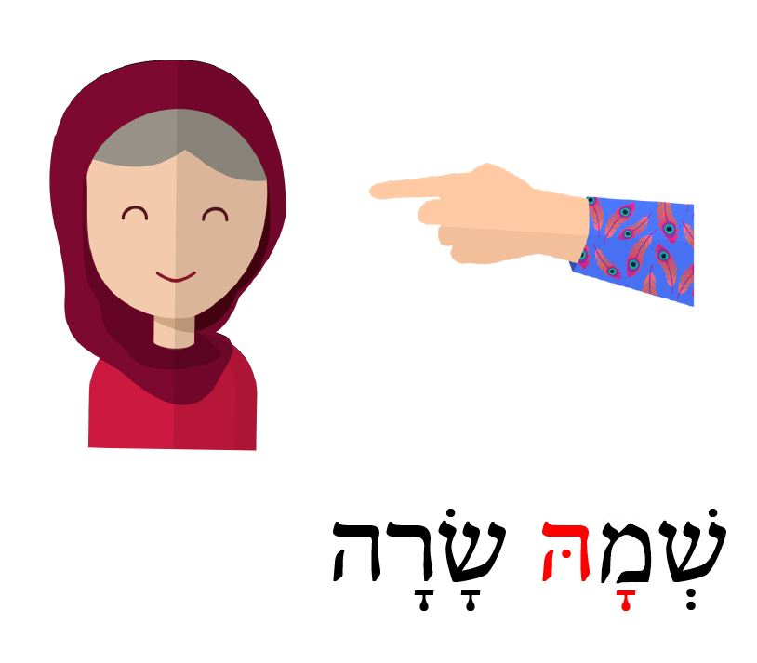

5.2 Construct forms
This lesson teaches terms for family relationships. Notice that the words for the relationships ‘husband’ and ‘wife’ are the same as ‘man’ and ‘woman.’
In this lesson, you will hear some of the words change form when a possessor follows. These are called “construct forms” in Hebrew grammar, and this is a fundamental feature of the structure of Hebrew. This is covered in more detail in Lesson 11, but for now, just focus on understanding the alternate forms of the words when they have a possessor.
Abraham is Isaac’s father. | אַבְרָהָם אֲבִי יִצְחָק | אָב ← אֲבִי
Esau is Jacob’s brother. | עֵשָׂו אֲחִי יַעֲקֹב | אָח ← אֲחִי
Sarah is Abraham’s wife. | שָׂרָה אֵשֶׁת אַבְרָהָם | אִשָּׁה ← אֵשֶׁת

Note that some words change the spelling of their vowels slightly when they are in construct
form, but the pronunciation is not affected.

David is Jesse’s son. | דָּוִד בֶּן־יִשַׁי | בֵּן ← בֶּן
Rachel is Leah’s sister. | רָחֵל אֲחוֹת לֵאָה | אָחוֹת ← אֲחוֹת

All nouns that are followed by a possessor are in construct form, but some words, like אֵם and בַּת, are exactly the same in construct form as their free form (called “absolute form”).

Sarah is Isaac’s mother. | שָׂרָה אֵם יִצְחָק׃ | אֵם ← אֵם
Whose daughter are you?  (lit. daughter of who (are) you?) | בַּת־מִי אַתְּ׃ | בַּת ← בַּת
Jacob is Leah’s husband. | יַעֲקֹב אִישׁ לֵאָה׃ | אִישׁ ← אִישׁ

Note that even though the word אָחוֹת aħot ‘sister’ ends in -ot וֹת-, it is singular and not plural.

5.3 Letters with two pronunciations
We saw in 3.2 how the begadkefat letters p פּ and k כּ change their sounds in some contexts and become fricativized to f and χ respectively. In this lesson, we hear b בּ undergoing the same change: After -וּ, it loses the dagesh and becomes ב, and is pronounced v.
k | כּ | p | פּ | b | בּ | Stops with dagesh
χ | כ | f | פ | v | ב | Fricatives without dagesh

בּ is a labial letter, so it triggers the change of the conjunction from vǝ- -וְ to u- -וּ that we saw in section 3.1.
וּבֵן | בֵּן | וּבַת | בַּת
u-ven | ben | u-vat | bat
and a son | son | and a daughter | daughter

5.4 Maqqef
You will see some words written connected with a bar ־, called a maqqef. This connects a short word to the word that follows it and marks them as forming one phonological word with one accented syllable. It does not appreciably affect the meaning or pronunciation. It is often optional in the Hebrew Bible, so in these lessons we try to follow the form that you will see most frequently.
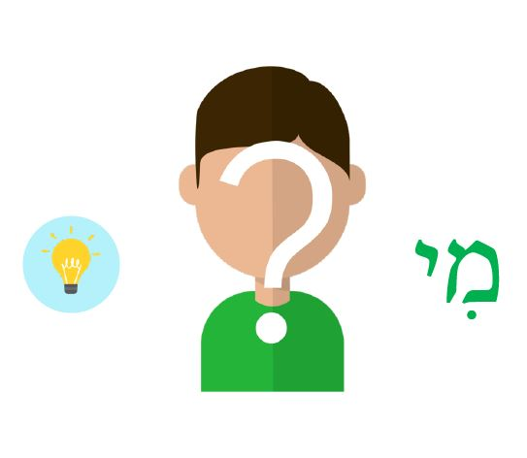
Key helps
מִי ← ?Who
אֵינֶנִּי יֹדַעַת ← I don’t know
גַּם ← Also

Lesson 6 - Prepositions and Location

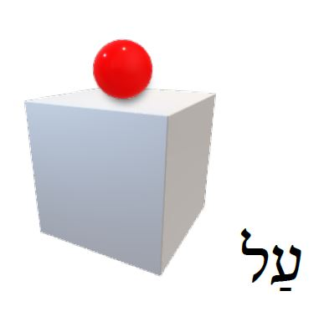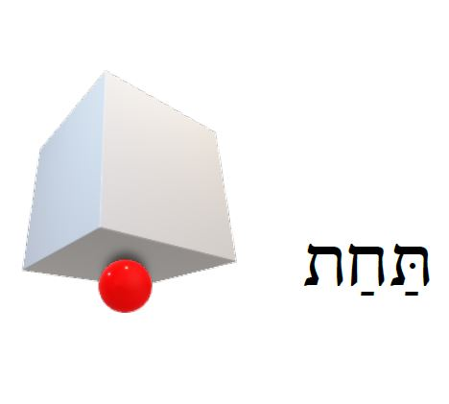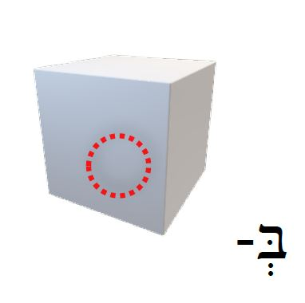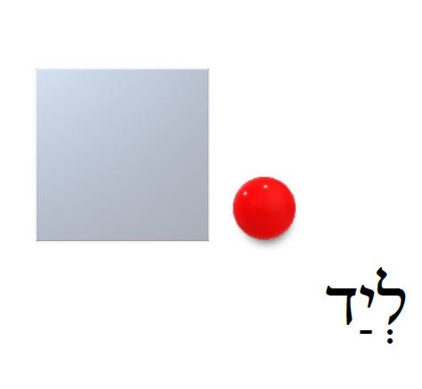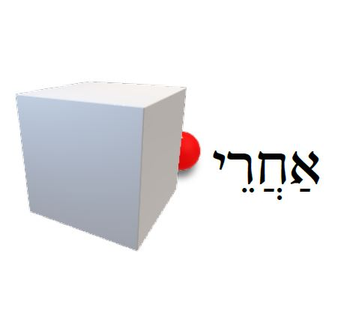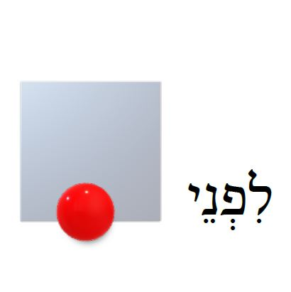

6.1 Prepositions
In this lesson, we learn some prepositions that describe location relative to an object. The shortest of these is -בְּ, which is one of three prepositions ( בְּ כְּ לְ ) that consist of only one letter prefixed to the following word, and they cannot be separated from the word. For that reason they are often called the inseparable prepositions. -בְּ has a broad range of meanings, but in the examples in this lesson it means ‘in’ or ‘on.’ As we’ll see more in later lessons, the one-letter prepositions combine with the vowel of the definite article -הַ when they occur together on the same word. So -בְּ plus -הַ becomes -בַּ as in the word בַּבַּיִת ‘in the house’ or בַּדֶּרֶךְ ‘in/on the road’.
בְּ- + הַ- + מִדְבָּר = בַּמִּדְבָּר
ba-midbar - ‘In the wilderness’
The other prepositions are not prefixed to the following words, but עַל־ is usually connected with a maqqef ־. As discussed briefly in 4.2, the sentences in this lesson are verbless, with the location of the subject indicated by simply juxtaposing the prepositional phrase with the subject. No verb is necessary.

הָעֵז לִפְנֵי הַפָּר׃
“The goat (is) in front of the bull.”

6.2 Imperative verb שִׂים
In this lesson we learn our first verb, in the imperative (command) form, שִׂים sim, ‘put!’ In the video, Beth tells Avram to put a cow or horse in specific places.

6.3 אֶת־ marks definite direct objects
When the direct object of a sentence is definite (i.e. it has the definite article -הַ, is a proper noun, or has a possessive suffix), it is usually marked with the preposition אֶת־. This preposition has a purely grammatical meaning that is not translatable into English. Like אֶת־ ,עַל־ is usually linked to the following word with a maqqef ־, but sometimes it appears on its own as אֵת.
Notice the difference between the sentence in 1 with an indefinite direct object פָּרָה ‘a cow,’ and the sentence in 3 with a definite direct object אֶת־הַפָּרָה ‘the cow.’

‘Put a cow behind the house.’ | שִׂים פָּרָה אַחֲרֵי הַבַּיִת׃ | 1
‘No, this cow is on the house.’ | לֹא, הַפָּרָה הַזֹּאת עַל־הַבַּיִת׃ | 2
‘Put the cow behind the house.’ | שִׂים אֶת־הַפָּרָה אַחֲרֵי הַבַּיִת׃ | 3

Lesson 7 - Alphabet part 1

This lesson teaches seven letters of the Hebrew alphabet and four vowel points (called niqqud). Hebrew is written right to left and originally was written with only the consonant letters. The system of writing vowels below and above the main line of consonants was added sometime during the last centuries of the first millenium A.D.

In discussions of the alphabet and elsewhere we’ll often explain pronunciations with the International Phonetic Alphabet (IPA). If you’re not familiar with the IPA, you can hear how each symbol sounds at internationalphoneticalphabet.org.

7.1 Consonants
Aleph א (usually transliterated as ’ ) is the first letter of the Hebrew alphabet and is pronounced as a glottal stop [ʔ]: the light sound of the throat closing between the vowels in “uh-oh.” To English speakers, words that start with aleph sound like they start with a vowel, but aleph is considered a consonant.

Bet ב (usually transliterated as b or v) is the second letter of the alphabet, and it has two pronunciations: with a dagesh בּ it is pronounced b and without a dagesh ב, it is pronounced v.

Yod י (usually transliterated as y) is the tenth letter of the alphabet. It has two functions, one consonantal and one vocalic:
- Yod may be a consonant with its own vowel, pronounced like y (like יָ ya), .
- Yod may accompany a vowel on the preceding letter (like אִי as a vowel indicator or part of a diphthong).

Tav ת (usually transliterated as t or th) is the twenty-second and last letter of the alphabet. In the pronunciation we use in the videos, it is always pronounced t, with or without a dagesh.

Shin שׁ (usually transliterated as š or sh) is the twenty-first letter of the alphabet. It is always pronounced sh [ʃ] with or without a dagesh. This letter can be confusing, because it’s so similar to שׂ, which will be introduced later. Really, we could say that the twenty-first letter of the alphabet is ש, and שׁ and שׂ are distinct letters under that umbrella. The reason they are considered distinct letters and given their own place in the aleph-bet song is because the meanings of word roots can completely change depending on which of them you use. So in one sense they are the same letter (in terms of the writing system), but in another sense they are not the same (when counting root consonants). The dot that makes them different is not like the dagesh dot in the begadkefat letters like בּ, which simply changes the pronunciation of the letter, but not the meaning of the word. So בּ and ב are not considered different letters of the alphabet.
He ה (usually transliterated as h) is the fifth letter of the alphabet. Like yod, it has two functions:
- He may be a consonant with its own vowel, pronounced h (like הָ ha).
- He may accompany a vowel on the preceding letter (like בָּה bah) at the end of a word. As a vowel indicator, he does not add any sound: בָּ and בָּה are pronounced the same: [ba].
Vav ו (usually transliterated as w or v) is the sixth letter of the alphabet. Like yod and he, vav has both consonantal and vocalic functions, but in this lesson, we only encounter consonantal vav as the prefix conjunction -וְ. In the third alphabet lesson (Lesson 13), we will see vav as a vowel indicator. As a consonant, vav is pronounced v, just like ב.

7.2 Vowels
Qamets ָ (usually transliterated as ā) is pronounced [a] “ah” as in “father.”
Hireq ִ (usually transliterated as i) is pronounced [i] “ee” as in “see.”
Pataħ ַ (usually transliterated as a) is pronounced [a] “ah” as in “father.” We pronounce qamets and patah the same, but historically qamets was a “long vowel” and pataħ a “short vowel.”
Shewa ְ (usually transliterated as ǝ) is pronounced [ǝ], a short relaxed central vowel like the first and last vowels of “banana” in American English [bǝˈnænǝ].

7.3 Definite article variants
The definite article “the” prefix -הַ consists of the he and pataħ and it also “doubles” the first consonant of the following letter (marking it with a dot called a dagesh).
הַ- + מִדְבָּר = הַמִּדְבָּר
הַ- + שֵׁם = הַשֵּׁם
However, when -הַ comes before a word that begins with א ע or ר, three letters that cannot take a dagesh, the pataħ vowel “lengthens” to qamets. Therefore, you will see words beginning with aleph take the article with qamets -הָ as in הָאִישׁ. This doesn’t affect the pronunciation, it’s just a spelling rule. We recommend not worrying about memorizing the rules right now, just be able to recognize both -הַ and -הָ as the definite article “the” when you see them.
As discussed in 6.1, the one-letter prepositions combine with the vowel of the definite article -הַ when they occur together on the same word. So -בְּ plus -הַ becomes -בַּ. We see this in the word בַּבַּיִת.
בְּ- + הַ- + בַּיִת = בַּבַּיִת
‘in the house’

Lesson 8 - Parts of the Body

8.1 Dual forms
Most nouns have forms for two numbers: singular (1) and plural (2 or more). However, some words in Hebrew have a dual form (2) instead of or in addition to a plural form (3 or more). Things that come in pairs, like many body parts, often take dual forms. The dual form is marked with the suffix -ayim יִם ַ -.
 | Dual |  |  | Singular
two eyes | עֵינַיִם  ʿenayim | 👁️👁️ | eye | עַיִן  ʿayin | 👁️
two ears | אָזְנַיִם  ʾoznayim | 👂🏽👂🏽 | ear | אֹזֶן  ʾozen | 👂🏽
two hands | יָדַיִם  yadayim | 🤚🏽🤚🏽 | hand | יָד  yad | 🤚🏽
two feet/legs | רַגְלַיִם  raglayim | 🦵🏽🦵🏽 | foot/leg | רֶגֶל  regel | 🦵🏽
two palms | כַּפַּיִם  kappayim | 🤲🏽 | palm | כַּף  kaf | ✋🏽

8.2 Nouns with plural form only
Some nouns occur only in plural form with no singular form. The word panim פָּנִים ‘face’ in this lesson is one of these. Therefore פָּנִים may be translated ‘face’ or ‘faces,’ depending on the context.

8.3 Nouns in construct form
In the last section of the video, all the body parts that appear with a possessor, such as regel sus רֶגֶל סוּס ‘a horse’s foot/leg’ or beten ishah בֶּטֶן אִשָּׁה ‘a woman’s belly,’ are in construct form, but they sound the same and are spelled the same in construct form as in their free absolute form (except yad יָד ‘hand,’ which changes its spelling to יַד in the construct form, but still sounds the same). In lesson 11, we will learn more about construct forms.

Lesson 9 - Things good and bad

9.1 Possessive suffixes review
In this lesson we review the possessive suffixes on the word ‘name’ that were introduced in 5.1. Remember that the conjunction -וְ becomes -וּ before words whose first letter has a shewa vowel ְ as in the example below.
שְׁמָהּ רוּת וּשְׁמָהּ נָעֳמִי | מִי הֵנָּה׃
Her name (is) Ruth and her name (is) Naomi. | Who (are) they (fem.)?

9.2 The word דָּבָר
דָּבָר means generally ‘thing’ or ‘word.’ In this lesson it is used in the sense of a physical ‘thing’ (1), in the sense of ‘word’ (2) and in the sense of a non-physical ‘thing,’ referring to a matter/situation/affair (3). Senses 2 and 3 are the most common in Biblical Hebrew.
What (is) this thing? This thing (is) a jar. | מָה־הַדָּבָר הַזֶּה׃ הַדָּבָר הַזֶּה כַּד׃ | 1
House, the man, father, these (are) words. | בַּיִת, הָאִישׁ, אָב, אֵלֶּה דְּבָרִים׃ | 2
[men fighting in anger] Is this thing good?  No, this thing is very bad. | הֲטוֹב הַדָּבָר הַזֶּה׃  לֹא, הַדָּבָר הַזֶּה רַע מְאֹד׃ | 3

9.3 Adjectives ‘good’ and ‘bad’
We learned two adjectives in this lesson: טוֹב ‘good,’ and רַע ‘bad.’ Note that they take the same suffixes that we learned in 2.3, agreeing with the noun they modify in gender and number.
 |  | Feminine |  | Masculine
Sg. | a good woman | אִשָּׁה טוֹבָה | a good man | אִישׁ טוֹב
 | a bad land | אֶרֶץ רָעָה | a bad thing | דָּבָר רַע
Pl. | good women | נָשִׁים טוֹבוֹת | good things | דְּבָרִים טוֹבִים
 | bad women | נָשִׁים רָעוֹת | bad things | דְּבָרִים רָעִים

9.4 The yes-no question marker prefix
So far, we have seen many content questions with interrogative pronouns, such as מִי הֵם “who (are) they?” and מַה־זֶּה “what (is) this?” On the other hand, a “yes-no” or “polar” question (whose answer is a simple yes or no), is usually signaled with the prefix -הֲ on the first word of the question:
הֲטוֹבִים הַדְּבָרִים הָאֵלֶּה׃ טוֹבִים הֵם׃
(Are) these things good? They (are) good.
The question marker -הֲ sounds just like the definite article -הַ, but in writing it usually looks different because of the ħaṭef pataħ vowel ֲ . The two prefixes can usually be distinguished without difficulty from context since the yes-no question marker always attaches to the first word of the question.

9.5 Hinneh הִנֵּה
The word הִנֵּה is used to draw the hearer’s attention to, present, or point to what follows. It has traditionally been translated in older English versions as ‘behold’ but a more modern idiom would be ‘Look, …’
Look, (here are) these people | הִנֵּה הָאֲנָשִׁים הָאֵלֶּה

Lesson 10 - Alphabet part 2
This lesson introduces three more letters of the alphabet and three more vowel points (niqqud).

10.1 Consonants
Resh ר (usually transliterated as r) is the twentieth letter of the alphabet and is pronounced in our videos as an alveolar flap or trill (like the Spanish or Arabic r sound). Most Modern Hebrew speakers pronounce this letter as a voiced uvular fricative (like the French or German r sound).
Dalet ד (usually transliterated as d or ḏ) is the fourth letter of the alphabet and is pronounced d, with or without a dagesh.
Mem מ ם (usually transliterated as m) is the thirteenth letter of the alphabet. Mem is one of five Hebrew letters that have two forms: one when it occurs at the beginning or in the middle of a word, and another (the sofit form: sofit means ‘final’) when it occurs at the end of a word. Mem מ comes at the beginning or in the middle of a word, and mem sofit ם at the end. Both are always pronounced m.

10.2 Vowels
Holem ֹ , (usually transliterated as ō) written as a single dot above and to the left of a letter, is pronounced like the vowel [o].
Tsere ֵ , (usually transliterated as ē) written as two horizontal dots under a letter, is pronounced like the vowel sound [e] “ey” as in “pay” or [ɛ] “eh” as in “pet,” depending on the context.
Shewa ְ , written as two vertical dots under a letter (introduced briefly in lesson 7), has two pronunciations:
- [ə], a short relaxed central vowel like the first and last vowels of “banana” in English [bəˈnænə]. This is called a vocal shewa or audible shewa in grammars. When ְ is the core vowel of a syllable, such as when it occurs on the first letter of a word (like שְׁמִי), it is pronounced [ə].
- Silent. When ְ comes after a closed syllable (such as in מִדְבָּר and אַבְרָם), it is not pronounced, and it merely indicates the absence of a vowel. This is called silent shewa in grammars. It does not occur on the final closing consonant of a word (e.g. not מִדְבָּרְ), except for in the word אַתְּ, some second person sg. feminine verb forms, and the letter kaf which we will see in later lessons.
At this point in your learning, we recommend not worrying about memorizing all the rules for when a shewa is pronounced and when it is silent. You can read about them in detail in any good Hebrew grammar if you like, but for now, we recommend just imitating the sound of the words you hear in the videos.

10.3 Maqqef (review from 5.4)
You will see some words written connected with a bar ־, called a maqqef, like in מַה־שְּׁמִי. This connects a short word to the word that follows it and marks them as forming one phonological word with one accented syllable. It does not appreciably affect the meaning or pronunciation. It is often optional in the Hebrew Bible, so in these lessons we try to follow the form that you will see most frequently.

Lesson 11 - Construct Forms

11.1 Plural forms of son and daughter
The plural forms of the family terms בֵּן ‘son’ and בַּת ‘daughter,’ are:
בָּנִים banim ‘sons’ 👦🏽👦🏽👦🏽
בָּנוֹת banot ‘daughters’👧🏽👧🏽👧🏽

11.2 Construct forms
As briefly introduced in 5.2, in Hebrew the relationship between two nouns that is usually expressed with the preposition “of” in English (often called genitive in classical languages), is expressed in Hebrew with what is called a “construct chain.” A chain may consist of just two nouns as in (1) and (2) or three or more nouns as in (3) and (4).

English joins the nouns with “of”...  _____ of _____  ___of___of___  Hebrew marks a noun as “possessed” (the following noun is its possessor) by putting it in construct form | אָב ← אֲבִי | אֲבִי הַנַּעַר  the father of the boy | 1
 | בֵּן ← בֶּן־ | בֶּן־יוֹסֵף  the son of Joseph | 2
 | בַּיִת ← בֵּית  אִשָּׁה ← אֵשֶׁת | בֵּית אֵשֶׁת הָאִישׁ  the house of the wife of the man | 3
 | בַּיִת ← בֵּית  אִשָּׁה ← אֵשֶׁת  בֵּן ← בֶּן־ | בֵּית אֵשֶׁת בֶּן־יוֹסֵף  the house of the wife of the son of Joseph | 4
Plural forms ending in ים ִ - or dual forms ending in יִם ַ - both change to end in י ֵ - in construct form:
בָּנִים ← בְּנֵי  בְּנֵי יוֹסֵף  The sons of Joseph | נָשִׁים ← נְשֵׁי  נְשֵׁי יַעֲקֹב  The wives of Jacob | אֹהָלִים ← אָהֳלֵי  אָהֳלֵי אַבְרָהָם  The tents of Abraham | עֵינַיִם← עֵינֵי  עֵינֵי אַבְרָם  The eyes of Avram

Nouns that end in ה ָ - change to end in ת ַ - in construct form:
פָּרָה ← פָּרַת
פָּרַת יוֹסֵף
Joseph’s cow
Plural nouns that end in וֹת- usually have their vowels constricted or shortened in construct form:
בָּנוֹת ← בְּנוֹת
בְּנוֹת יוֹסֵף
The daughters of Joseph
An important feature of the construct chain structure is that the definiteness of the final noun in the chain determines the definiteness of the entire chain. An indefinite final noun as in (1) means the whole chain is indefinite. A definite final noun as in (2) and (3) means the whole chain is definite.

a house of a man | בֵּית אִישׁ | 1 | 🧍🏠
the house of the man | בֵּית הָאִישׁ | 2
the house of Abraham | בֵּית אַבְרָהָם | 3

Note that proper nouns (names of people and places) are considered definite by default, so (3) above is a definite construct chain because the final word in the chain is a proper noun.
Only the final noun is marked for definiteness, so it is incorrect to mark a noun in construct form with the definite article -הַ as in (4). Instead, it should be like (2) above.

the house of the man | *הַבֵּית הָאִישׁ incorrect | 4

11.3 Good or bad in the eyes of...
In Hebrew, a person’s approval or disapproval is expressed with the idiom “good/bad in their eyes.”

Is this thing good in the eyes of Avram? | הֲטוֹב הַדָּבָר הַזֶּה בְּעֵינֵי אַבְרָם: | 👁👁
The thing is not good in the eyes of Avram. | לֹא טוֹב הַדָּבָר בְּעֵינֵי אַבְרָם:
The thing is bad in the eyes of Avram. | רָע הַדָּבָר בְּעֵינֵי אַבְרָם:

Notice that “eyes” in construct form does not have the vowel of the definite article on the preposition -בְּ.
בְּעֵינֵי and not בָּעֵינֵי
Instead, the definiteness of “the eyes of Avram” comes from the definiteness of the final noun in the construct chain: the proper name Avram.

Lesson 12 - Numbers 1-5

12.1 Numbers 1-5
This lesson introduces the cardinal numbers one through five. Like adjectives, numbers have distinct forms for masculine and feminine nouns. When counting, the feminine forms are used.
 | With masculine nouns | With feminine nouns
1 ◦ | אֶחָד ʾeħad | אַחַת ʾaħat
2 ◦◦ | שְׁנַיִם shǝnayim | שְׁתַּיִם shǝtayim
3 ◦◦◦ | שְׁלֹשָה shǝloshah | שָׁלוֹשׁ shalosh
4 ◦◦◦◦ | אַרְבָּעָה ʾarbaʿah | אַרְבַּע ʾarbaʿ
5 ◦◦◦◦◦ | חֲמִשָּׁה ħamishshah | חָמֵשׁ ħamesh
Numbers can appear before or after the noun they modify, but the most common pattern is for the number one אַחַת / אֶחָד to appear after its noun, and the rest of the numbers to appear before.
🧍 | one man | אִישׁ אֶחָד
🧍🧍🧍 | three men/people | שְׁלֹשָׁה אֲנָשִׁים
🧍🧍🧍🧍🧍 | five men/people | חֲמִשָּׁה אֲנָשִׁים
Not surprisingly, the number two, שְׁתַּיִם, has a dual form. It is often shortened to its construct form before the noun it modifies.
two young women | שְׁתֵּי נְעָרוֹת | שְׁתַּיִם ← שְׁתֵּי
two young men | שְׁנֵי נְעָרִים | שְׁנַיִם ← שְׁנֵי

Hebrew numbers are odd in that the form that appears to be feminine (ending in ה ָ -) is actually used with masculine nouns (like סוּס), while the numbers that appear to be masculine (not ending in ה ָ -) are used with feminine nouns.

סוּס אֶחָד | 🐎 | פָּרָה אַחַת | 🐄
שְׁנֵי סוּסִים | 🐎🐎 | שְׁתֵּי פָרוֹת | 🐄🐄
שְׁלֹשָׁה סוּסִים | 🐎🐎🐎 | שָׁלוֹשׁ פָּרוֹת | 🐄🐄🐄
אַרְבָּעָה סוּסִים | 🐎🐎🐎🐎 | אַרְבַּע פָּרוֹת | 🐄🐄🐄🐄
חֲמִשָּׁה סוּסִים | 🐎🐎🐎🐎🐎 | חָמֵשׁ פָּרוֹת | 🐄🐄🐄🐄🐄

12.2 Imperative verb קַח
In this lesson we learn another verb, in the imperative (command) form, קַח qaħ, ‘take!’ Beth tells Avram to take various numbers of cows, horses or people.

12.3 All - כָּל־ / כֹּל
כֹּל (usually written כָּל־, both pronounced kol) means “all,” “every” or “entire.”
In this lesson we only hear it in the sense of “all” when Beth tells Avram to take all the horses, all the people, etc.

all the horses | כָּל־הַסּוּסִים
every man | כָּל־אִישׁ
the entire house | כָּל־הַבַּיִת

Lesson 13 - Alphabet part 3

13.1 Consonants
Lamed ל (usually transliterated as l) is the twelfth letter of the alphabet. It is always pronounced like the letter l, with or without a dagesh.
Nun נ ן (usually transliterated as n) is the fourteenth letter of the alphabet. Nun is like mem, having two forms: nun נwhen it occurs at the beginning or in the middle of a word, and nun sofit ן (the sofit form: sofit means ‘final’) when it occurs at the end of a word. Both are always pronounced n.

13.2 Vowels
Segol ֶ , (usually transliterated as e) written as three dots in a triangle under the letter, is pronounced like the vowel sound [ɛ] “eh” as in ‘pet’ or [e] “ey” as in ‘pay’ depending on the context.
Vav in its consonantal use occurs in lessons 7 and 10, pronounced [v] as in the conjunction -וְ. Now we learn the two vocalic uses of vav:
- Holem vav וֹ (usually transliterated as ô) is pronounced [o] as in ‘core.’
- Shureq וּ (usually transliterated as û) is pronounced [u] as in flute.’
There is an another [u] vowel called qibbuts ֻ that is written as three dots in a diagonal line under the letter, and is pronounced exactly the same as shureq וּ (usually transliterated as u). This vowel is infrequent. We don’t teach it in the first five alphabet videos because it will still be a long time before we learn any words that are spelled with qibbuts. Just be aware that it exists, and that you will see it in lists of Hebrew niqqud, or vowel pointings.

13.3 Letters with two pronunciations
As introduced in 3.2 and 5.3, the begadkefat letters lose their dagesh in certain contexts. The general pattern is that they lose the dagesh when they appear between two vowels, such as after the conjunction -וְ or -וּ, as in וּבַת u-vat ‘and a daughter.’
Another of these contexts that frequently (but not always) triggers a loss of dagesh in a begadkefat letter is when the preceding word ends with an accented vowel. In this lesson we see how the letter bet בּ loses its dagesh after שְׁלֹשָׁה and שְׁתֵּי/שְׁנֵי, words that end in an accented vowel (shəlosháh, shətéy, shənéy).
בָּתִּים ← בָתִּים | בָּנוֹת ← בָנוֹת
שְׁלֹשָׁ֫ה בָתִּים  three houses  🏠🏠🏠 | שְׁתֵּ֫י בָנוֹת  two daughters  👧🏽👧🏽
The word אֵ֫לֶּה also ends with a vowel, but because it is the first syllable that is accented instead of the last one (‘élleh), it does not trigger the change.
אֵ֫לֶּה בָּנִים
These (are) sons

Lesson 14 - Nature and existence clauses

14.1 Nouns with plural form only
Like the word פָּנִים that we learned in lesson 8, שָׁמַיִם ‘sky/skies’ and מַיִם ‘water/waters’ are both always plural. They have no singular form. Therefore, any adjectives, demonstratives or verbs that agree with them will also be plural.
הַמַּיִם הָאֵלֶּה - this water (lit. these waters)
מַיִם רַבִּים - much water (lit. many waters)

14.2 Metaphorical uses of body parts


Hebrew is rich with metaphorical uses of body parts. In this lesson we see the word שָׂפָה ‘lip’ used metaphorically to mean ‘shore’ or ‘edge’, and the word פָּנִים ‘face’ to mean ‘surface.’
שְׂפַת הַיָּם - the seashore (lit. the lip of the sea)
פְּנֵי הַמַּיִם - the surface of the water (lit. the face of the water)

14.3 Day and night adverbs
The words יוֹם yom ‘day’ and לַיְלָה lailah ‘night,’ have different adverbial forms when expressing the idea ‘by day/during the day’ and ‘by/at night’. יוֹם takes a suffix and becomes יוֹמָם yomam ‘by day,’ while לַיְלָה is often unchanged when it means ‘by night.’ לַיְלָה may also sometimes take the preposition -בְּ and become בַּלַּיְלָה, ‘by night’ or literally ‘in the night.’

הָאִישׁ בַּמִּדְבָּר יוֹמָם  The man (is) in the wilderness by day. | יוֹם  day | ☀️
הָאִישׁ בַּמִּדְבָּר לַיְלָה  The man (is) in the wilderness by night. | לַיְלָה  night | 🌒

14.4 Collective nouns
Hebrew has many collective nouns that are singular in form but usually refer to a plurality. Many of these collective nouns refer to different groups of animals. דָּגָה dagah ‘fish’ is one of these. There are two versions of the word for ‘fish’: דָּגָה is feminine and collective (uncountable: no plural form), and דָּג is masculine and is not collective (countable: has a plural form: דָּגִים). Though they are different in their grammatical features, there is no apparent difference in meaning between the two words for fish. In fact, both דָּג and דָּגָה are used to refer to the same single large fish in the book of Jonah.


עוֹף is another collective noun, always singular in form, but referring almost always to a plurality of birds.
דְּגַת הַיָּם - the fish of the sea
עוֹף הַשָּׁמַיִם - the birds of the skies

14.5 Existence clauses
There are two short words that indicate the existence or non-existence of something. The positive is יֵשׁ yesh ‘there is’ and the negative is אַיִן ’ayin ‘there is not.’ אַיִן ’ayin has a construct form אֵין ’eyn that is used when something follows. יֵשׁ yesh is often written יֶשׁ־, and sometimes יֵשׁ־.
There is a man in the field | יֵשׁ אִישׁ בַּשָּׂדֶה | there is | יֵשׁ
There is no man in the field | אֵין אִישׁ בַּשָּׂדֶה | there is not | אַיִן

When asking a question about the existence of something, the question marker -הֲ prefixes to יֵשׁ to make הֲיֵשׁ ‘is there…?’ or to אֵין to make הַאֵין ‘is there not…?’ (the latter does not appear in the lesson 14 video). Biblical Hebrew had no general word for ‘yes,’ so to answer a question affirmatively, a Hebrew speaker would repeat the relevant verb or other part of the question in the affirmative. So, יֵשׁ and אַיִן can indicate ‘yes’ and ‘no’ respectively when used to answer a question of existence.
יֵשׁ  Yes (lit. there is) | 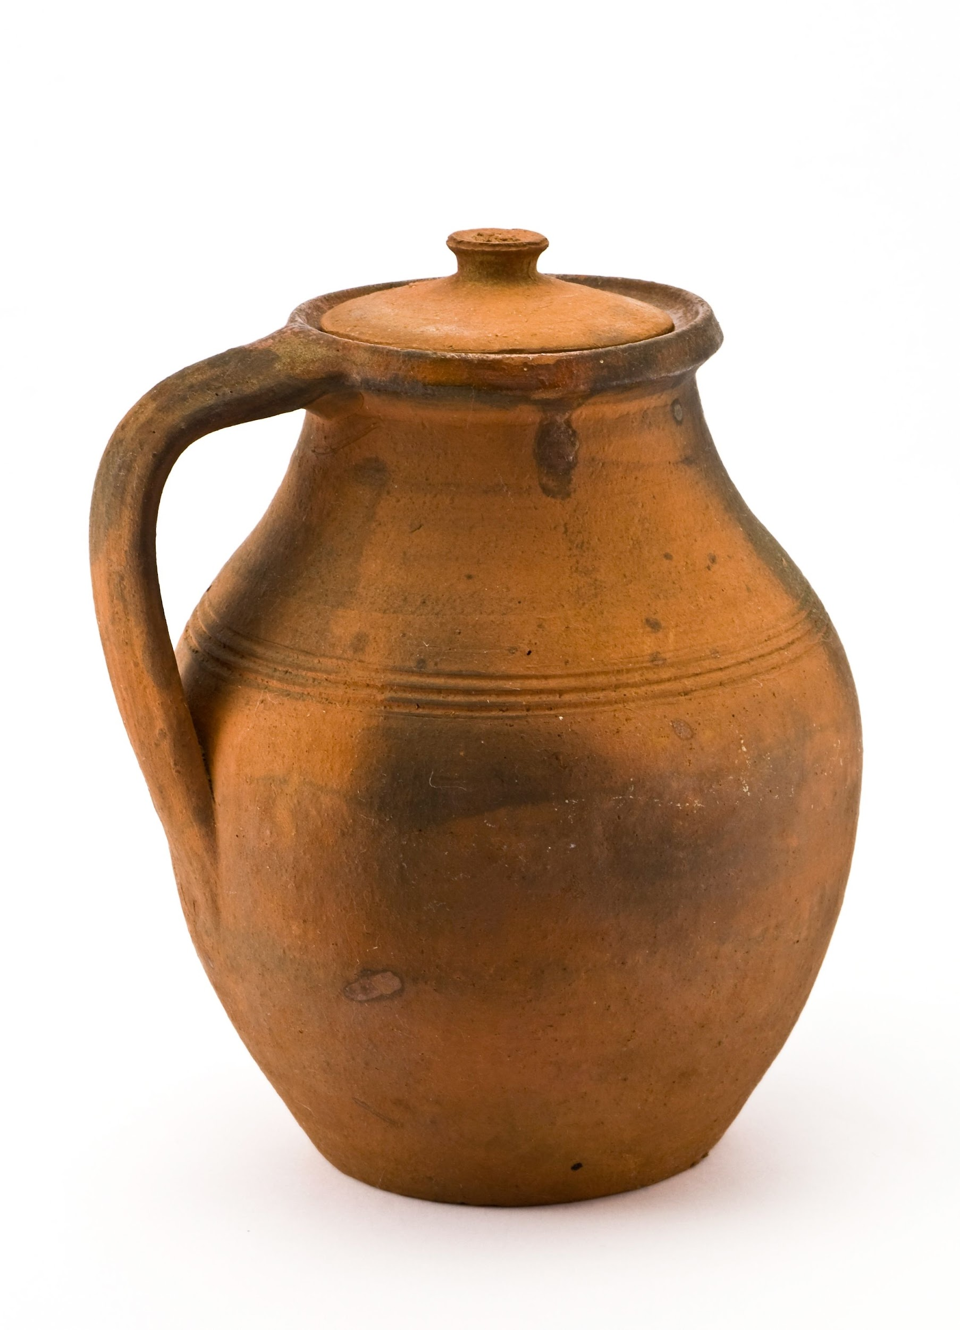  הֲיֵשׁ מַיִם בַּכַּד  Is there water in the jar?
אַיִן, אֵין מַיִם בַּכַּד
No, there is no water in the jar.
(lit. there is none, there is no water in the jar)

Notice the difference in the vowels under the בּ in the following two sentences:
יֵשׁ בְּיַד אַבְרָם דָּבָר׃ - there is something in Avram’s hand
יֵשׁ דָּבָר בַּיָּד הַזֹּאת׃ - there is something in this hand
Remember that a noun in construct form will not take the definite article -הַ (section 11.2), so there is no definite article on ‘hand’ in the phrase בְּיַד אַבְרָם ‘the hand of Avram’. Instead, ‘hand’ is definite because the final word in the construct chain, ‘Avram,’ is definite. By contrast, in the phrase בַּיָּד הַזֹּאת ‘this hand’, ‘hand’ is not in construct form and does take the definite article, which we see in the pataħ vowel under the -בּ preposition (section 6.1).

Lesson 15 - Geography and more

15.1 Much/many
The word רַב ‘much/many’ is an adjective that agrees with the noun in gender and number, so it has four possible forms. Collective nouns, because they are singular in form, take singular adjectives.
Pl. | Sg.
כְּבָשִׂים רַבִּים  many sheep | בָּקָר רַב  much cattle | Masc.
פָּרוֹת רַבּוֹת  many cows | דָּגָה רַבָּה  much/many fish | Fem.

15.2 Collective nouns
We learn two more collective nouns in this lesson, again referring to groups of animals. צֹאן tso’n and בָּקָר baqar are singular in form, though almost always referring to a plural group.
צֹאן is typically translated into English as ‘flock(s),’ and it includes sheep, goats, rams, etc.
בָּקָר is usually translated ‘cattle’ or ‘herd(s),’ and includes cows, bulls, oxen, etc.


15.3 Rivers and wadis
There are two words for waterways in Hebrew that sound a bit similar but refer to different types of waterways. נָהָ֫ר nahár refers to a larger river like the Jordan, and נַ֫חַל náħal to a torrent of rushing water, a stream or a wadi. A wadi, like in the picture on the right, is a stream that flows deep in desert ravines and may dry up and disappear seasonally. נַחַל can refer to the stream of water, or to the dry streambed at the bottom of the ravine. Wadis are common in the desert mountains to either side of the Jordan River Valley.

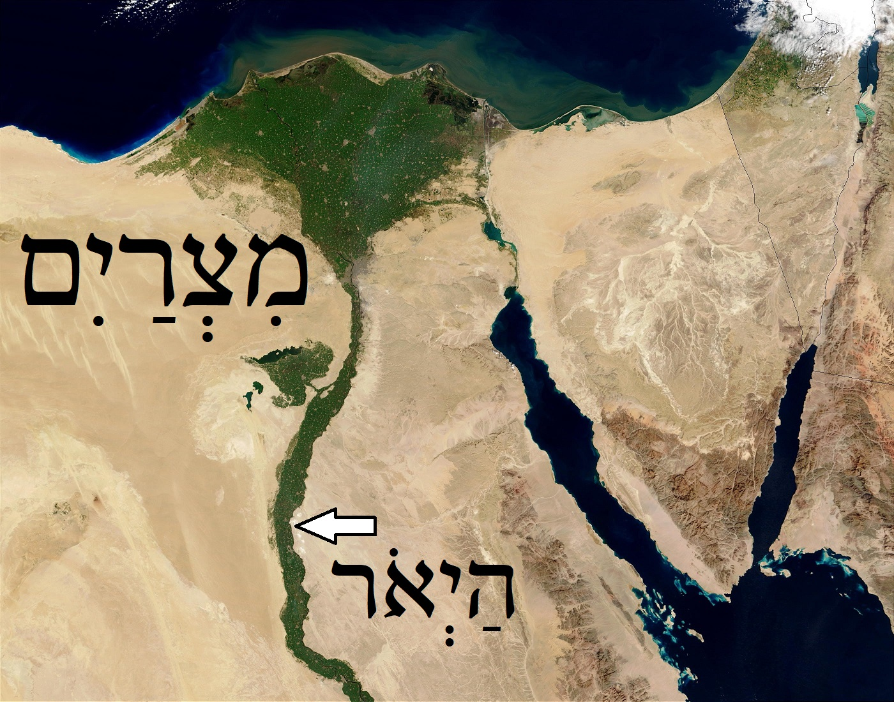
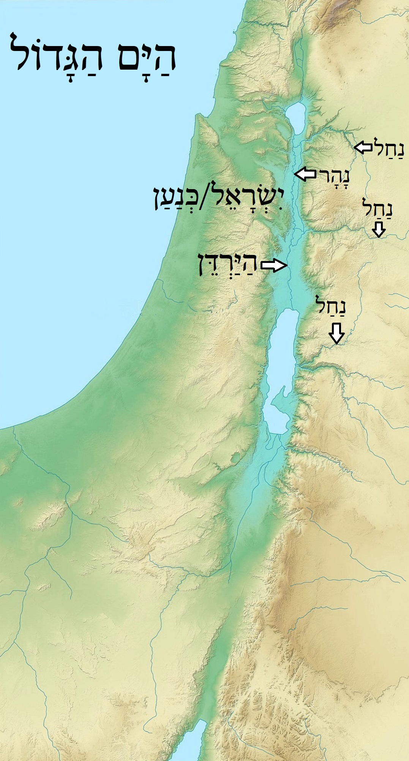

Lesson 16 - Alphabet part 4

16.1 Consonants
Gimel ג is the third letter of the alphabet, and is always pronounced ɡ, with or without dagesh.
Sin שׂ is the twenty-first letter of the alphabet, and is always pronounced s, with or without dagesh. Check out section 7.1 to understand how שׂ and שׁ are different.
Kaf ך כ כּ is the eleventh letter of the alphabet, and is pronounced k when it has a dagesh ךּ כּ, and χ (a uvular trill like German Bach or in the English sound of disgust “yeach”) when it has no dagesh ךְ כ.
- Kaf also has a sofit (final) form ך. Kaf sofit is unique in that, unlike other sofit forms that almost never take vowels, it must take either the qamets vowel ךָ for the ending χa or “kha” or the silent shewa vowel ךְ when it has no vowel after it.
Pe ף פ פּ is the seventeenth letter of the alphabet and is pronounced p when it has a dagesh פּ, and f when it has no dagesh ף פ. Pe sofit ף is always pronounced f.

Lesson 17 - Lamed and Possession

17.1 Expressing possession
Hebrew has no verb that corresponds to the English verb ‘to have.’ Instead, Hebrew expresses possession by saying a thing is ‘to me,’ or ‘to him,’ using the preposition -לְ. Like -בְּ (section 6.1), -לְ is always adjoined to the noun after it, or else it takes a pronominal suffix, as below:
Person | Sg.  Masc. Fem. |  | Pl.  Masc. Fem.
1 | לִי  to me |  | לָנוּ  to us
2 | לְךָ  to you (masc.sg.) | לָךְ  to you (fem.sg.) | לָכֶם  to you (masc.pl.) | לָכֶן  to you (fem.pl.)
3 | לוֹ  to him | לָהּ  to her | לָהֶם  to them (masc.) | לָהֶן  to them (fem.)
This is often combined with the existence words יֵשׁ and אֵין (section 14.5), forming a phrase like __יֶשׁ־לִי ‘I have __,’ or literally ‘there is __ to me’ and __ אֵין־לוֹ ‘he does not have __’ or ‘there is no __ to him.’
יֶשׁ־לִי דְבַרִים רַבִּים
I have many things.
אֵין־לִי כֶּבֶשׂ
I don’t have a sheep.
יֶשׁ־לָהֶם סוּס
They have a horse.
Likewise, combining the existence words with the yes-no question prefix, we can ask ‘do you have ___?’
הֲיֵשׁ לָךְ כַּד
Do you (fem.sg.) have a jar?

17.2 Adjectives as nouns
In the Bible verse Genesis 29:16, we encounter adjectives that take the definite article prefix and are being used as nouns, which is common in Biblical Hebrew.
וּלְלָבָן שְׁתֵּי בָנוֹת שֵׁם הַגְּדֹלָה לֵאָה וְשֵׁם הַקְּטַנָּה רָחֵל׃
And Laban had two daughters, the name of the older one (was) Leah and the name of the younger one (was) Rachel.
הַגְּדֹלָה – ‘the big/older one (fem.)’
הַקְּטַנָּה – ‘the small/younger one (fem.)’
Key helps
I don’t have anything ← אֵין לִי מְאוּמָה

Lesson 18 - Children and Elders

18.1 Vocabulary Notes
There are no new grammar points in this video, but here are a few notes on the new vocabulary introduced in this lesson. We learn singular and plural nouns, plus their construct forms (when followed by a possessor, see lesson 11).
Pl Constr. | Sg. Constr. | Plural | Singular
יַלְדֵי הָאִישׁ  The boys of the man |  | יְלָדִים yəladim 👦🏽👦🏽👦🏽 | יֶלֶד yeled | 👦🏽
 | יַלְדַּת הָאִשָּׁה  The girl of the woman | יְלָדוֹת yəladot 👧🏽👧🏽👧🏽 | יַלְדָּה yaldah | 👧🏽
זִקְנֵי יִשְׂרָאֵל  The elders of Israel |  | זְקֵנִים zəqenim 👴🏽👴🏽👴🏽 | זָקֵן zaqen | 👴🏽

עַם ‘am is a collective noun for ‘people.’
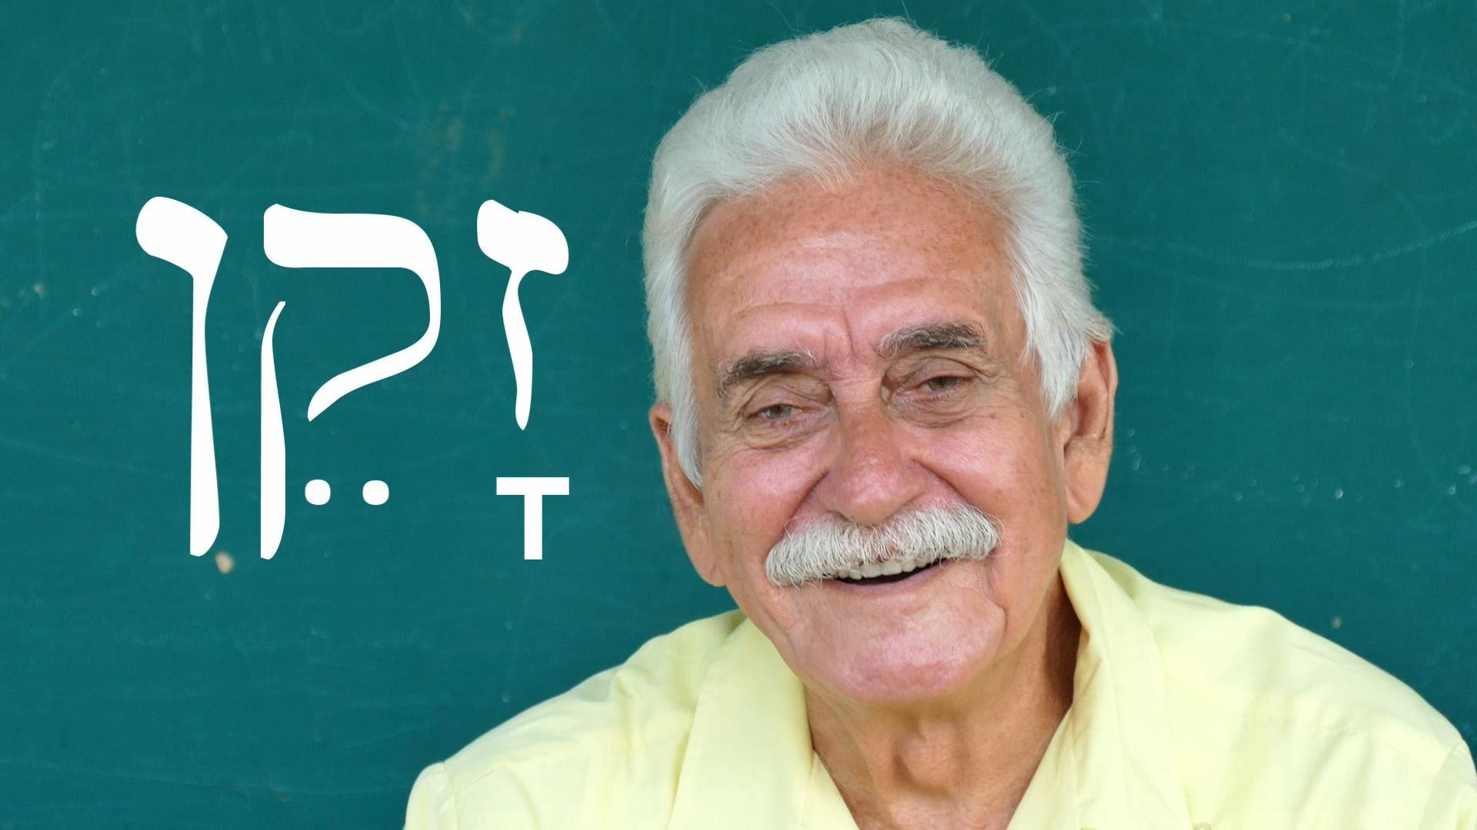
וַיְהִי vayyəhi is a form of the verb ‘to be’ that starts a story sequence, like “There was…”



Lesson 19 - Alphabet part 5

19.1 Consonants
ז zayin is the seventh letter of the alphabet, and is always pronounced z, with or without a dagesh.
ע ‘ayin is the sixteenth letter of the alphabet, and it is pronounced in our videos as a voiced pharyngeal fricative [ʕ]. This sound, also found in Arabic, is made by tightening the muscles of the throat to constrict the pharynx while vibrating the vocal cords. You can practice this sound 1) by first pronouncing ח ħet and then adding the vibration of the vocal cords, or 2) by making the sound of a German, French or Modern Hebrew r, and then moving the same constricting movement as far back in the throat as possible.
ץ צ tsade is the eighteenth letter of the alphabet, and it is pronounced ts, with or without a dagesh. Tsade sofit ץ is also always pronounced ts.
ח ħet is the eighth letter of the alphabet, and it is pronounced in our videos as a voiceless pharyngeal fricative [ħ]. Just like ‘ayin, this sound is found in Arabic, and is made by constricting the muscles of the throat to tighten the pharynx. The difference from ‘ayin is that the vocal cords are not vibrated when pronouncing ħet, producing a deep and rough h sound. You can practice this sound 1) by first pronouncing ע ‘ayin and then stopping the vibration of the vocal cords, or 2) by starting with the χ sound of kaf with no dagesh (like German Bach, or the sound at the end of the word מֶלֶךְ) and moving the same constricting movement as far back in the throat as possible (once you get back into the throat, you will no longer be able to vibrate the uvula like you do with χ).
ק qof is the nineteenth letter of the alphabet, and in Modern Hebrew and in our videos, it is pronounced k, with or without a dagesh. This means that it sounds the same as כּ kaf with a dagesh.
ט tet is the ninth letter of the alphabet, and in Modern Hebrew and in our videos, it is pronounced t, with or without a dagesh. This means that it sounds the same as ת tav.
ס samekh is the fifteenth letter of the alphabet, and in Modern Hebrew and in our videos, it is pronounced s, with or without a dagesh. This means that is sounds the same as שׂ sin.

19.2 Reduced pataħ
ֲ ħatef pataħ or reduced pataħ is a shortened version of pataħ ַ , and is pronounced a, just like pataħ but a little shorter.
It only occurs on letters that cannot take a vocal/audible shewa vowel ְ : the guttural letters א, ח, ע, and ה. This means that you will usually see this vowel under one of these four letters at the beginning of words that would normally begin with shewa because of the vowel pattern. Compare the two plural forms:
כְּבָשִׂים – sheep אֲנָשִׁים - people
According to the pattern, the first vowel would normally be a shewa, as in כְּבָשִׂים, but because אֲנָשִׁים starts with aleph, the first vowel is ħatef pataħ instead.

19.3 Furtive pataħ
When pataħ ַ appears on ח, ע, or הּ at the end of a word, it is pronounced before the consonant instead of after. This is represented by the fact that it is written slightly more to the right than a normal pataħ. This is called a “furtive pataħ” or a “transitional pataħ.”
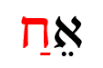  furtive pataħ pronounced aħ | חַ  normal pataħ pronounced ħa

The furtive pataħ is an a sound inserted to make the transition between the previous vowel and the guttural consonant easier to pronounce. So far, the only word we have learned that contains a furtive pataħ is יָרֵחַ yareaħ ‘moon’ (Note that most Modern Hebrew fonts do not include a special furtive pataħ character that is on the right side instead of centered, including the Times New Roman font in this document).
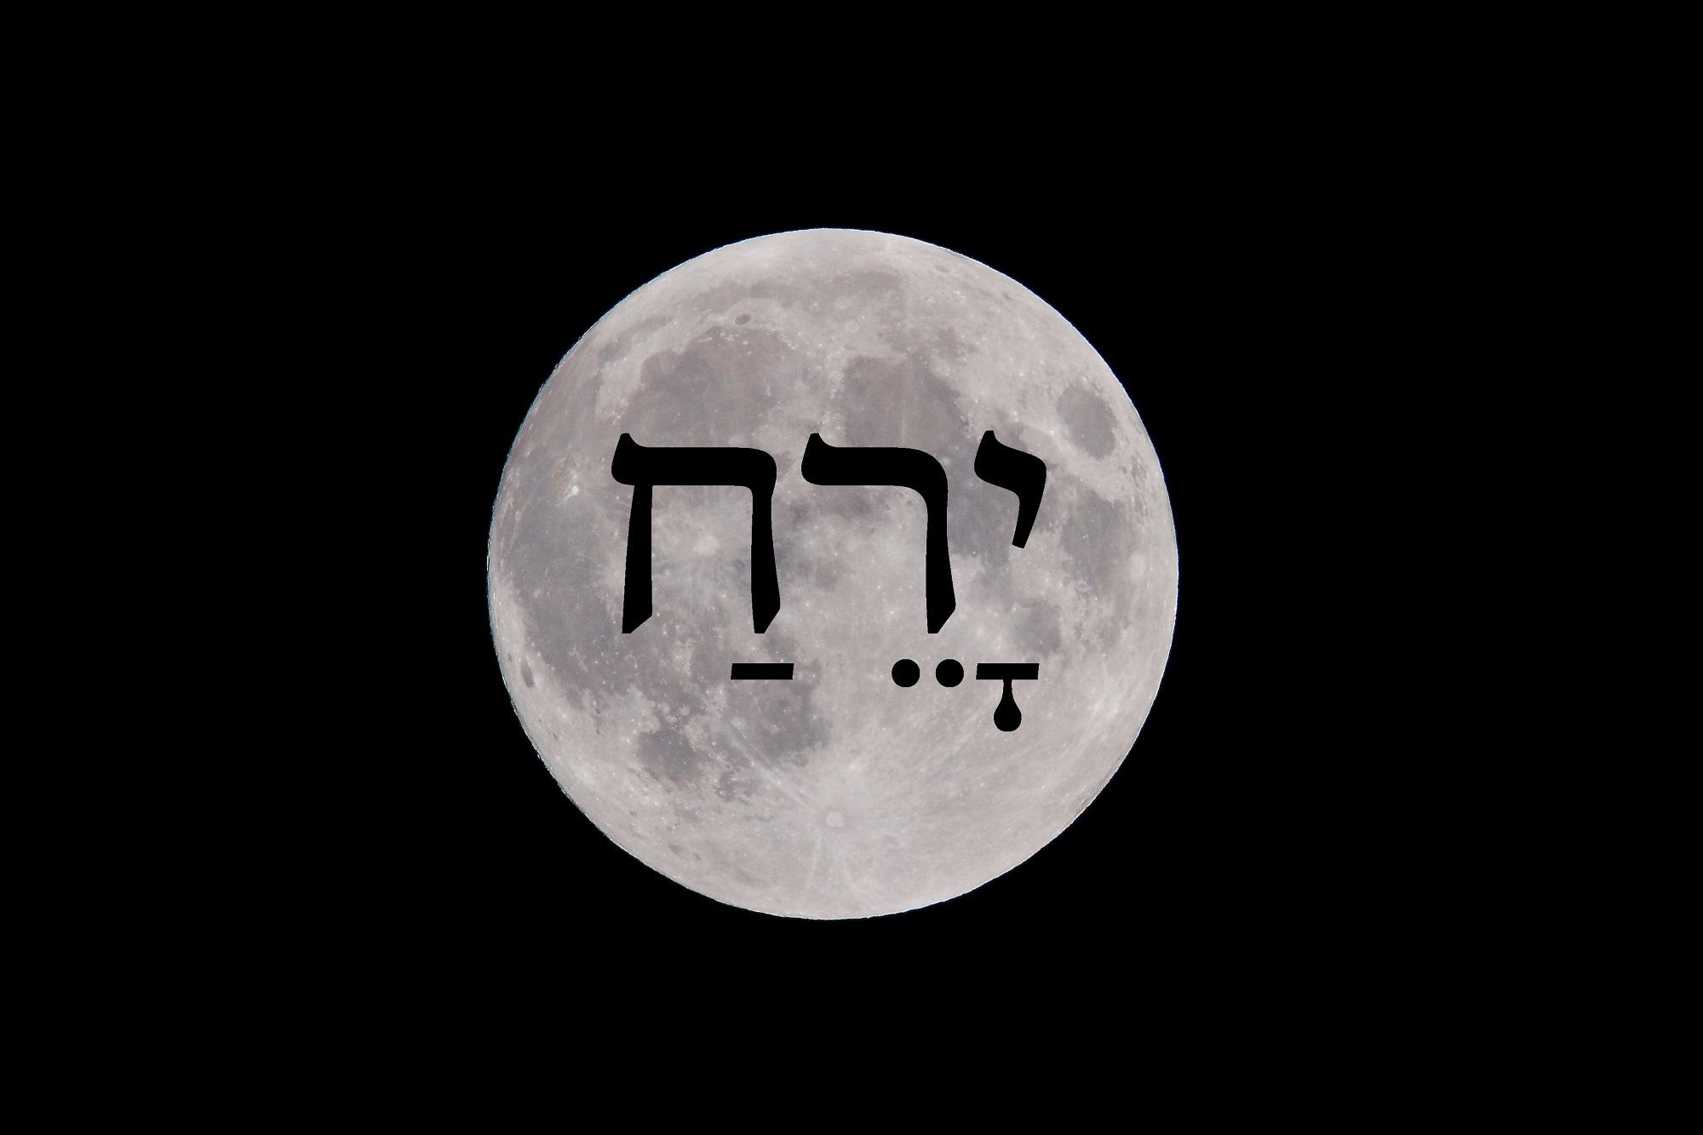

Lesson 20 - Asher & Relative Clauses

20.1 Morphology of prepositions
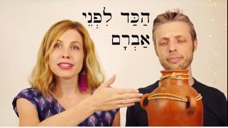
Some prepositions were derived from parts of the body in their construct forms.
לְיַד ‘next to’ from יָד ‘hand’ → lit. ‘to the hand of…’
לִפְנֵי ‘in front of’ from פָּנִים ‘face’ → lit. ‘to the face of…’
(Recall that the construct form of פָּנִים is פְּנֵי, as in פְּנֵי אַבְרָם ‘Avram’s face.’)

20.2 Inseparable prepositions with the definite article
There are three prepositions in Hebrew that consist of only one letter, and always affix to the word that follows. These are -בְּ- ,לְ and -כְּ (the last one will be introduced in lesson 41). When these affix to a noun that has a definite article -הַ or -הָ ha- ‘the,’ the letter ה he disappears and the preposition takes the vowel of the article (We saw this briefly in 7.3).
בְּ + הַ + מִדְבָּר ← בַּמִּדְבָּר ’in the wilderness‘
בְּ + הַ + שָׂדֶה = בַּשָּׂדֶה ’in the field‘
Contrast the two words below, with and without the definite article:
לְ + אִשָּׁה ← לְאִשָּׁה ’to a woman‘
לְ + הָ + אִשָּׁה ← לָאִשָּׁה ’to the woman‘

20.3 When -וְ (vǝ-) becomes -וּ (u-) (Review from 3.1)
In some contexts, -וְ (vǝ-) becomes -וּ (u-), depending on the word it is attached to. This sound change happens:
- before the labial (involving the lips) letters פ , ב , מ (and ו when it is pronounced as consonant v)
- before a word with shewa vowel ְ under the first letter, as in וּגְמַלִּים, וּנְעָרוֹת etc.

20.4 Relative Pronoun אֲשֶׁר ’asher
The word אֲשֶׁר ’asher functions as a relative pronoun like ‘that,’ ‘who,’ or ‘which’ in English. It introduces a relative clause such as “the man that is in the field” or “the woman who came to the house.”
Where is the boy that is on a donkey?  He is the boy that is on a donkey. | אַיֵּה הַיֶּלֶד אֲשֶׁר עַל־חֲמוֹר?  הוּא הַיֶּלֶד אֲשֶׁר עַל־חֲמוֹר׃
Where is the man who has a boy?  He is the man who has a boy. | אַיֵּה הָאִישׁ אֲשֶׁר יֶשׁ־לוֹ יֶלֶד?  הוּא הָאִישׁ אֲשֶׁר יֶשׁ־לוֹ יֶלֶד׃

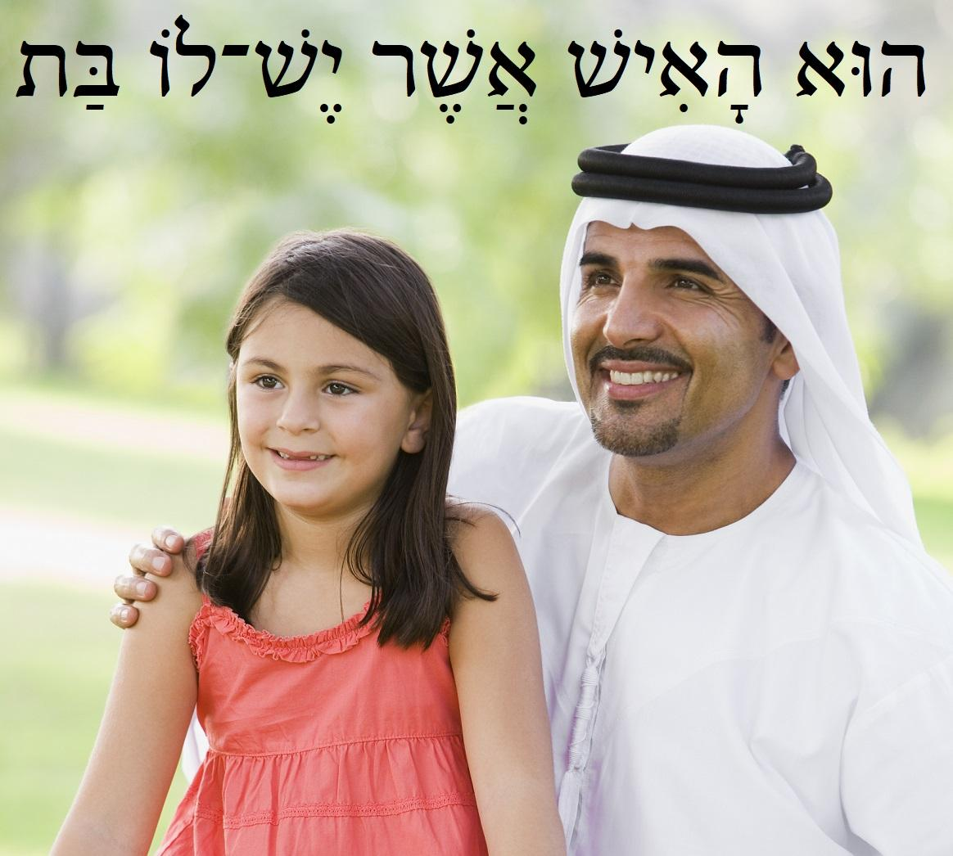
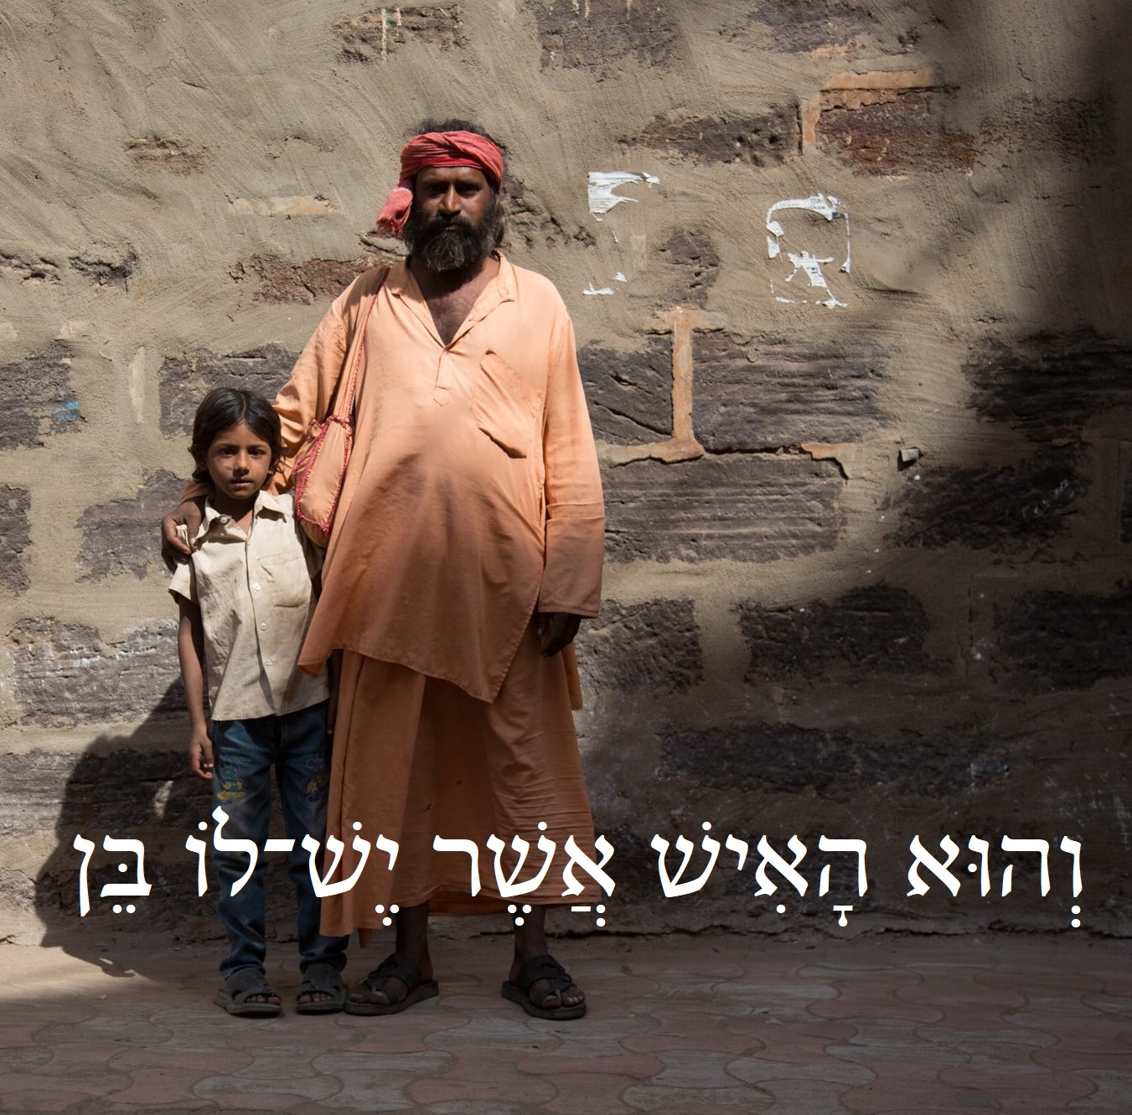

Lesson 20b - Writing the Hebrew Alphabet

20b.1 The Hebrew Alphabet or Aleph-Bet
The Hebrew alphabet didn’t always look like you see it today. Sometime before 1500 B.C. Semites somewhere between Phoenicia and Sinai devised an alphabet that used symbols that looked like little pictures of animals and objects. You can read more about the most ancient versions of the Hebrew alphabet here.
Today the Hebrew alphabet we use is also known as the “aramaic square script.” It has twenty-two consonants, and was written with only consonants for thousands of years. Eventually four of the letters (ה and ו for example) were sometimes used to represent vowels, as we can see in the Dead Sea Scrolls.
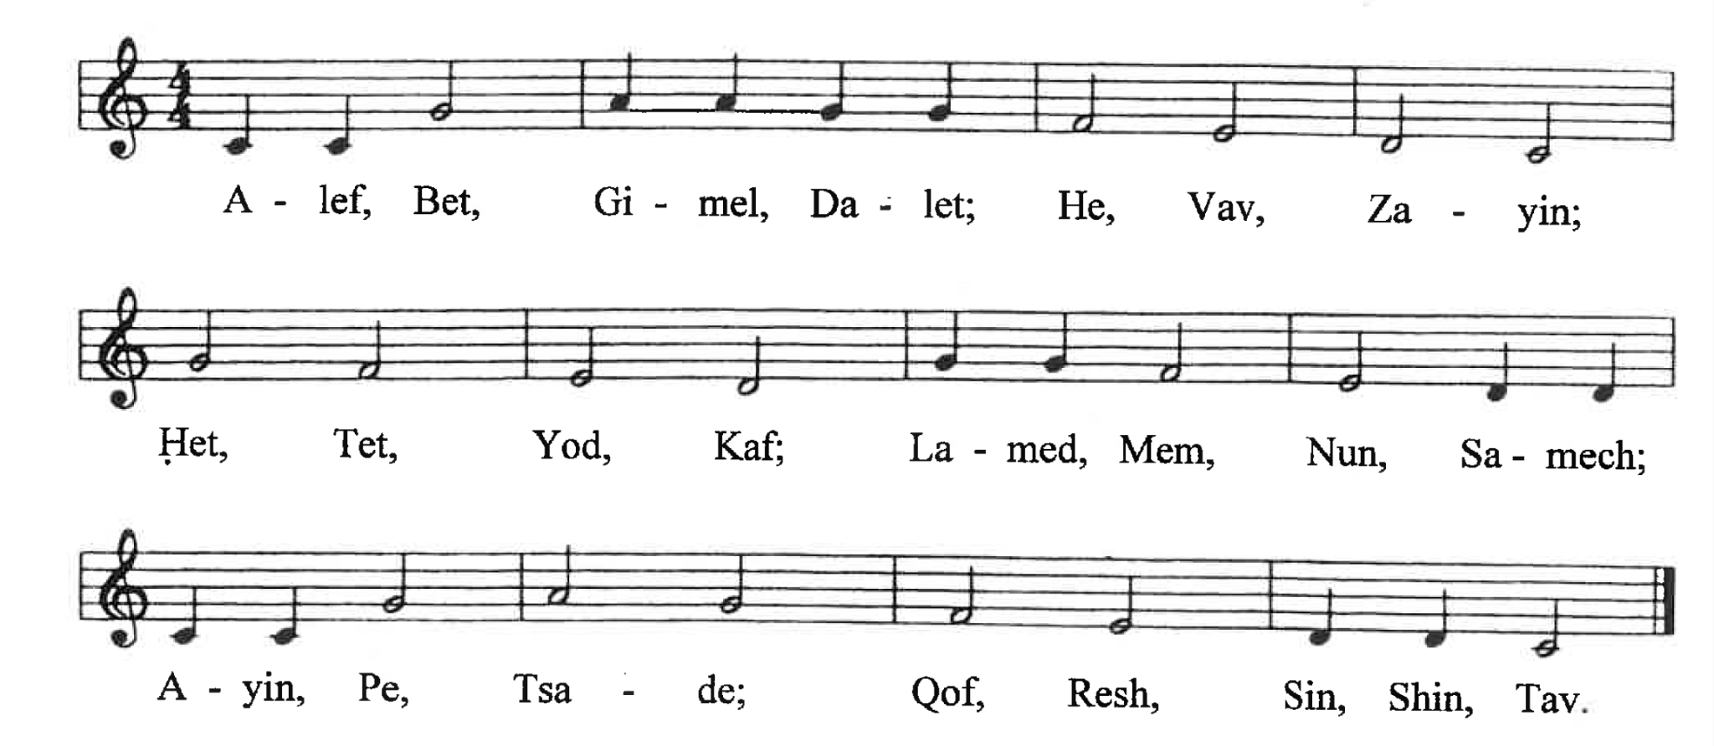
The scrolls used in Jewish synagogues are still written without vowels and modern Hebrew also does not usually represent the vowels (except in poetry and children’s books). A system of vowel symbols was gradually added to the Hebrew Old Testament in order to preserve the traditional pronunciation of the language. The process of adding vowels (also known as niqqud) began about A.D. 700 and was finished by around A.D. 950. These vowels we see in our Hebrew bibles today were added by scribes called Masoretes.
It’s important to memorize the letters in order, so that you can use a lexicon/dictionary. You can use the alphabet song to do that.

When you learn to write the alphabet, practice following the video and write each letter at least ten times. Keep writing until you feel comfortable writing the letters at a good speed. Write the alphabet in order twenty times, including the final (sofit) forms of the letters that have them (for example ן נ). For those of you who want to learn to type Hebrew, this page will give some options.

Lesson 21- Verbs come & go (qatal singular)

21.1 Introduction to the Hebrew Verb
Hebrew verbs are made up of three letter roots. By adding suffixes and prefixes to that root, or by changing vowel patterns, you can change what the verb communicates. For example, in this video we see that a man walked/went (הָלַךְ). This verb is what we could classify as a third-person-masculine-singular (3MS) verb. That means that the third person (he or she) is doing the action, a man is doing the action, and only one man is doing the action (singular): he walked. In a lot of Hebrew grammars and commentaries you’ll see authors talking about which person is doing the action: first, second, or third. Here are what those numbers refer to for future reference:
1st person: I, we
2nd person: you or y’all
3rd person: he, she, they
So if we change the root הָלַךְ (which means “he walked/went”) to הָלְכָה (by adding ־ָה to the end as a suffix) then the meaning changes to “she walked.” Here’s another example from the video:
He came - בָּא
She came - בָּאָה
I came - בָּאתִי
It’s important to understand that in our videos we are first focusing on verb forms that communicate an action that was completed, that already happened, or happened in the past. You won’t see infinitives or participles or other forms of verbs for a while. This is because most of the Hebrew Bible is narrative, describing things that happened in the past, so naturally these kinds of verbs are the most common. They will equip you to read more of the Bible sooner.

21.2 Aspect
Hebrew doesn’t have verb tenses like English. Instead it has aspects. Verbal aspect is a way of talking about an action that depends on the speaker’s point of view. Hebrew has two basic aspects: imperfective and perfective. Perfective aspect communicates something that has been completed (often in the past), and imperfective aspect communicates something that hasn’t been completed (often in the future). One conjugation of the perfective aspect is called qatal, which is introduced in this video. Qatal gets its name from the Hebrew verb קָטַל to kill, which is often used in charts showing how to conjugate verbs in Hebrew. You can think of the qatal verb forms as the most basic ones that communicate completed actions.

21.3 Weak & Strong Verbs
In Hebrew, as with other languages, there are regular and irregular verbs. Irregular verbs change in irregular ways when you add affixes (prefixes or suffixes), whereas regular verbs are more predictable in how they will look and sound when you change them. For example, in English walk is a regular verb because walk is always there when you conjugate it: I walk, he walks, I walked, he walked, etc. But the verb go is irregular in English, because you can’t simply say, “I goed” to communicate what you did in the past. Instead you have to say, “I went.” Irregular verbs tend to be verbs that are used a lot, so that means that you will be learning many irregular verbs first in Hebrew, because they are so common.
Irregular Hebrew verbs are often called weak verbs because they contain a letter or two that can easily be swallowed up by another one. For example, ה is a weak letter because it’s just a breath and can easily get replaced by other sounds when they are added. We’ll explain more about this later. On the other hand, regular Hebrew verbs are usually called strong verbs.

21.4 Binyanim & Qal
Hebrew not only has different aspects, it also has stems or binyanim. There are seven main binyanim, and our videos begin by introducing you first to the one called qal. So you can assume that all the verbs you’ll be seeing for a while will be qal, which is the simplest stem. If you’re going to look up a verb in a biblical Hebrew dictionary or lexicon, the entry will always appear as the qal form of the verb, third person, masculine, singular (3MS). So, for example, if you saw the verb הָלְכָה and needed to look it up in a lexicon, you would want to look for the basic three-letter root form הלך.

Lesson 22 - Say & Imperatives

22.1 אָמַר - He Said
In this lesson we introduce the verb “say,” אָמַר. Remember that we are focusing first on perfective aspect verbs, which are verbs that describe an action that has been completed. In the case of this lesson we are describing things that happened in the past. So אָמַר means “he said,” and is the form that you’ll find in the dictionary. Here are the rest of the forms of אָמַר presented in the video:
She said (qatal 3FS) | אָמְרָה
You (feminine) said (qatal 2FS) | אָמַרְתְּ
You (masculine) said (qatal 2MS) | אָמַרְתָּ
I said (qatal 1CS) | אָמַרְתִּי

22.2 Imperatives
An imperative is a command. The first command we see in this lesson is לֵךְ which is what you would say to a man/boy if you want him to go. If you say “Go!” to a woman, the word is לְכִי. The root of this command is the verb we learned in the last lesson: הָלַך which is the form you would look up in the dictionary/lexicon. Notice that the ה at the beginning got chopped off. This kind of chopping will happen often with Hebrew imperatives when the verb root has weak letters like ה (see the last lesson). But a verb like בָּא won’t lose its first letter when pronounced as a command. Instead it will simply change vowels. In the video Beth commands Avram: בּוֹא. This is the masculine imperative form of בָּא. But if Avram commands Beth to come, he must use the feminine form: בּוֹאִי.
Imperative verbs only occur for the second person: you/y’all. The imperative forms in Hebrew are only used for positive commands, not for negative ones. If you want to say, “Don’t go,” Hebrew has another form for that which we will learn later. So, for example, the ten commandments are not imperative Hebrew forms, because they are negative commands.

22.3 The vayyiqtol or vav-consecutive-imperfect
Unlike English, Hebrew has a special verb form for telling stories. This is called the vav-consecutive-imperfect or vayyiqtol (also known as waw-consecutive-imperfect, or wayyiqtol in other textbooks). Biblical Hebrew uses this verb form to string verbs together like a chain to form a narrative. This may be hard to wrap your mind around, but you’re going to see thousands of these forms in the Hebrew Bible, so it’s important to take the time to grasp it.
As we’ve already explained, אָמַר (he said) is a verb with perfective aspect (completed action), which often communicates past events. This may seem like it’s precisely the kind of verb to tell a story with in Hebrew, but that’s not how Hebrew works. There’s another conjugation that you use when you’re telling a sequence of events in a story: the vayyiqtol form. In the video you see the first example of this: וַיּ̇אמֶר. In simplified terms, when you add the וַיּ prefix to a verb, you get the vayyiqtol form, which is used for narratives. Qatal and vayyiqtol verbs have the same perfective aspect, usually communicating past actions. So both אָמַר and וַיּ̇אמֶר essentially communicate the same thing: “he said.” But many English translations will often translate the ו as and: “and he said.” And if you think about it, most native English speakers find it natural to use and a lot when they’re telling stories: “this happened... and this happened... and this happened….” Hebrew does the same kind of thing.
So in the video, when Beth is recounting a sequence or chain of events that happened, she says:
אָמַרְתִּי אֶל־אַבְרָם שָׁלוֺם׃ וַיּ̇אמֶר אַבְרָם שָׁלוֺם׃
I said to Avram, “Shalom.” And Avram said, “Shalom.”
Here’s one more example:
אָמַרְתִּי אֶל־יַעֲקֹב בֶּן־מִי אַתָּה׃ וַיּ̇אמֶר בֶּן־יִצְחָק אָנֹכִי׃
I said to Jacob, “Whose son are you?” And he said, “I’m the son of Isaac.”

Lesson 23 - Possessive Suffixes part 1 & Body Parts

23.1 Possessive Suffixes
In Hebrew, if you want to say that something belongs to someone, you can add a suffix onto the end of a word. These are called possessive or pronominal suffixes. For example, to say, “My head,” simply take the word רֹאשׁ and put a hireq-yod י ִ on the end of it, and you get רֹאשִׁי. With a word like mouth פֶּה you lose the weak letter ה when you add the possessive suffix: פִּי “my mouth.”
Here are some more examples:
אַף ← אַפִּי  my nose ← nose | כַּף ← כַּפִּי  my palm ← palm

The וֺ- suffix is the 3MS (third-masculine-singular) suffix: his. So “his name” would be שְׁמוֺ. If a vowel comes before the 3MS suffix, then it will turn into a simple vav: פִּי ← פִּיו “his mouth.” To say “her name” you use the הּ ָ - suffix: שְׁמָהּ. Keep in mind that הּ has an aspirated/rough sound to distinguish it from a simple ה ending.
The following chart provides all the possessive suffixes presented in the video:
His (3MS)👳 | וֹ
Her (3FS)👩 | ָהּ
Your (2MS)👳 | ְ ךָ
Your (2FS)👩 | ֵ ךְ
My (1CS)👩/👳 | ִ י

Lesson 24 - Possessive Suffixes part 2 & Family Terms

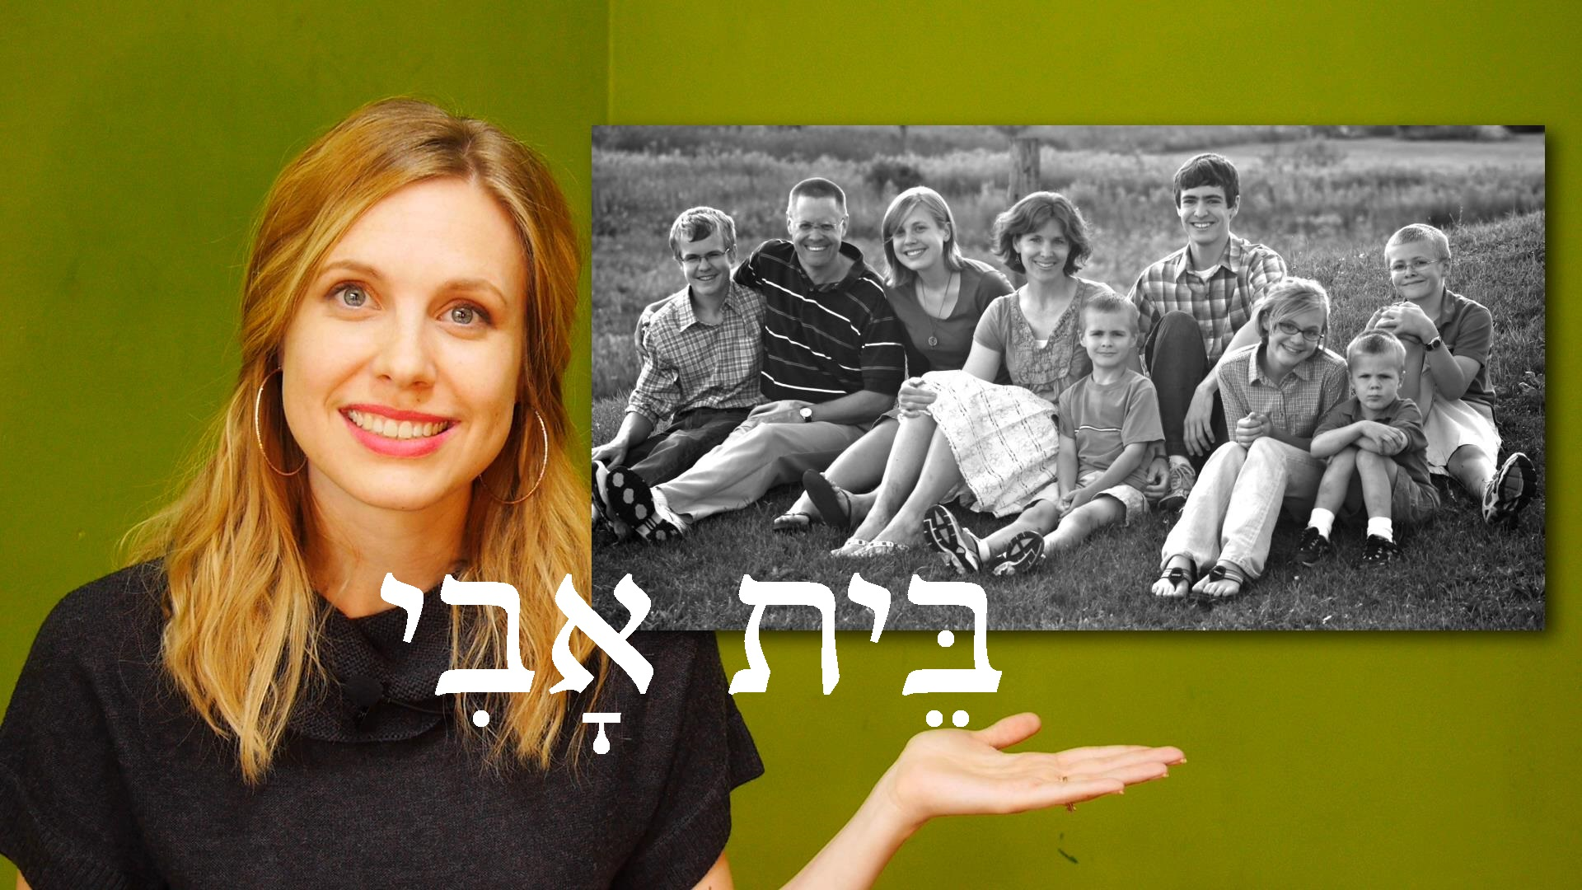
24.1 Family Terms
In this lesson a new term is introduced: בֵּית אָב “A father’s house.” This refers to a family. So Beth introduces her own family, saying “This is my father’s house” זֶה בֵּית אָבִי. The next segment helps reinforce the 1CS possessive suffix (my) from the previous lesson, when she says: “He is my father” הוּא אָבִי and “She is my mother” הִיא אִמִּי and “he is my brother” הוּא אָחִי, “she is my sister” הִיא אֲחֹתִי, etc.
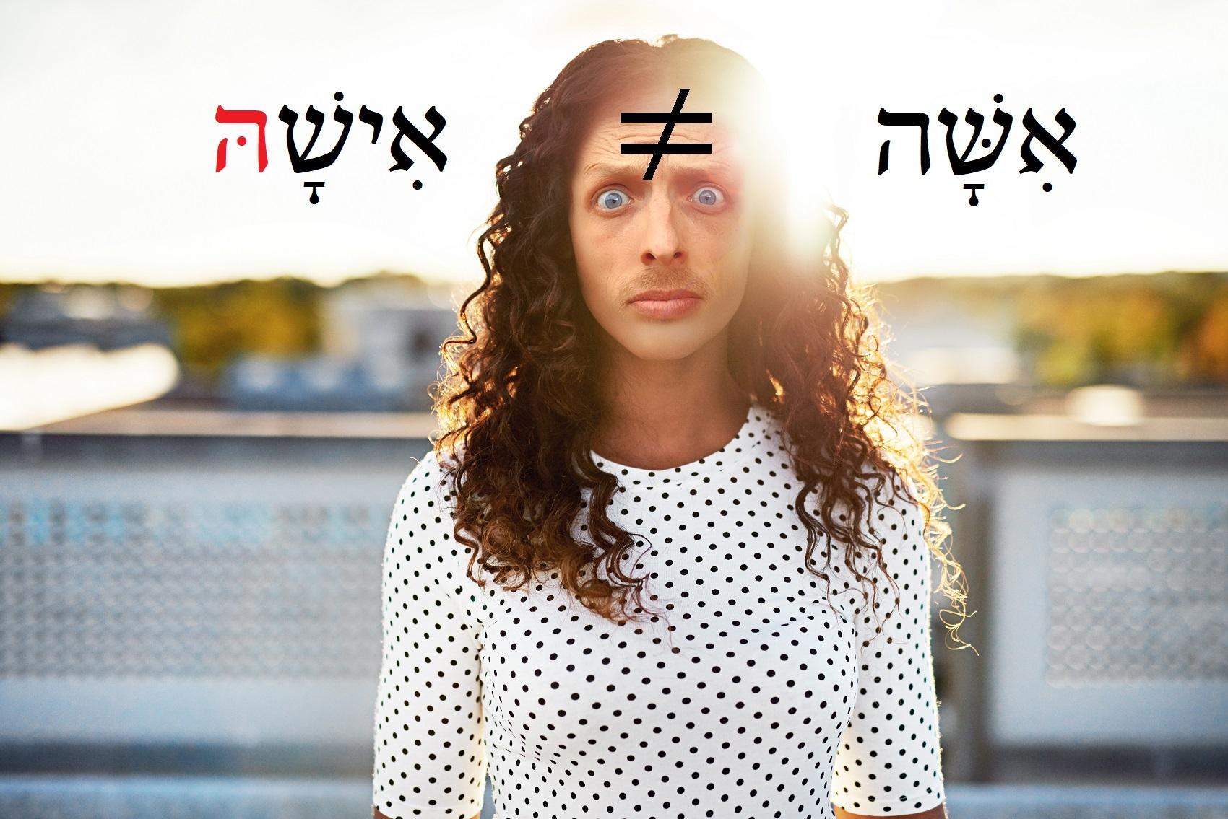
When Avram’s father is introduced you’ll hear: הוּא אֲבִי אַבְרָם. Even though אֲבִי sounds exactly the same as אָבִי, they aren’t the same. אֲבִי means “father of” and אָבִי means “my father.” Notice the subtle difference in the vowels under the א. In technical terms, אֲבִי is the construct form of אָב. Remember that when something is in a construct relationship with a proper name (e.g. _____ of Name), it is understood as definite (which means it has the word “the” in front of it). So the phrase הוּא אֲבִי אַבְרָם means “He is the father of Avram” and not “He is a father of Avram.”
Another tricky thing to keep in mind when adding possessive suffixes to family terms is when saying, “I am her husband/man” אֲנִי אִישָׁהּ. When Avram says this about Beth, it sounds very much like he’s saying “I am a woman” אֲנִי אִשָּׁה. This is why it’s important to aspirate the הּ at the end, to distinguish it as the possessive “her” (as in “her husband”).
Later in the video we see that when the 3FS possessive suffix הּ ָ comes after י ִ it turns into יהָ ִ . This happens in phrases like “her brother” אָחִיהָ and “her father” אָבִיהָ.
In this lesson we are introduced to more possessive suffixes and how they attach to singular nouns. The first is “our” (1CP = first-person-common-plural). So to say “our horse” you would take the word סוּס and add the suffix נוּ ֵ to it: סוּסֵנוּ. “Our house (בַּיִת)” would be בֵּיתֵנוּ.
The כֶם- suffix communicates “your” = possessed by y’all (you plural). In technical terms it is the 2MP (second-masculine-plural) pronominal suffix. Beth’s first example is: יֵשׁ לָכֶם בַּיִת, which means literally “There is to you a house,” which is better translated as “You have a house.” To say, “This is your house,” you would say: זֶה בֵּיתְכֶם. If you want to say that something belongs to a group of women, then the suffix changes to כֶן-. For example, “He is your father” הוּא אֲבִיכֶן, or “He is your brother” אֲחִיכֶן.
The following chart provides all the possessive suffixes presented in the video:
Their (3MP)👳👳 | ָ ם
Their (3FP)👩👩 | ָ ן
Your/y’all’s (2MP)👳👳 | כֶם
Your/y’all’s (2FP)👩👩 | כֶן
Our (1CP)👩👳 | ֵ נוּ

Lesson 25 - Hear & Obey

25.1 Voice/Sound - קוֺל
The word for voice or sound is introduced in this lesson: קוֺל. Make sure not to confuse קוֺל with כֹּל or כָּל־, which means all/every. The construct form of קוֺל is the same as its normal or absolute form, so to say “voice of a man” or “a man’s voice” you would simply say קוֺל אִישׁ. “The sound of feet” would simply be קוֺל רַגְלַיִם.

25.2 Hear & Obey
In biblical Hebrew the same verb is used to communicate both hearing and obeying: שָׁמַע. Once again, all the uses of the verb in this video are in perfective aspect, communicating completed or past action. שָׁמַע is the root of the verb, the lexical/dictionary form, and means “he heard.” Here are some examples of its conjugation:
אַבְרָם שָׁמַע
Avram heard (3MS)
בֵּת שָׁמְעָה
Beth heard (3FS)
אֲנִי שָׁמַ֫עְתִּי
I heard (1CS)
So how do you know when שָׁמַע means hear or obey? Answer: when it is used in combination with בְּקוֺל. In the word בְּקוֺל the בְּ is acting as a kind of direct object marker on קוֺל. Many Hebrew grammars include a section on “special uses of בְּ”. For example, בְּ can be used in an “adversative” sense, communicating that something was against something else. And there are many other “special uses.” In the case where it is used after שָׁמַע it wouldn’t make sense to translate שָׁמַעְתִּי בְּקוֺלוֺ as “I listened in/with his voice,” which would be the most common use of בְּ. Instead, we understand the phrase שָׁמַעְתִּי בְּקוֺלוֺ to mean “I obeyed him” or, more literally, “I obeyed his voice.”
So in the video, after watching a flashback, we hear Beth say:
אַבְרָם שָׁמַעְתִּי בְּקוֺלְךָ
“Avram, I obeyed you.”
And Avram responds: שָׁמַעַתְּ בְּקוֺלִי “You obeyed me.”

25.3 The Name of God
The personal name of God (אֱלֹהִים), as introduced in Exodus 3:15, is יהוה. We do not usually write it with vowels in our videos because its exact historical pronunciation has unfortunately been lost. There is a longstanding tradition within Judaism of using a substitute title to speak of God: אֲדֹנָי. This tradition was preserved by the Masoretes who developed the vowel system for Hebrew. They did this by inserting the vowels for אֲדֹנָי into יהוה which gives you יְהֹוָה . Many times they drop the holem and simply write it as יְהוָה.
If you’re wondering why we choose to pronounce God’s personal name as Yahweh in our videos, please visit http://freehebrew.online/pronunciation and scroll to the bottom of the page where you’ll find links to help you understand our reasons, including a video we’ve created. The book we’ve written on the issue explains everything you may want to know about why some people avoid pronouncing God’s name, as well as what the Bible teaches about the subject.

Lesson 26 - Be & Beauty

26.1 To Be - הָיָה
The verb root הָיָה means “he was” or “there was” or “it was.” As in past videos, the perfective aspect of the verb is demonstrated, which refers to a past state. Let’s look at the following example:
אַבְרָם הָיָה יֶלֶד׃ הוּא הָיָה יֶלֶד׃ עַתָּה אַבְרָם אִישׁ׃
“Avram was a child. He was a child. Now Avram is a man.”
Notice that הָיָה is not used when talking about the present, as we see in this sentence:
“Now Avram is a man” עַתָּה אַבְרָם אִישׁ. Biblical Hebrew usually uses verbless clauses to talk about the present state or existence of something, as we’ve seen in past videos. For example, every time Beth says, אֲנִי בֵּת “I’m Beth” at the beginning of a video, she doesn’t use some other aspect or form of הָיָה. She simply uses the verbless clause “I Beth.”
This is the conjugation for הָיָה:
He was (3MS)👳 | הָיָה
She was (3FS)👩 | הָיְתָה
You were (2MS)👳 | הָיִיתָ
You were (2FS)👩 | הָיִית
I was (1CS) | הָיִיתִי
It’s important to distinguish between אַתָּה and עַתָּה which sound very similar. The first is the masculine pronoun “you” and the second is the word for “now.”
הָיָה is often used in telling stories, but in the vayyiqtol (or vav-consecutive-imperfect) form, which is וַיְהִי. Remember that the vayyiqtol form communicates the same perfective aspect as the qatal form, so וַיְהִי can usually simply be translated as “And there was…” or simply “There was....” It’s often used to begin a new narrative or a new part of a story. For example, when introducing Elkanah for the first time in 1 Samuel we could say something like this:
וַיְהִי אִישׁ אֶחָד וּשְׁמוֺ אֶלְקָנָה׃
“There was a man and his name was Elkanah.” Or “Now there was a certain man whose name was Elkanah.”

26.2 Beauty - יָפֶה and יָפָה
יָפֶה is an adjective that means “beautiful.” You may remember that Beth also used the word to praise Avram for correct answers in some of the early lessons, but in the Bible it usually refers to beauty. Although יָפֶה is used to refer to a man as handsome (like in Genesis 39:6), the feminine form of the adjective is more common, used to describe women: יָפָה. Often the word is combined with מַרְאֶה which means “appearance.” For example, “She is a woman beautiful of appearance” would be: הִיא אִשָּׁה יְפַת מַרְאֶה׃. Some might translate this as “She is a woman who is beautiful to look upon,” but most modern versions of the Bible would simply say, “She is a beautiful woman.” יְפַת is the construct form of יָפָה. Another way of saying a woman is beautiful is by using the phrase “good of appearance” טוֺבַת מַרְאֶה.

Lesson 27 - Give & Take, Silver & Gold

27.1 Give נָתַן & Take לָקַח
In earlier lessons we’ve already seen the imperative form of “take”: קַח. In this lesson we’re learning how to use it to communicate what happened in the past. Here is the singular conjugation of the qatal forms of לָקַח:
He took (3MS)👳 | לָקַח
She took (3FS)👩 | לָקְחָה
You took (2MS)👳 | לָקַחְתָּ
You took (2FS)👩 | לָקַחְתְּ
I took (1CS) | לָקַחְתִּי
We also introduce the command “give!” תֵּן (which is what you would say a man, not a woman) as well as the perfective aspect of the verb נָתַן (“he gave”). This is the singular conjugation of the qatal forms of נָתַן:

He gave (3MS)👳 | נָתַן
She gave (3FS)👩 | נָתְנָה
You gave (2MS)👳 | נָתַ֫תָּ
You gave (2FS)👩 | נָתַתְּ
I gave (1CS) | נָתַ֫תִּי

The verb נָתַן is what some textbooks call a doubly weak verb. This is because it has two weak letters in its root: נ. This letter is said to be weak because it has a tendency to be assimilated, which is the technical way of saying that it often gets absorbed or swallowed by stronger letters next to it. You can see this happen with “I gave” נָתַ֫תִּי. Notice that the final nun of the root completely disappears when it comes into contact with the 1CS תִי ending. The loss of this letter is marked by the dagesh dot in the תּ. It might help to imagine this as the ת swallowing the נ, which then ends up as a little dot in its stomach. So that’s how you know that the original root of that verb is נָתַן, which is the form you would look up in a dictionary/lexicon.
When you look up נָתַן in a lexicon you’ll find that it can also mean “to put/set.”

27.2 Conjugating more verbs in the plural
The second part of the video shows how to talk about what we and they and y’all did. For example:
אַבְרָם וְהַנְּעָרוֺת לָקְחוּ אֲבָנִים׃
“Avram and the young ladies took stones.”
אֲנַחְנוּ לָקַחְנוּ אֲבָנִים׃
“We took stones.”
לְקַחְתֶּם אֲבָנִים
“Y’all took stones.”
Remember that the masculine form of the verb is used if there is a man in the group, even if the majority are women. So in “y’all took stones” לְקַחְתֶּם אֲבָנִים the form is second-masculine-plural from the root לָקַח because Avram was part of the group. If it had been all women then it would be conjugated as לְקַחְתֶּן.
The following should help you navigate some of the plural conjugations in this video:
Root | הָלַך | בּוֹא | נָתַן | הָיָה
Conjugation | הָלַכְנוּ  we went/walked | בָּ֫אנוּ  we came | נָתַ֫נּוּ  we gave | הָיִינוּ  we were

Lesson 28 - Marriage

28.1 New Vocabulary
It’s important to understand that רוּחַ can mean spirit, breath, or wind. If you need to, go back to 19.3 to review the furtive pataħ, which appears in רוּחַ. Also, keep in mind that this font doesn’t allow the pataħ to be offset as it should be (see the image below).


28.2 Vayyiqtol Review
As we already saw in 22.3, Hebrew uses a special form of verb for narrating a sequence of events: the vayyiqtol or vav-consecutive-imperfect. The historical books of the Hebrew Bible use these kinds of verbs regularly. While we’ve already seen וַיּ̇אמֶר “and he said,” we’re introduced to the vayyiqtol form of “and she said” וַתֹּאמֶר (otherwise known as the 3FS form: third-person-feminine-singular). Remember that the default word order when using these forms is to have the verb come first, followed by the subject. So, for example:
וַיּ̇אמֶר הָאִישׁ... וַתֹּאמֶר הָאִשָּׁה…
“...And the man said...And the woman said”
Literally: “...And he said (verb) the man (subject)...And she said (verb) the woman (subject)”
We’re also introduced to the 3FS vayyiqtol form of the verb root הָיָה (“to be”) which is וַתְּהִי. For example:
וַיְהִי אִישׁ וּשְׁמוֺ אֶלְקָנָה׃ וַתְּהִי אִשָּׁה וּשְׁמָהּ חַנָּה׃
“And there was a man, and his name was Elkanah. And there was a woman, and her name was Hannah.”

28.3 Taking & Giving Wives
In Hebrew the typical way to talk about “getting married” is to say that someone “took for himself a wife/woman” לָקַח לוֺ אִשָּׁה. For example, to say “Avram married Beth,” it would be: אַבְרָם לָקַח אֶת־בֵּת לוֺ לְאִשָּׁה׃, literally, “Avram took Beth for himself for a wife.” In the Bible mothers and fathers can also “take a wife” for their sons (Gen 21:21, 38:6). Fathers can also give (נָתַן) their daughters as wives. For example:
לָבָן נָתַן לְיַעֲקֹב אֶת־לֵאָה בִתּוֺ לוֺ לְאִשָּׁה׃
“Laban gave to Jacob Leah his daughter for a wife.”

Lesson 29 - More Prepositions

29.1 City - עִיר
When the word for “city” עִיר is introduced, Beth points out that it is yet another irregular noun that takes a masculine plural ending, even though it is feminine (נְקֵבָה). That means that any adjectives that modify it will take the feminine ending. Here are some examples where this happens with עִיר and other irregular nouns:
עָרִים גְּדֹלוֺת  “big cities” | נָשִׁים טֹבוֺת  “good women” | אֲבָנִים קְטַנּוֺת  “small stones”

29.2 To Say - לֵאמֹר
לֵאמֹר “to say” is a very common word, which you’ll see over 900 times in the Hebrew Bible, so it’s important to learn how it’s used. The root verb is אָמַר, and לֵאמֹר is what grammars usually call an infinitive construct. Infinitives in English are verbs like “to eat,” “to sleep,” etc. They’re called infinitives because they aren’t bound by time; they aren’t past or future or present. Infinitives often attach the ל preposition as a prefix, which is the case with לֵאמֹר. This construction is what is often called a “speech reporting” device in the study of discourse analysis. In other words, when direct speech or dialogue is about to appear in a narrative, לֵאמֹר serves as a signal to the reader that someone is about to say something. For example, at the beginning of Jonah, we read:
וַיְהִי דְּבַר־יהוה אֶל־יוֺנָה לֵאמֹר לֵךְ אֶל־נִינְוֵה
Literally: “And the word of Yahweh was to Jonah to say, ‘Go to Nineveh.’”
In normal English we would translate this example as, “And the word of Yahweh came to Jonah, saying, ‘Go to Nineveh.’” Modern translations sometimes don’t translate לֵאמֹר when it sounds redundant in natural English. But when you see the word “saying” in traditional translations, it’s usually because לֵאמֹר is in that verse.

29.3 The מִן Preposition
The preposition מִן “from” can be written separately or as a prefix on a word. If it’s written separately it must be joined to the word with a maqqef (see section 5.4). Here are some examples:
As a prefix: מֵאֶרֶץ מִצְרַיִם “from the land of Egypt.”
Separately: מִן־הַיְאֹר “from the Nile.”
When מִן is attached as a prefix, there are a few rules to keep in mind:
- Before non-guttural letters (anything besides letters like א and ע), the ן assimilates to the first consonant of the word it’s attached to and becomes a dagesh forte dot. In other words, the ן gets swallowed up into the letter following it and is then represented by a dot. For example: מִבֵּיתוֺ אֶל־הַיָּם “from his house to the sea.”
- If you attach מִן to a word beginning with a letter with shewa under it, the dot may not appear. And if the first letter is י, then the shewa will disappear.
For example: מִיהוּדָה “from Judah” = יְהוּדָה + מִן
- When you attach מִן to words that begin with guttural letters (which can’t take a dagesh forte dot), the vowel turns into a tsere ֵ . This is what many grammars call “compensatory lengthening” of the vowel to compensate for the loss of the ן.
For example: מֵאֶרֶץ מִצְרַיִם “from the land of Egypt.”
קַח אֶת־הַכּוֺס מֵעַל רֹאשִׁי “take the cup from upon my head.”

29.4 More Prepositions
סָבִיב usually means “around,” and is sometimes followed by the ל preposition to mark the object that something is around or going around. This ל, like the אֵת direct object marker, is not translated in English.
For example: אַבְרָם הָלַךְ סָבִיב לַכִּסֵּא׃ “Avram walked around the chair.”
עַד is a preposition meaning “toward, as far as, until, while, or during.” Like most prepositions in Hebrew, it has a lot of uses, depending on the context. In this lesson it’s being used in the sense of “up to” and “until.” Examples:
הַסּוּס הָלַךְ עַד־הַבַּיִת׃ “The horse walked (all the way) up to the house.”
מֵעַתָּה עַד־עוֺלָם “from now until eternity.”
עִם־ is also introduced in this lesson, and can mean “with, by, near, at, beside” depending on the context.

Lesson 30 - Possessive Suffixes 3 - plural masc. nouns with suffixes
When possessive suffixes attach to plural nouns, they are slightly different from how they appear attached to singular nouns. And there is also a distinction between how possessive suffixes attach to masculine plural nouns and feminine plural nouns. But don’t lose heart, because the basic underlying pattern for the possessive suffixes always stays the same. This lesson provides exposure to possessive suffixes on masculine plural nouns. The clue to recognizing these suffixes as plural is that all of them use a yod י. The following chart provides all the suffixes:
3MS his 🧔 | - ָ יו |  | 3MP their 🧔🧔 | -ֵ יהֶם
3FS her 👩 | - ֶ יהָ |  | 3FP their 👩👩 | -ֵ יהֶן
2MS your 🧔 | - ֶ יךָ |  | 2MP y’all’s 🧔🧔 | -ֵ יכֶם
2FS your 👩 | - ַ יִךְ |  | 2FP y’all’s 👩👩 | -ֵ יכֶן
1CS my 👩🧔 | - ַ י |  | 1CP our 👩🧔 | - ֵינוּ

To see examples of all of these suffixes in action, check out the Lesson 30 script Google Doc, or review the video lesson.

Lesson 31 - Numbers 6-10

31.1 Numbers 6-10
This lesson introduces the cardinal numbers six through ten (to review numbers 1-5, go to section 12.1). Remember that, like adjectives, numbers have distinct forms for masculine and feminine nouns. When counting, the feminine forms are used.
 | With masculine nouns | With feminine nouns
6 ◦◦◦◦◦◦ | שִׁשָּׁה | שֵׁשׁ
7 ◦◦◦◦◦◦◦ | שִׁבְעָה | שֶׁ֫בַע
8 ◦◦◦◦◦◦◦◦ | שְׁמֹנָה | שְׁמֹנֶה
9 ◦◦◦◦◦◦◦◦◦ | תִּשְׁעָה | תֵּ֫שַׁע
10 ◦◦◦◦◦◦◦◦◦◦ | עֲשָׂרָה | עֶ֫שֶׂר
Numbers can appear before or after the noun they modify. But remember that the most common pattern is for the number one אַחַת / אֶחָד to appear after its noun, and the rest of the numbers to appear before.
🧍 | one man | אִישׁ אֶחָד
🧍🧍🧍🧍🧍🧍 | six men/people | שִׁשָּׁה אֲנָשִׁים
🧍🧍🧍🧍🧍🧍🧍🧍 | eight men/people | שְׁמֹנָה אֲנָשִׁים

As we’ve already mentioned, Hebrew numbers can be confusing because the forms that appear to be feminine (ending in ה ָ -) are actually used with masculine nouns (like סוּס), while the numbers that appear to be masculine (not ending in ה ָ -) are used with feminine nouns. You can see many examples in the lesson 31 script or video.

Lesson 32 - Prophets & More Verbs

32.1 New Vocabulary
דִּבֶּר - he spoke
יָשַׁב - he sat, dwelled
קָם - he rose, got up
רָאָה - he saw
קָרָא - he called

32.2 דִּבֶּר & Piel
דִּבֶּר follows a different vowel pattern than most verbs we’ve seen so far. This is because it appears here in the piel form or stem. If you review section 21.4 you’ll remember that we introduced the binyanim or stems. So far we’ve seen lots of verbs in the qal stem, which is the most common (about 70% of all verbs in the Hebrew Bible). But with דִּבֶּר we meet a verb in the piel stem. We’ll talk more at length about the piel later, but all you need to know for now is that the piel pattern that distinguishes it is:
- Doubling the second letter of the root with a dagesh forte dot: דִּבֶּר
- The i/e vowel pattern in the 3MS perfective form. Usually the vowels are hireq ִ and tsere ֵ
But keep in mind that as a piel verb takes on different conjugations, the vowel patterns will change.

32.3 רָאָה
In section 21.3 we introduced weak verbs and said that ה is a weak letter. Because of this רָאָה is considered a weak verb, and when you start to add endings to it the weak ה gets kicked out. For example, רָאוּ֫ “they saw” has lost the ה. For the purpose of speaking the language this is not very important. But if you ever needed to look up the root of רָאוּ֫ in a dictionary, you’d need to figure out that the root is רָאָה. Another example that is a little different than we’re used to is the 3FS form “she saw” רָאֲתָה. Notice that the ה is lost and a ת stands in its place. In the form “I saw” רָאִ֫יתִי the ה turns into a י.

Lesson 33 - אֶת־ with definite direct objects

33.1 Review of definiteness & examples
Although we introduced the idea of אֶת־ with definite direct objects back in section 6.3, this video helps further flesh out the use of אֶת־ and expose you to more examples. Definite nouns in Hebrew are either:
- Nouns that have the הַ/הָ prefix “the” (as in הָאֶבֶן “the stone” )
- Nouns that are possessed (as in עַבְדּוֺ “his servant”).
- Proper names, such as מֹשֶׁה “Moses.”
The sign of the direct object אֶת־ only appears with definite nouns. Here are some examples in each of the three above categories:
- יִתְרוֺ נָתַן אֶת־הַבַּת לְמֹשֶׁה׃ “Jethro gave the daughter to Moses.”
- יִתְרוֺ נָתַן אֶת־בִּתּוֺ לְמֹשֶׁה׃ “Jethro gave his daughter to Moses.”
- יִתְרוֺ נָתַן אֶת־צִפֹּרָה לְמֹשֶׁה׃ “Jethro gave Zippora to Moses.”

Lesson 34 - Truth, Lies & Imperative forms

34.1 He’s not, I’m not, but rather
In the first part of this lesson we learn how to say “He is not” and “I am not.”
אֵין + הוּא ← אֵינֶ֫נּוּ “He’s not”
אֵין + אֲנִי ← אֵינֶ֫נִּי “I’m not”
In order to say something contrastive, which is sometimes communicated in English as “but rather,” כִּי אִם־ is used. For example, to say, “I’m not a cow! I’m a woman!” in Hebrew would be: אֵינֶ֫נִּי פָּרָה כִּי אִם־אִשָּׁה׃ Another way we could translate the sentence a little more literally so that כִּי אִם־ is represented would be: “I’m not a cow, but rather a woman!”
Another example: אֵינֶ֫נּוּ חֲמוֺר כִּי אִם־גִּבּוֺר׃ “He’s not a donkey, but rather a warrior.”

34.2 Truth & Lie
אֱמֶ֫ת = truth
שֶׁ֫קֶר = lie
אֱמֶ֫ת is a key attribute of God and has a wide range of meaning. In this episode we focus on its meaning as “truth” but it can also be used to communicate that something is true. It often has the meaning of faithfulness in other biblical contexts.
שֶׁ֫קֶר refers to a lie, deception, falsehood, fraud.
Examples: אֱמֶת הַדָּבָר “The thing is truth.” שֶׁקֶר הַדָּבָר “The thing is a lie.”

34.3 Imperative forms
Next we learn another verb, in the imperative (command) form קוּם “arise!” or “get up!” We see that the masculine form, used to command a man, is קוּם and the feminine form is קוּמִי, used to command a woman.
When commanding someone to “sit down!” we use שֵׁב for a man and שְׁבִי for a woman. (Keep in mind that commands to a group of people will have a different form.)
The masculine command for “listen!” is שְׁמַע and the masculine command for “speak!” is דַּבֵּר. When Beth commands Avram to speak, he responds by saying the equivalent of “bla bla bla” in Hebrew: בָּבֶל בָּבֶלְבָּבֶלְבָּבֶלְבָּבֶלְבָּבֶלְבָּבֶלְבָּבֶל.
The masculine command for “call!” or “read!” is קְרָא. This verb has many uses, including to call, proclaim, or cry, but in this video we focus on the meaning “to read.” For example:
קְרָא בַּסֵּפֶר הַזֶּה׃ קַח אֶת־הַסֵּפֶר וּקְרָא בְּאָזְנַי׃
Literally: “Read in this book! Take the book and read in my ears.”

Lesson 35 - Fruit & Prepositions with Suffixes

35.1 Adding suffixes to prepositions
When we add suffixes to prepositions in Hebrew it works as you see in the example charts below:
3MS - 3rd person, masculine, singular
לְ + הוּא | לוֹ to him
בְּ + הוּא | בּוֹ with him
עַל + הוּא | עָלָיו upon him
אֶל + הוּא | אֵלָיו to him
לִפְנֵי + הוּא | לְפָנָיו before him
אַחֲרֵי + הוּא | אַחֲרָיו after him
תַּ֫חַת + הוּא | תַּחְתָּיו under him

3FS - third person, feminine, singular

לִפְנֵי + הִיא | לְפָנֶיהָ before her
אַחֲרֵי + הִיא | אַחֲרֶיהָ after her
תַּ֫חַת + הִיא | תַּחְתֶּיהָ under her
עַל + הִיא | עָלֶיהָ upon her
אֶל + הִיא | אֵלֶ֫יהָ to her

3MP - third person, masculine, plural

אַחֲרֵי + הֵם | אַחֲרֵיהֶם after them
תַּ֫חַת + הֵם | תַּחְתֵּיהֶם under them
עַל + הֵם | עֲלֵיהֶם upon them

2MS - second person, masculine, singular

לִפְנֵי + אַתָּה | לְפָנֶיךָ before you
אַחֲרֵי + אַתָּה | אַחֲרֶיךָ after you
תַּ֫חַת + אַתָּה | תַּחְתֶּיךָ under you
עַל + אַתָּה | עָלֶיךָ upon you

1CS - first person, common, singular
עַל + אֲנִי | עָלַי upon me
אֶל + אֲנִי | אֵלַי to me
לִפְנֵי + אֲנִי | לְפָנַי before me
אַחֲרֵי + אֲנִי | אַחֲרַי after me
תַּ֫חַת + אֲנִי | תַּחְתַּי under me

35.2 מַעֲשֶׂה
In this lesson we also introduce the word מַעֲשֶׂה which is a noun meaning work, vocation, or something made. You can see that it’s based on the root עשׂה which means to do, make. Many times a noun will be formed in Hebrew by simply adding a מ prefix to a verb root.

Lesson 36 - Flesh & Blood, Altars & Anointing

36.1 New vocabulary
Most of this lesson focuses on teaching the following new vocabulary:
בָּשָׂר - flesh, meat
דָּם - blood
דָּמִים - blood that has been shed (note that this is simply the plural of דָּם, but it refers to blood that is outside of the body [because of violence]).
זֶבַח - a sacrifice
מָשַׁח - he anointed

Lesson 37 - Dead & Alive

37.1 בָּנָה - “build”
בָּנָה is a verb meaning “he built.” Example: אַבְרָם בָּנָה מִזְבֵּחַ “Avram built an altar.”

37.2 Dead & Alive
In this lesson we introduce “dead” מֵת and “alive” חַי. These modify masculine nouns. To describe feminine nouns Hebrew uses מֵתָה and חַיָּה. To talk about more than one thing being alive or dead, you’ll say חַיִּים or מֵתִים.
Let’s talk about the example from Exodus 14:30:
וַיַּרְא יִשְׂרָאֵל אֶת־מִצְרַיִם מֵת עַל־שְׂפַת הַיָּם׃
“And Israel saw the Egyptians dead on the edge of the sea.”
The first word וַיַּרְא is the vayyiqtol form of the root רָאָה, which means “And he saw.”

37.3 וַיֵּרַע
At this point it would be a good idea to review section 11.3 where we discuss things being good or bad in the eyes of someone. Make sure not to confuse the following words:
וַיֵּרַע is the vayyiqtol form of the verb root רָעַע, which means “And he/it was evil/bad.”
וַיַּרְא is the vayyiqtol form of the root רָאָה, which means “And he/it saw.”
Remember that we’ve already learned the noun רַע “evil/bad/disaster.” Now we’re introducing its verbal form רָעַע. Because two letters in this root are the same, scholars often call this kind of verb a geminate verb (since there are twin letters). When geminate verbs are conjugated they often lose one of the twin letters, which is why וַיֵּרַע lost an ע at the end. Our Scripture example comes from 2 Samuel 11:27b:
וַיֵּרַע הַדָּבָר אֲשֶׁר־עָשָׂה דָוִד בְּעֵינֵי יהוה׃
“And the thing that David did was evil in the eyes of Yahweh.”

37.4 יִהְיֶה - he will be
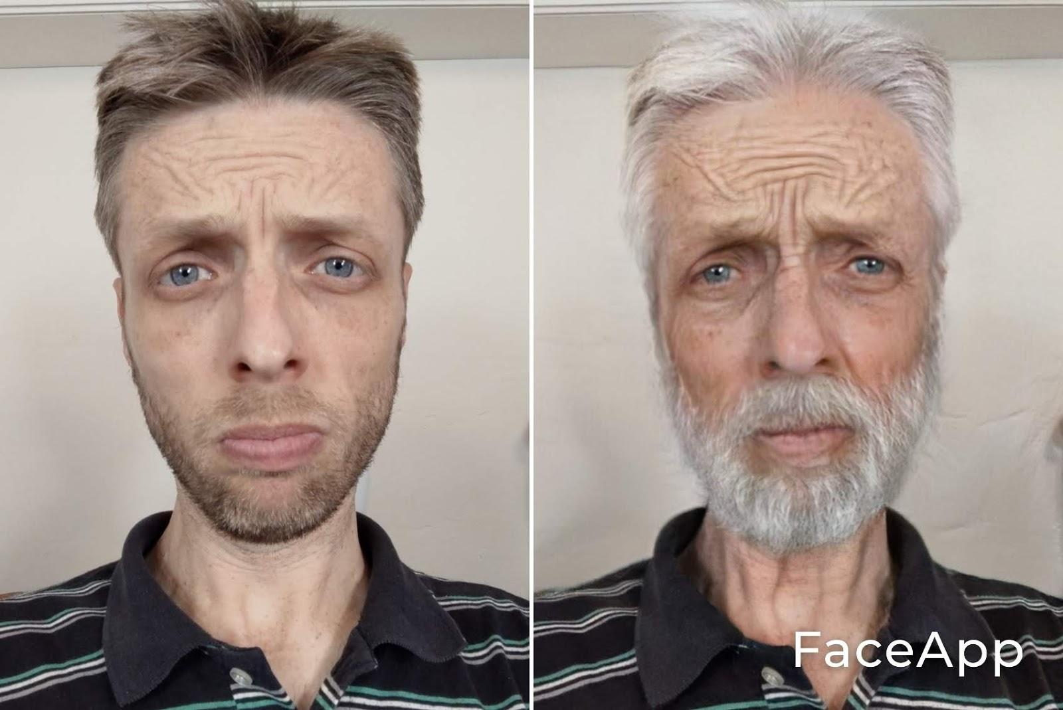
Back in section 21.2 we introduced the idea of imperfective aspect. As we’ve seen, when we analyze types of verbs we often label imperfective aspect verbs with the shorter word imperfect, as in vav-consecutive-imperfect (vayyiqtol). Here we introduce יִהְיֶה as our first imperfect (yiqtol) verb form, which comes from the verb root הָיָה (which you can review in section 26.1). As we’ve said before, imperfective aspect doesn’t always communicate something that will happen in the future, but in this lesson we are using it that way because it’s the most common use in the Hebrew Bible. So an example in the video is:
אַבְרָם יִהְיֶה אִישׁ זָקֵן
“Avram will be an old man.”

The example of the use of יִהְיֶה in Scripture comes from 1 Samuel 17:37b:
וַיּ̇אמֶר שָׁאוּל אֶל־דָּוִד לֵךְ וְיהוה יִהְיֶה עִמָּךְ׃
“And Saul said to David, ‘Go. And Yahweh will be with you.’”
Before the next lesson, take a moment to look closely at the changes when going from perfective to imperfective aspect in these two verbs:
impf ← perf
הָיָה ← יִהְיֶה
בָּנָה ← יִבְנֶה

Lesson 38 - Israel asks for a king
Since this lesson doesn’t introduce new grammar, we’ll provide a literal translation of the simplified story below.
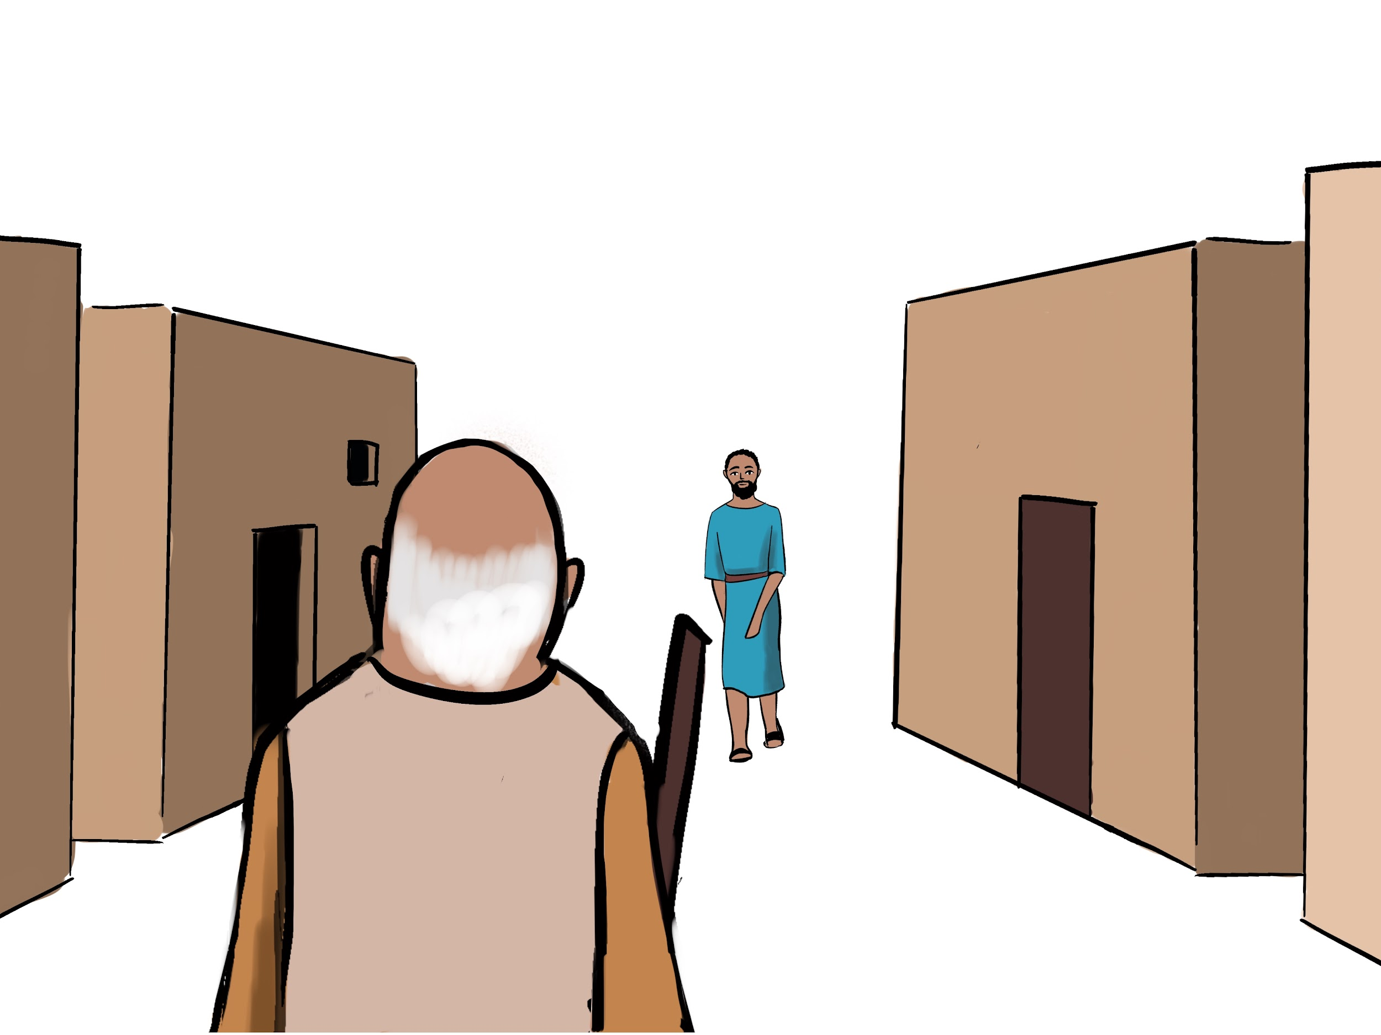
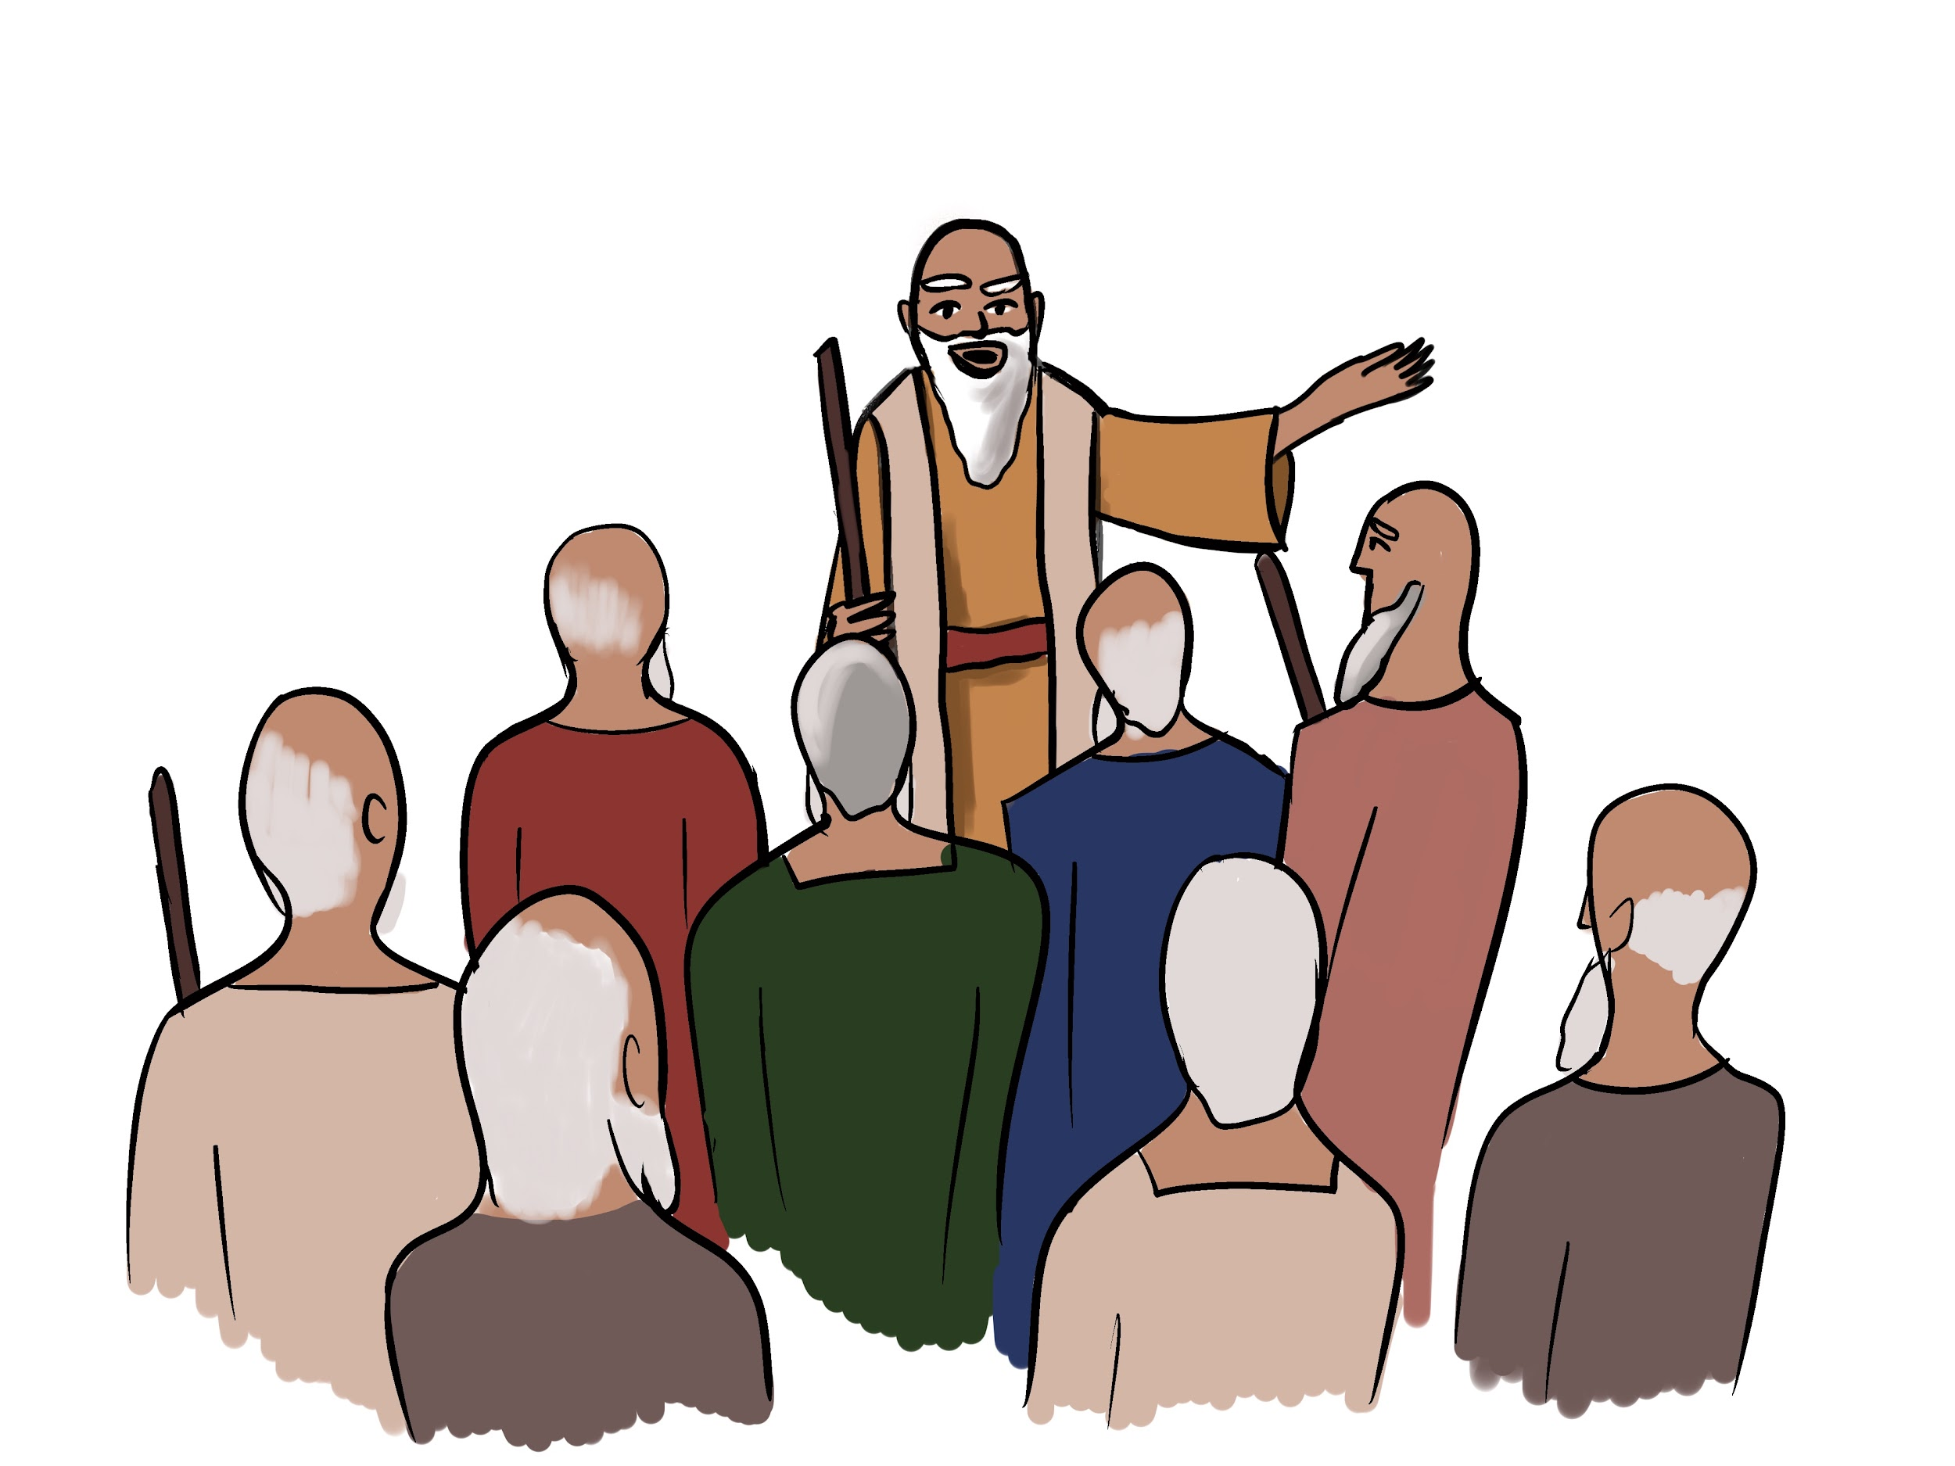
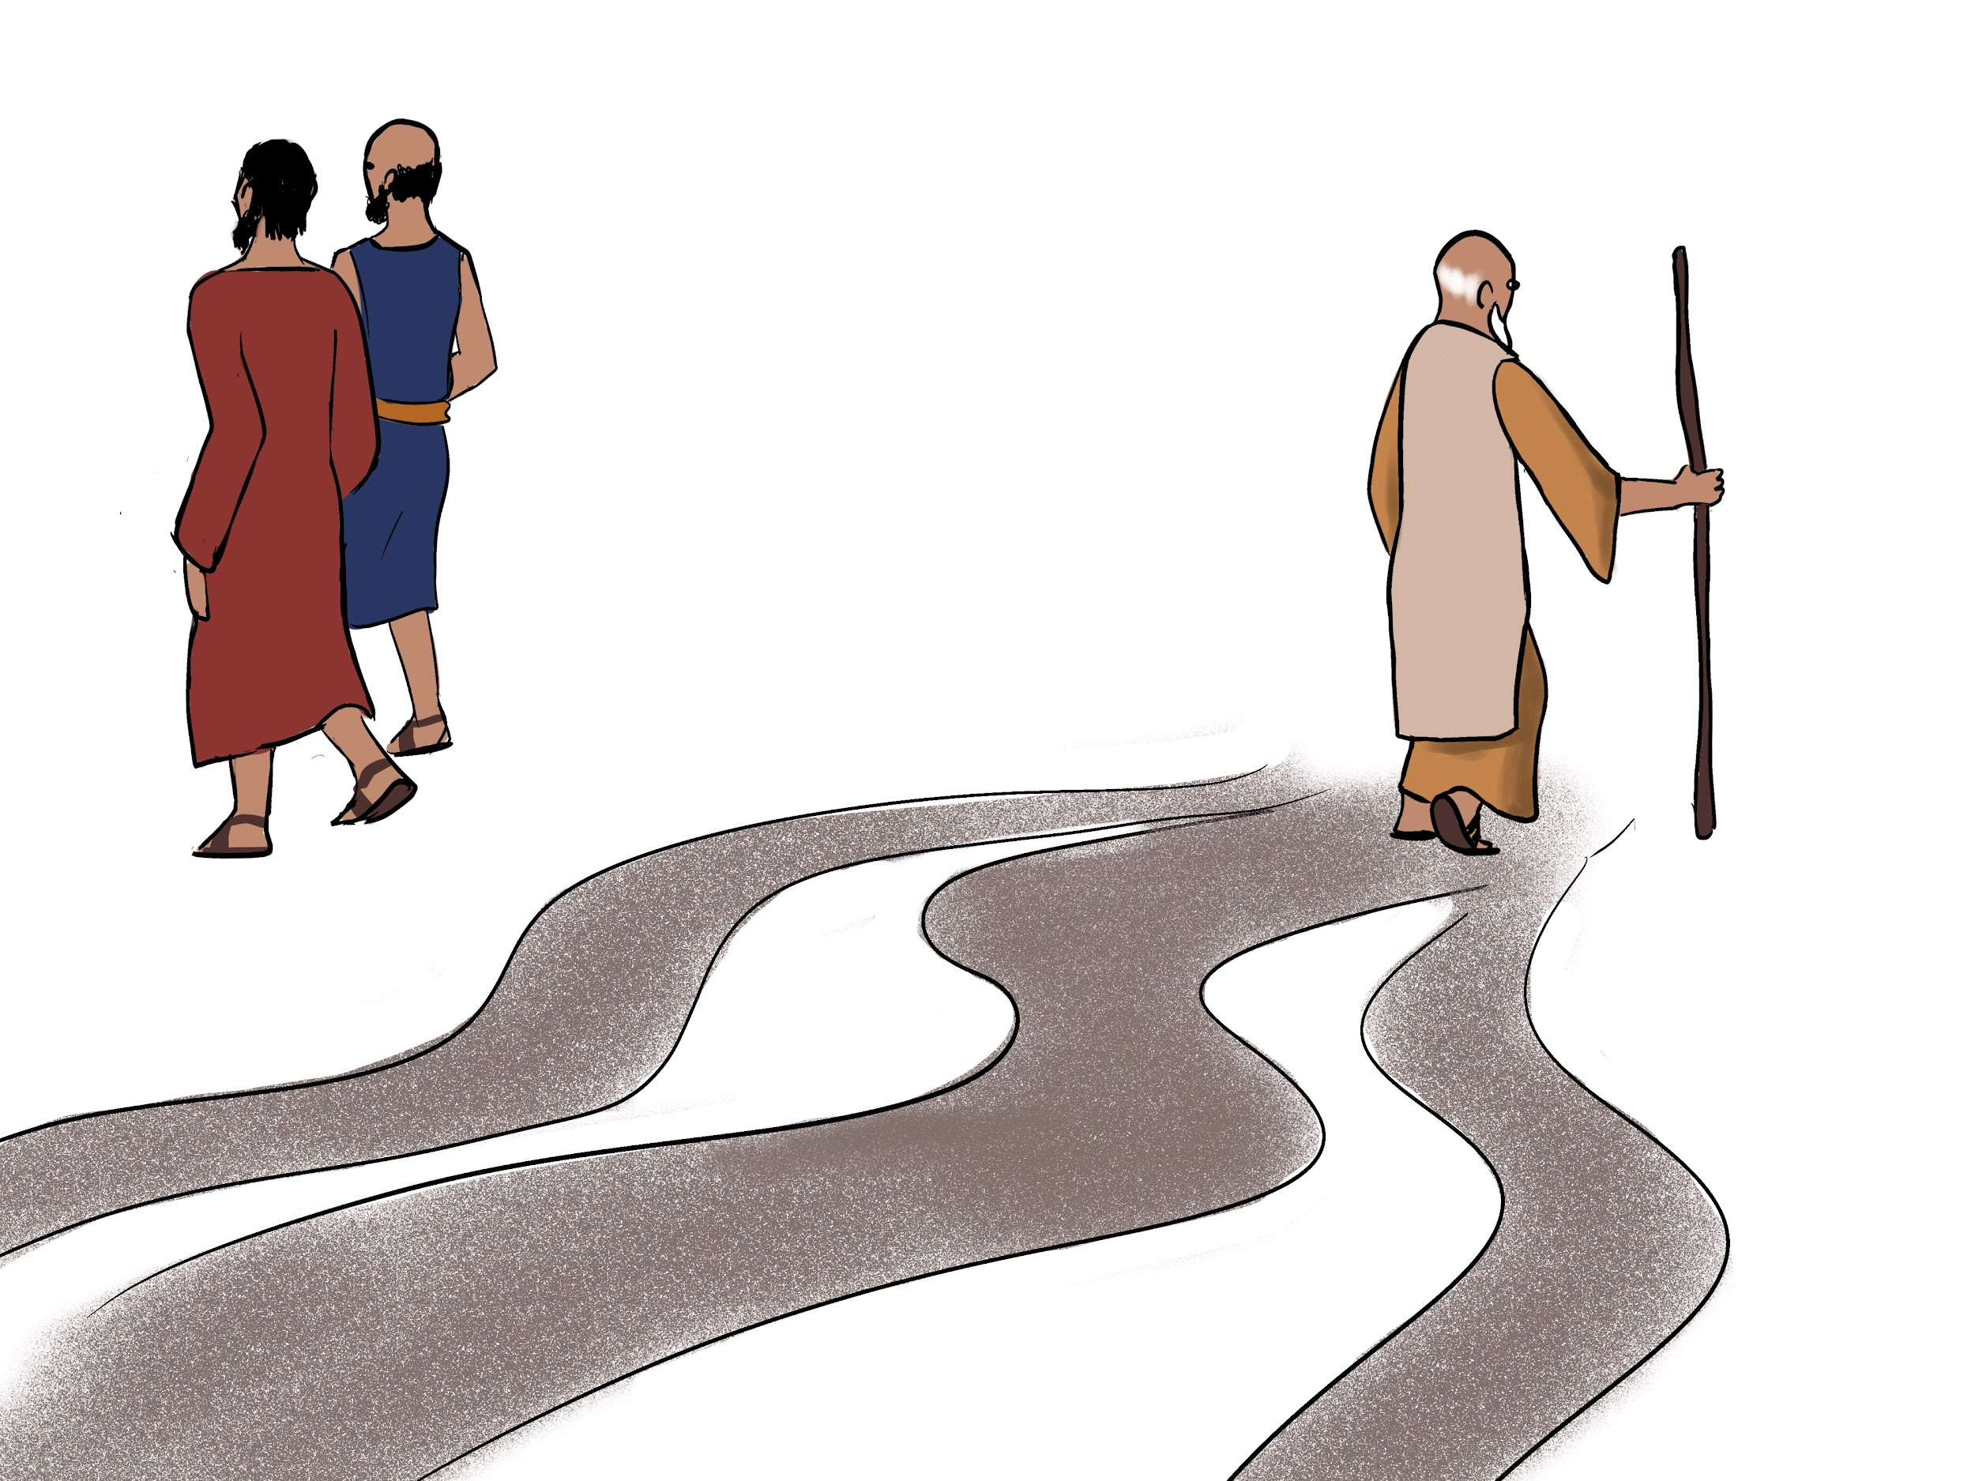
וַיְהִי כִּי־זָקֵן שְׁמוּאֵל וְלֹא־הָלְכוּ בָנָיו בִּדְרָכָיו׃
And it was that Samuel was old, and his sons did not walk in his ways.
וַיָּבֹאוּ כֹּל זִקְנֵי יִשְׂרָאֵל אֶל־שְׁמוּאֵל וַיֹּאמְרוּ אֵלָיו הִנֵּה אַתָּה זָקַנְתָּ וּבָנֶיךָ לֹא הָלְכוּ בִּדְרָכֶיךָ עַתָּה שִׂים־לָנוּ מֶלֶךְ׃
And all the elders of Israel came to Samuel, and they said to him, “Look, you are old, and your sons do not walk in your ways. Now put for us a king.”
וַיֵּרַע הַדָּבָר בְּעֵינֵי שְׁמוּאֵל׃ וַיֹּאמֶר יהוה אֶל־שְׁמוּאֵל שְׁמַע בְּקוֹל הָעָם׃
And the thing was evil in the eyes of Samuel. And Yahweh said to Samuel, “Obey [listen to the voice of] the people.”
וַיֹּאמֶר שְׁמוּאֵל אֶל־הָעָם הַמֶּלֶךְ יִקָּח אֶת־בְּנֵיכֶם וְאֶת־בְּנוֹתֵיכֶם וְאֶת־שְׂדוֹתֵיכֶם וְאֶת־עַבְדֵיכֶם וְאֶת־שִׁפְחוֹתֵיכֶם׃
And Samuel said to the people, “The king will take your sons and your daughters, and your fields, and your menservants and maidservants.”
וְלֹא שָׁמַע הָעָם בְּקוֹל שְׁמוּאֵל וַיֹּאמְרוּ לֹּא כִּי אִם־מֶלֶךְ יִהְיֶה עָלֵינוּ׃
But the people did not obey [listen to the voice of] Samuel, and they said, “No, but a king shall be over us.”
וַיִּשְׁמַע שְׁמוּאֵל אֵת דִּבְרֵי הָעָם וַיְדַבֵּר אֶת־דִּבְרֵיהֶם בְּאָזְנֵי יהוה׃
And Samuel listened to the words of the people, and he spoke their words in the ears of Yahweh.
וַיֹּאמֶר יהוה אֶל־שְׁמוּאֵל שְׁמַע בְּקוֹלָם׃
And Yahweh said to Samuel, “Obey [listen to the voice of] them.”
וַיֹּאמֶר שְׁמוּאֵל אֶל־אַנְשֵׁי יִשְׂרָאֵל לְכוּ אִישׁ לְעִירוֹ׃
And Samuel said to the men of Israel, “Go, each man to his city.”
וַיְהִי־אִישׁ מִבִּנְיָמִין וּשְׁמוֹ שָׁאוּל׃ וַיָּבֹא שָׁאוּל אֶל־עִיר שְׁמוּאֵל׃
And there was a man from Benjamin, and his name was Saul. And Saul came to the city of Samuel.
וּשְׁמוּאֵל רָאָה אֶת־שָׁאוּל ויהוה אָמַר־לוֹ הָאִישׁ הַזֶּה יִהְיֶה מֶלֶךְ עַל־עַמִּי׃
And Samuel saw Saul, and Yahweh said to him, “This man shall be king over my people.”
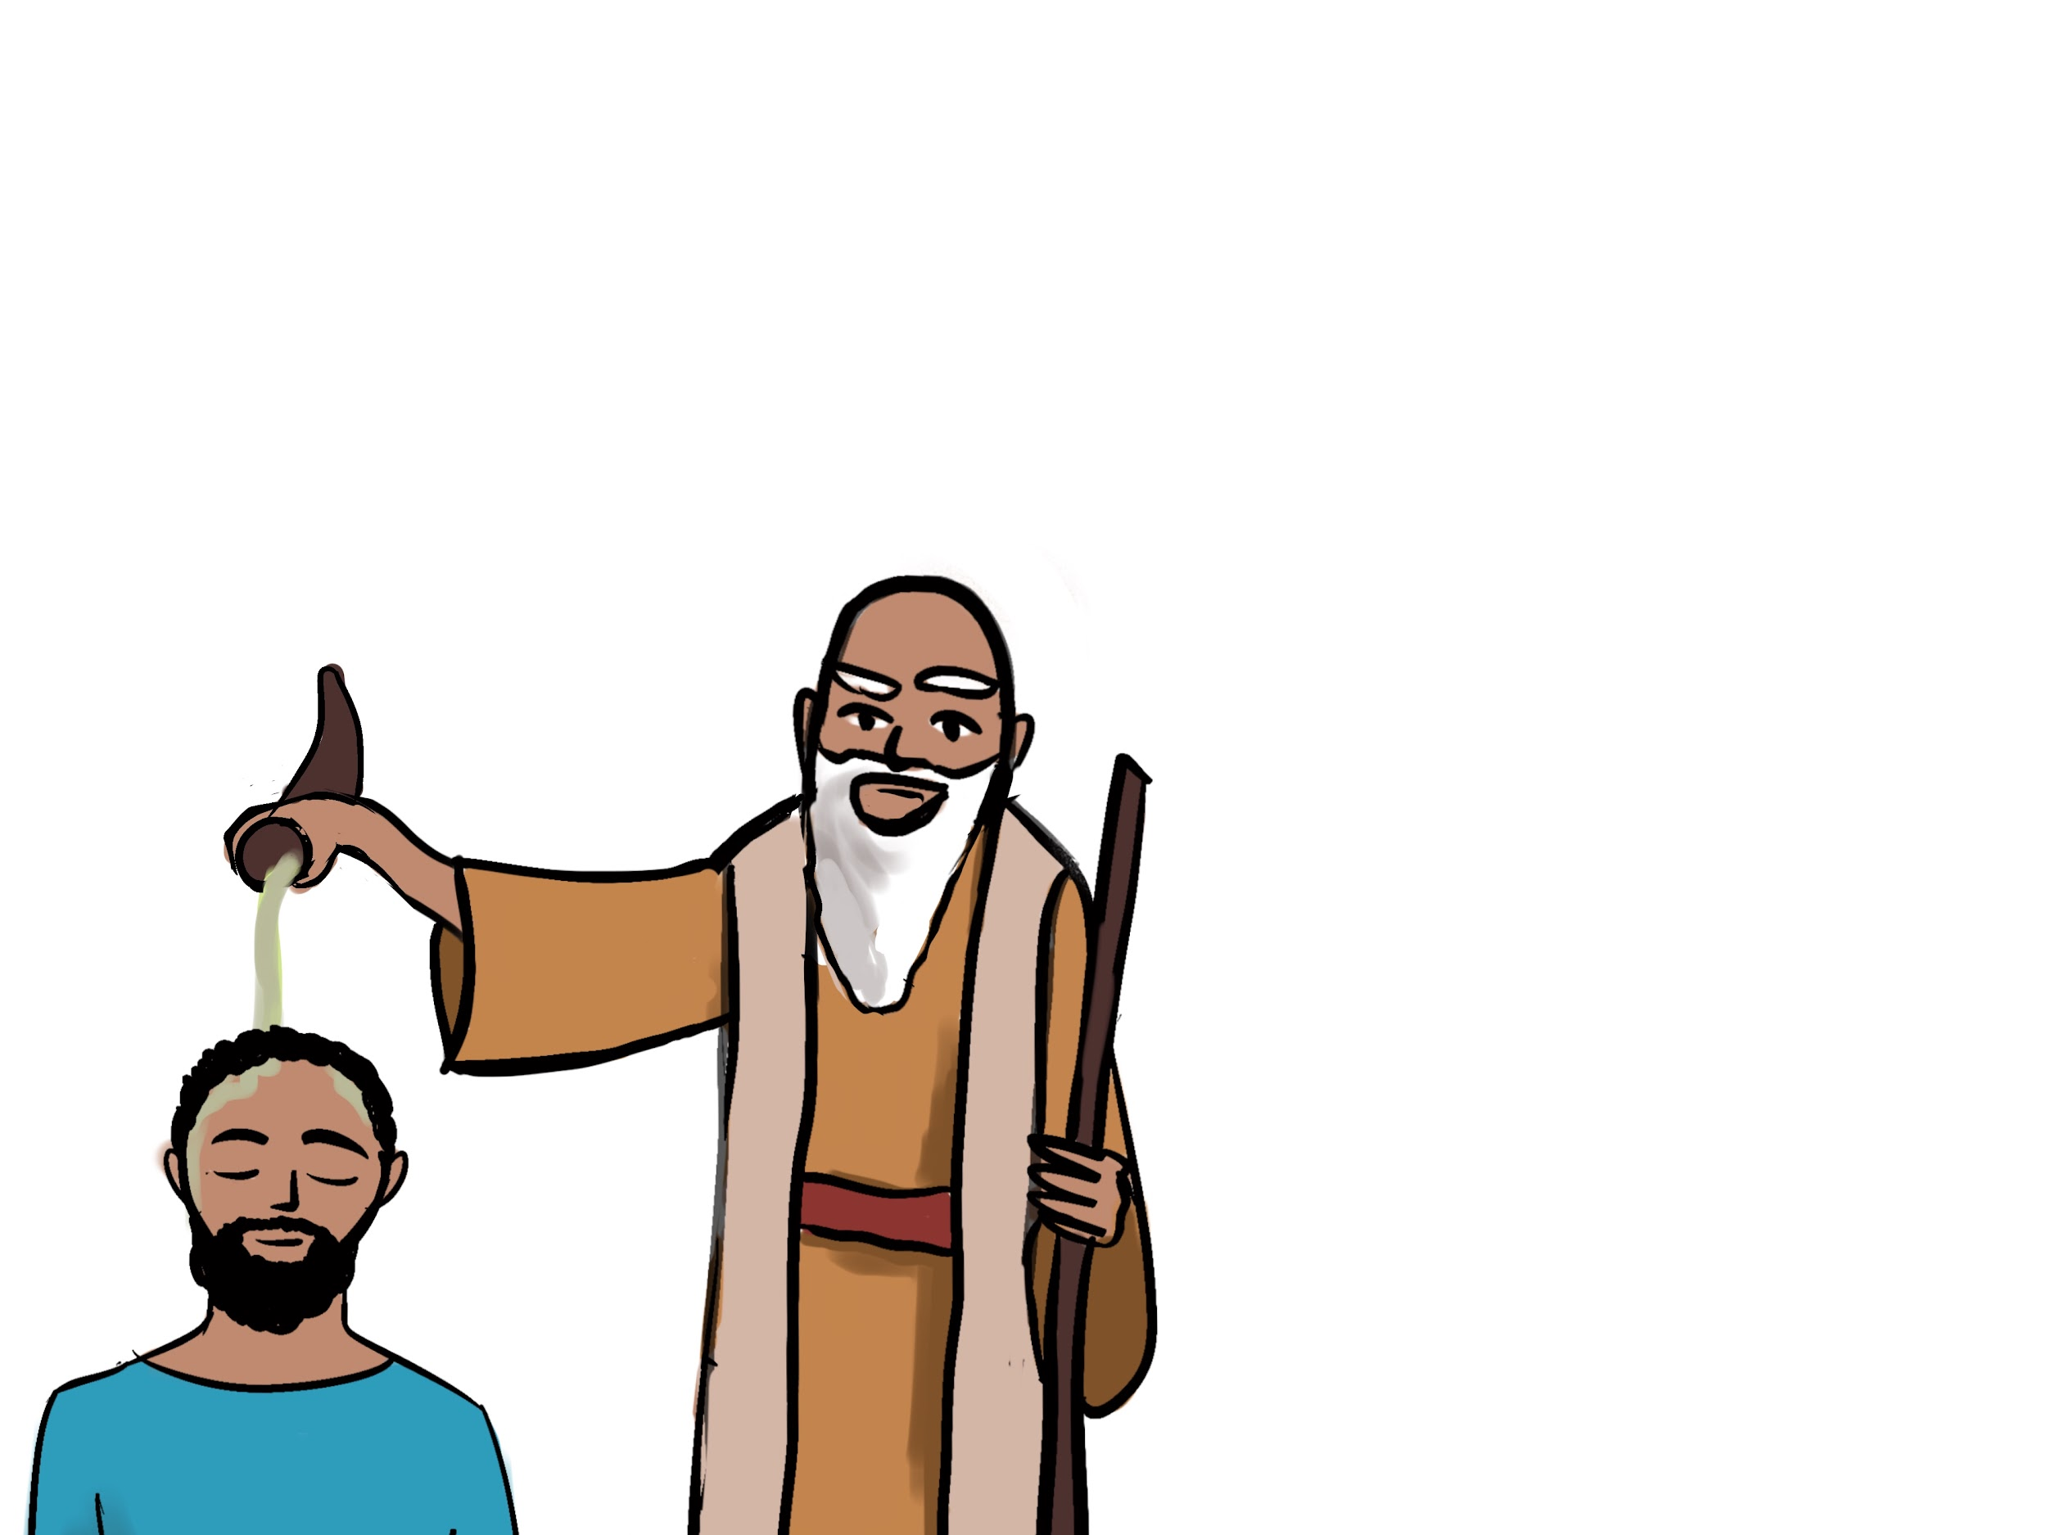

וַיִּמְשַׁח שְׁמוּאֵל אֶת־שָׁאוּל לְמֶלֶךְ׃
And Samuel anointed Saul as king.
וַתְּהִי עָלָיו רוּחַ אֱלֹהִים וַיְהִי שָׁאוּל מֶלֶךְ עַל־יִשְׂרָאֵל׃
And the Spirit of God was upon him, and Saul was king over Israel.

Lesson 39 - Strength & Wisdom: Comparisons

39.1 New Vocabulary
חָזָק - strong
כֹּחַ - strength
חָכָם - wise, skillful, shrewd
חָכְמָה - wisdom, skill, shrewdness
אֲרוֺן הַבְּרִית - ark of the covenant
צָבָא - army, war, warfare (plural: צְבָאוֺת)

39.2 Comparative מִן
The מִן preposition is used to compare things using adjectives. In English we usually use the -er ending, as in stronger (strong+er), followed by the word than, to communicate comparisons (e.g. “I’m stronger than you”). But Hebrew uses מִן to do the same thing, as in the following example:
הַסּוּס הַזֶּה גָּדוֺל מִן־הַסּוּס הַזֶּה
Very literally: “The horse the this (is) big from the horse the this.”
Which means: “This horse is bigger than this horse.”
When מִן connects to a word as a prefix, the ן disappears (assimilates) and we are left with one of the following: מִ or מֵ. For example:
רָחֵל יָפָה מִלֵּאָה אֲחֹתָהּ
Very literally: “Rachel (was) beautiful from Leah her sister.”
Which means: “Rachel was prettier than Leah, her sister.”
Just as אֵין can combine with pronouns like הוּא to create one word אֵינֶנּוּ “he/it is not,” מִן can combine with pronouns. Here are some examples:
מִן + הוּא ← מִמֶּנּוּ “from/than him/it”
מִן + אֲנִי ← מִמֶּנִּי “from/than me.”
מִן + אַתָּה = מִמְּךָ “from/than you (masculine)”
מִן + אַתְּ = מִמֵּךְ “from/than you (feminine)”
So when Avram says, “Beth, I’m stronger than you,” he says: בֵּת, אֲנִי חָזָק מִמֵּךְ.

Lesson 40 - Noah & the Ark: Categories of Creatures

40.1 Creature Categories
The ancient Hebrews did not categorize things as we do in modern science today. For example, Hebrew does not have a word for reptile as we understand it scientifically. Instead, Hebrew has the word רֶ֫מֶשׂ which can include reptiles, but also includes other small creatures that move along the ground, like mice and insects.
אָדָם - mankind, humans
בְּהֵמָה - beasts, larger animals, cattle
רֶ֫מֶשׂ - small creatures that move along the ground, “creeping things.”
חַיָּה - living thing, animal, wild animal. (Not to be confused with the verb חַיָה without the dagesh, which means “to live.”)
אֱלֹהִים - spiritual beings. Even though this is the same word for God, it is also used for created spiritual beings such as cherubim or angels. These beings are in a category all by themselves, not considered to be “flesh” בָּשָׂר. (This video series on spiritual beings from the Bible Project may be helpful.
All of the creatures that are not אֱלֹהִים are considered בָּשָׂר “flesh” or נֶ֫פֶשׁ חַיָּה “living beings/souls” or simply חַיָּה “a living thing.” נֶ֫פֶשׁ חַיָּה can be translated either as plural or singular. Adam became a נֶ֫פֶשׁ חַיָּה when God breathed life into him, and the animals did as well.

בְּהֵמָה, רֶ֫מֶשׂ, עוֺף, דָּגָה
↖
אָדָם חַיָּה
↗ ↖
נֶ֫פֶשׁ חַיָּה

When Hebrew specifies a category or main characteristic of something, it often uses the formula “son of …” Here are some examples:
בֶּן־אָדָם - son of man = human
בְּנֵי אָדָם - sons of man = humans
בְּנֵי אֱלֹהִים - sons of God = spiritual beings (some examples: Job 1:6, Deut 32:8)

40.2 More vocabulary
תֵּבָה - ark, box
רוּחַ חַיִּים - breath of life
עֲצֵי־גֹפֶר - gopher wood (trees/wood of gopher)
מַּבּוּל - flood, deluge
רָעָה - adjective: evil, bad; noun: evil, disaster

Lesson 41 - Kaf & Similarities

41.1 New Vocabulary
יָשָׁר - straight, right, upright (adjective)
כְּ - like, as
כַּאֲשֶׁר - just as, as

41.2 The כְּ Preposition
The preposition כְּ usually functions to compare similar things. It attaches as a prefix in the same way as the other inseparable prepositions attach, such as בְּ. When כְּ precedes a definite word (with the definite article הַ), the ה is gobbled up (or assimilated) by the preposition, and only the vowel is left.
כְּ + הַ ← כַּ
Or in the case where the definite article precedes a letter that causes its vowel to lengthen to a qamets:
כְּ + הָ ← כָּ
For example, in the lesson Beth says, “I am like the small woman” אָנֹכִי כָּאִשָּׁה הַקְּטַנָּה׃.
As an example without the definite article, Beth says, “Avram walks like an Egyptian man” אַבְרָם הָלַךְ כְּאִישׁ מִצְרִי׃

41.3 כַּאֲשֶׁר
When comparing actions, כַּאֲשֶׁר serves as the equivalent of “just as” or “as” in English. For example, Beth says:
אַבְרָם עָשָׂה כַּאֲשֶׁר דִּבַּרְתִּי׃
“Avram did just as I said.”

Lesson 42 - Light & Darkness, Morning & Evening

42.1 New Vocabulary
אוֺר - light
חֹ֫שֶׁךְ - darkness
בֹּ֫קֶר - morning
עֶ֫רֶב - evening
רֵאשִׁית - beginning
קֵץ - end
רִאשׁוֹן - first, chief

Lesson 43 - Creation (no new grammar to discuss)

Lesson 44 - Go out & lift up

44.1 New Vocabulary
יָצָא - he went out (the vayyiqtol form is וַיֵּצֵ֫א “and he went out.”)
נָשָׂא - he lifted, raised up (the vayyiqtol form is וַיִּשָּׂ֫א “and he lifted up.” The נ is assimilated into the following letter when it is conjugated, because it’s a weak letter, and assimilation is signaled by the dagesh dot in the שׂ.)

44.2 More Conjugations of רָאָה
Once again Beth is introducing more forms of what grammars will call a weak verb. In the case of רָאָה the weak part is the last letter ה. Since ה is weak, it easily gets lost when the verb is conjugated. But we want to remind you that these technicalities are not important for internalizing the language. When you’re reading you shouldn’t be doing mathematical reconstructions of verbs in your head based on whether they’re weak or not. The best way to reach fluency is to master the different forms as they are without worrying too much about the morphological changes. But for those who are curious, we provide these explanations.
So when רָאָה takes the vayyiqtol form וַיַּרְא (“and he saw”) the root is more difficult to distinguish because the ה gets chopped off the end.

44.3 אֵת “with”
It’s important to avoid confusing אֵת as the direct object marker with the preposition “with.” Context will make this clear, since there is often no other way to know the difference. In the video Beth explains that there are two prepositions used to communicate “with” in Hebrew: אֵת and עִם. When you add pronominal suffixes onto them, you get the following:
עִם = אֵת
עִמִּי = אִתִּי “with me”
עִמּוֺ = אִתּוֺ “with him”
עִמְּךָ = אִתְּךָ “with you”

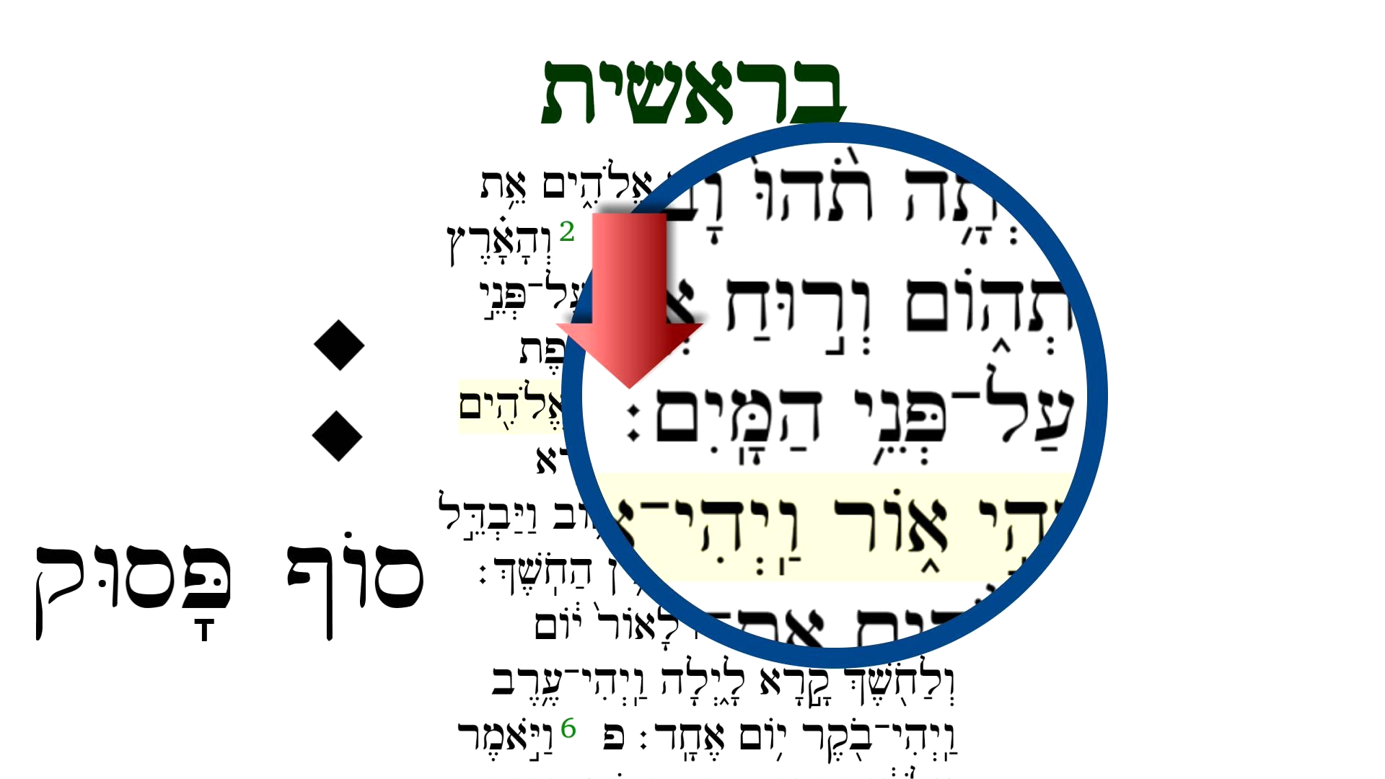
44.4 Sof Pasuq ׃
The sof pasuq (סוֺף פָּסוּק) is a mark that occurs on the last word of every verse in the Hebrew Bible passed down to us from the Masoretes. Basically, the sof pasuq acts like a period or punctuation at the end of a verse that tells the reader to pause. This leads to what are called pausal forms, which often involves vowel changes in the last word before the sof pasuq. In the video Beth gives the following examples of how vowels can change in words because of the sof pasuq. The forms in red are called pausal forms:
לְךָ becomes לָךְ before sof pasuq.
עִמְּךָ becomes עִמָּךְ before sof pasuq.
אִתְּךָ becomes אִתָּךְ before sof pasuq.

Lesson 45 - Verb Sequences: Vayyiqtol Forms 1

45.1 Vayyiqtol
In section 22.3 we discussed verb sequences using vayyiqtol at length.

45.2 Qamets Hatuf
וַיָּ֫קָם is pronounced as vayyaqom rather than vayyaqam because of the qamets hatuf rule: ָ in a closed unaccented syllable is pronounced as [o]. Unfortunately, you’ll see plenty of exceptions to this rule, but it’ll be helpful to be aware of it.

45.3 Review Weak Verbs
At this point it may be a good idea to review section 27.1 where we discuss how נָתַן behaves as a weak verb, which will help explain why it becomes וַיִּתֵּ֫ן when in the vayyiqtol conjugation.

Lesson 46 - Send, Messenger & Object Pronouns

46.1 More on Both Kinds of אֵת
אֵת “with” | אֵת sign of the direct object
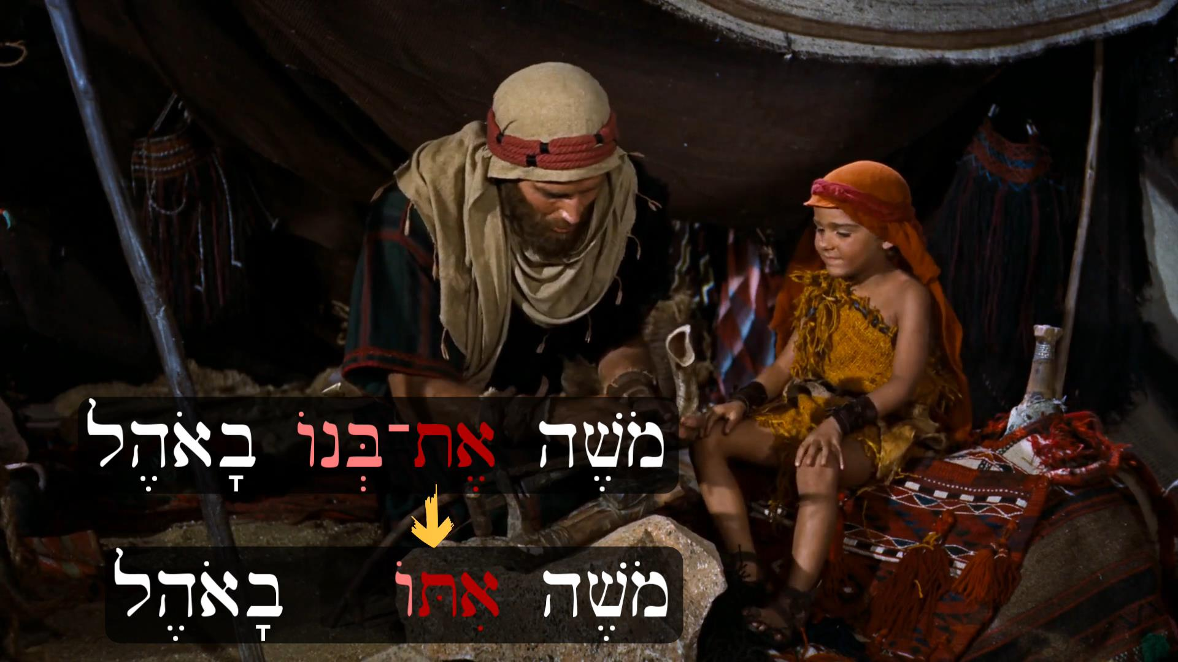  אִתִּי “with me”  אִתְּךָ “with you (m.)”  אִתָּךְ “with you (f.)”  אִתּוֺ “with him”  אִתָּהּ “with her”  אִתָּנוּ “with us”  אִתְּכֶם “with ya’ll”  אִתָּם “with them” | אֹתִי “___ me”  אֹתְךָ “___ you (m.)”  אֹתָךְ “___ you (f.)”  אֹתוֺ “___ him”  אֹתָהּ “___ her”  אֹתָנוּ “___ us”  אֶתְכֶם “___ ya’ll”  אֹתָם “___ them”

Notice that one of the main differences between the two is the presence or absence of the dagesh dot when combined with pronoun suffixes.
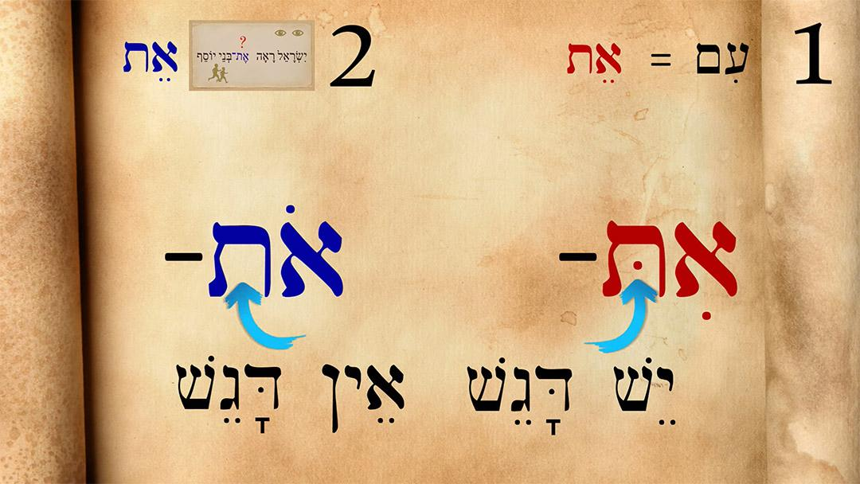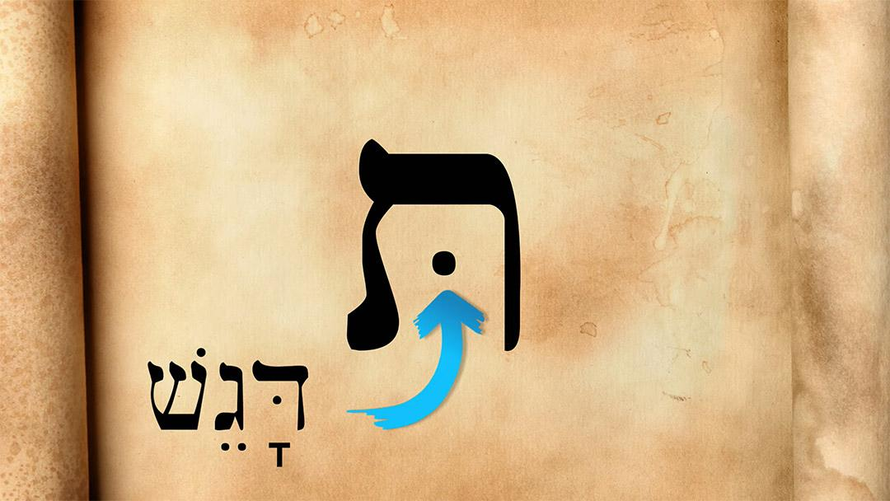

46.2 New Vocabulary
שָׁלַח - he sent (in vayyiqtol: וַיִּשְׁלַח)
מַלְאָךְ - messenger
מַאֲכֶ֫לֶת - knife

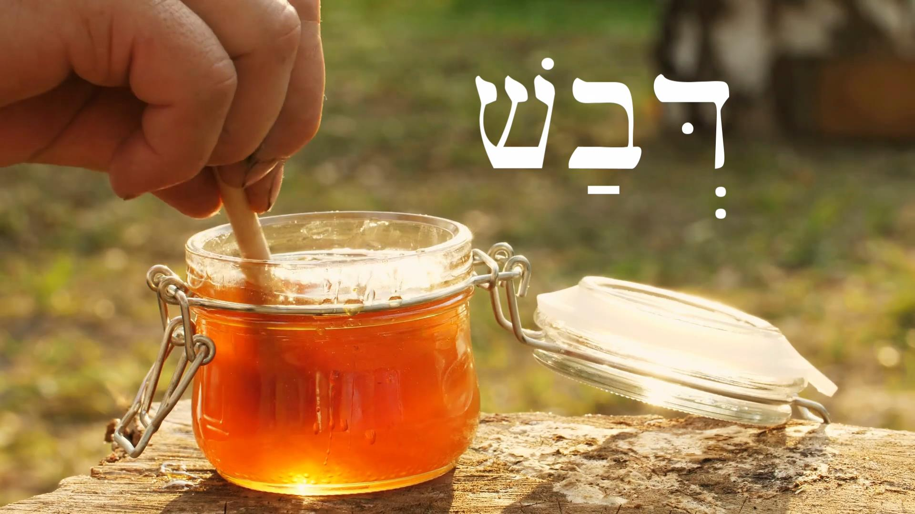
Lesson 47 - Food & Drink

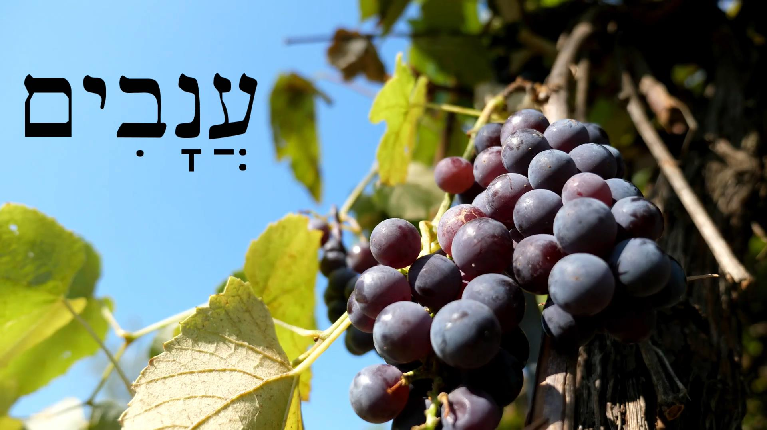
47.1 New Vocabulary
יַיִן - wine
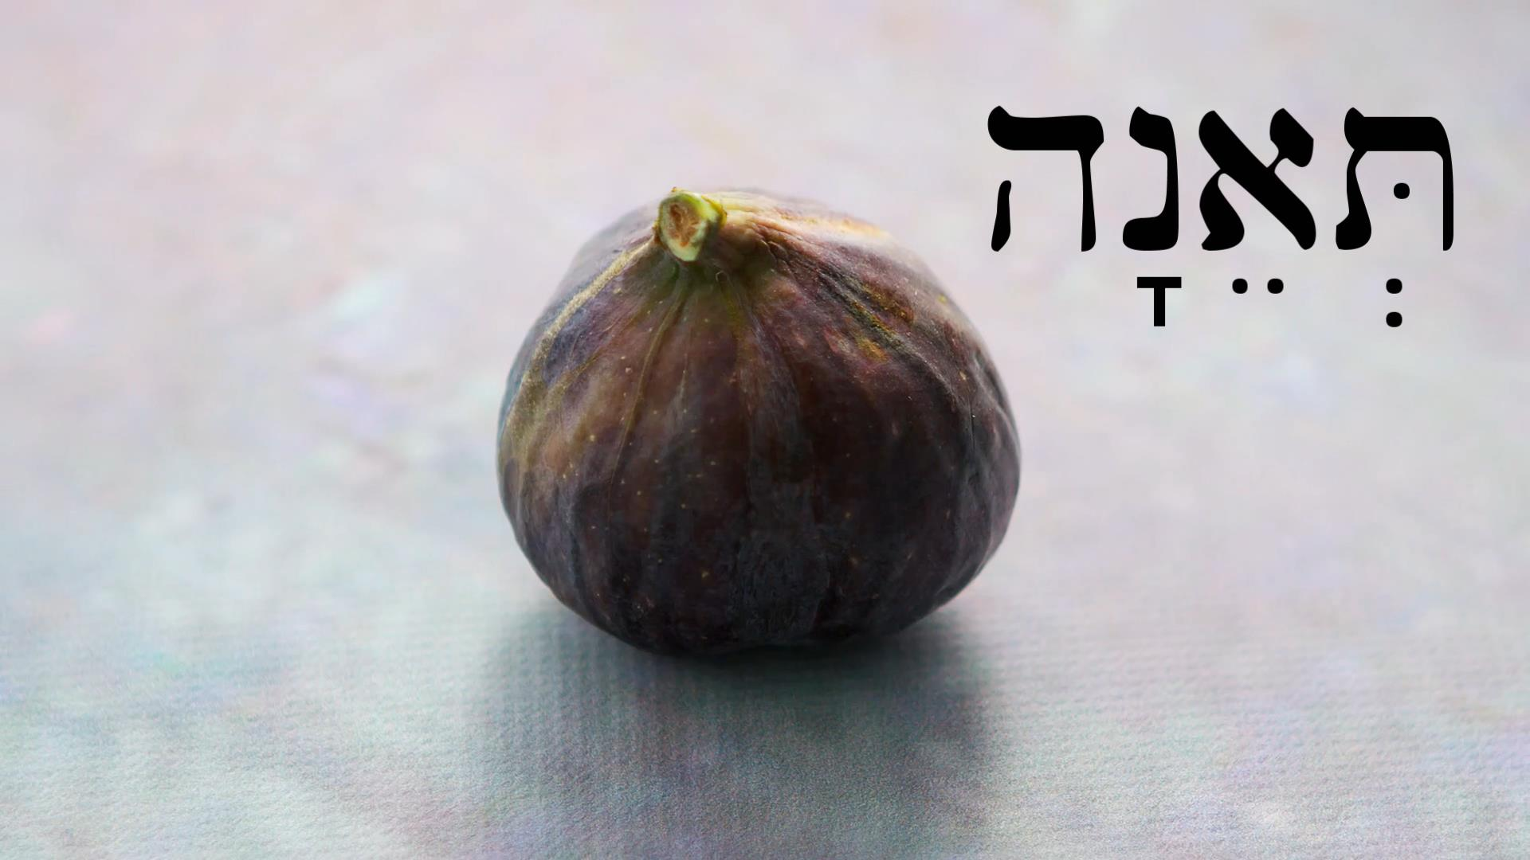
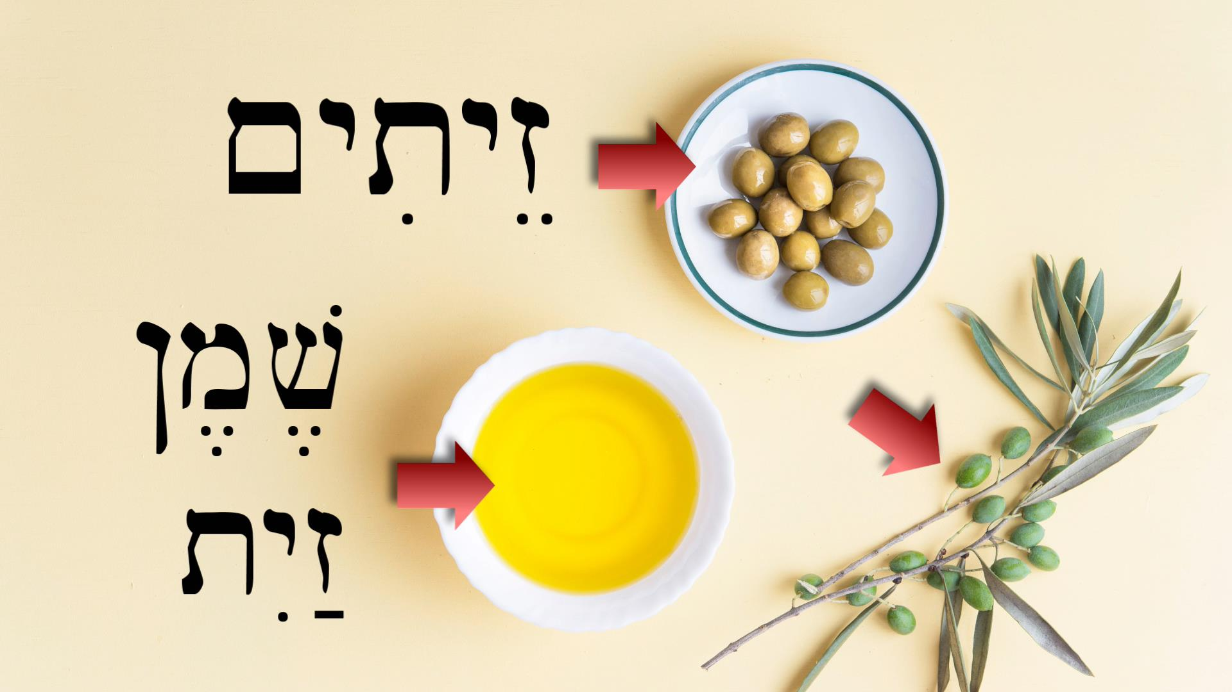
חָלָב - milk
דְּבַשׁ - honey
תְּאֵנָה - fig
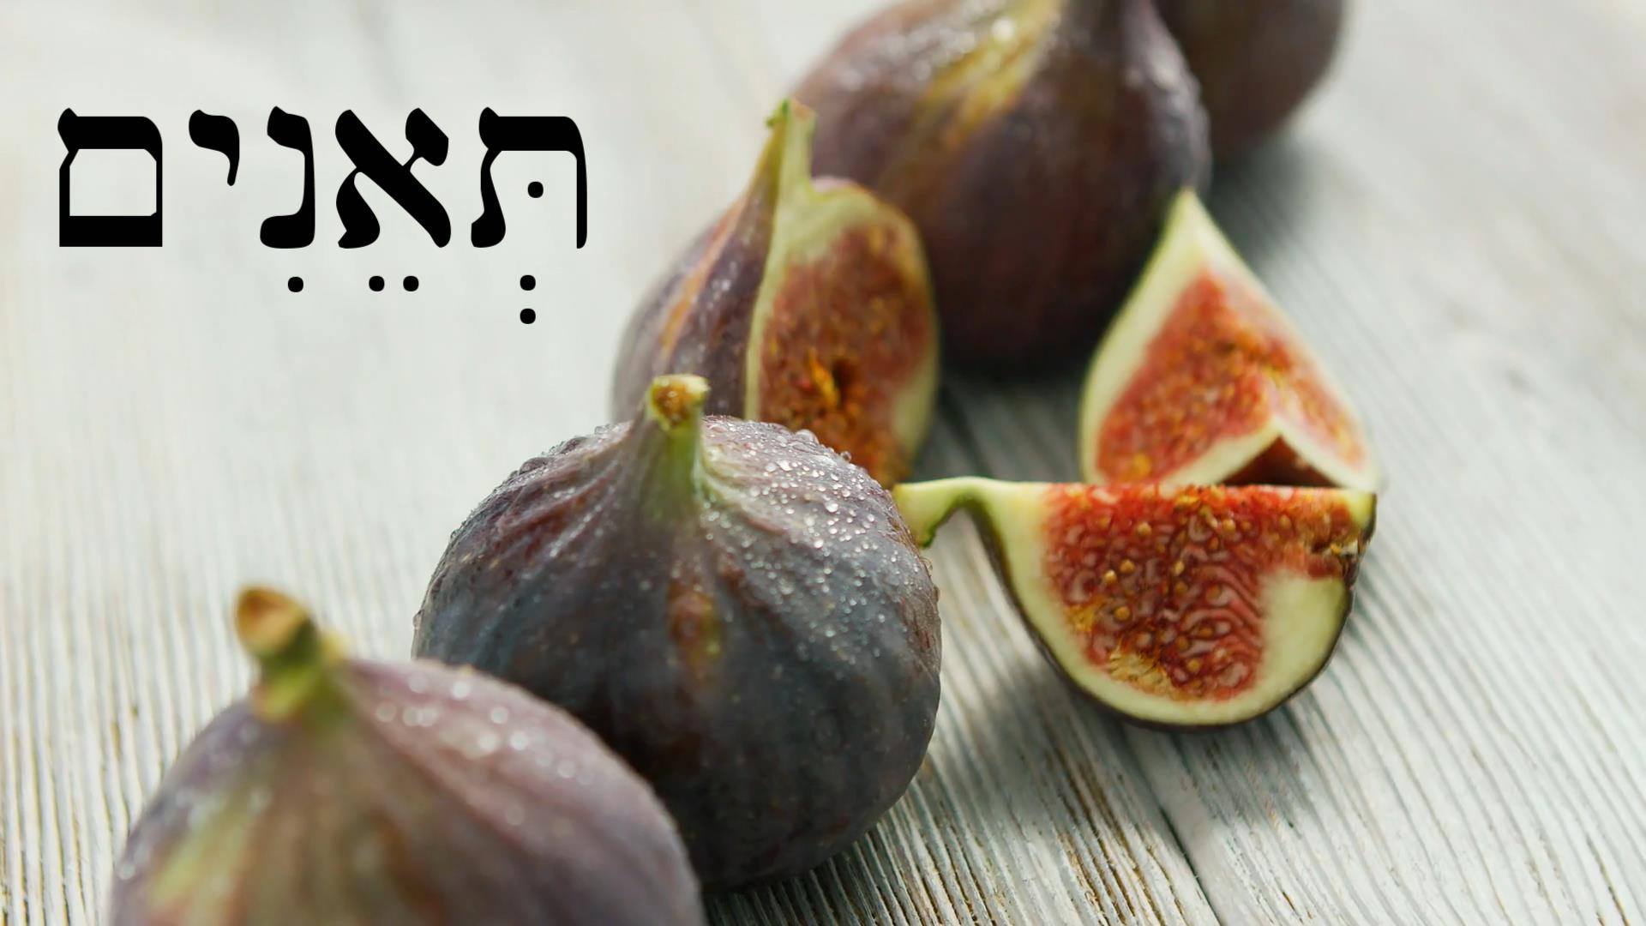
זַ֫יִת - olive
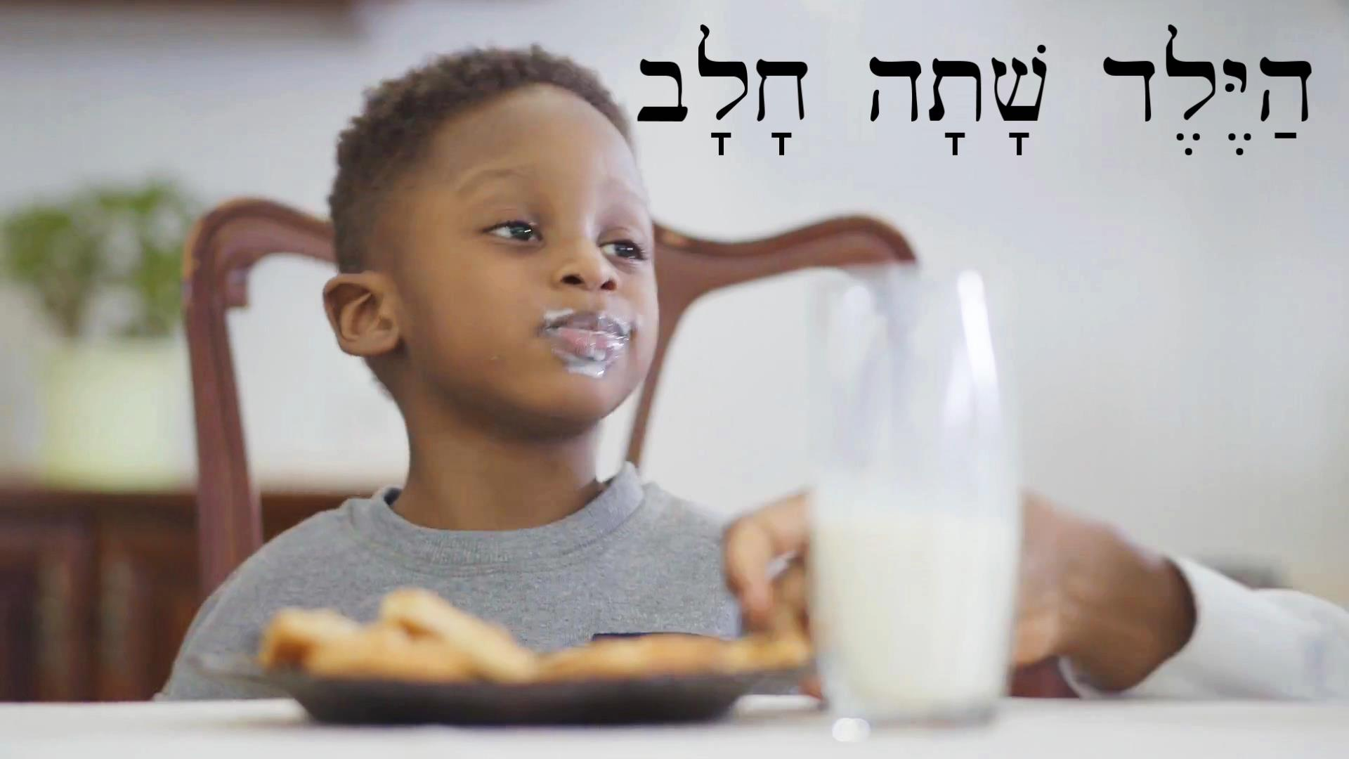
עֵנָב - grape

אֹ֫כֶל or מַאֲכָל - food
אָכַל - he ate
שָׁתָה - he drank

Lesson 48 - 40 Days & 40 Nights

48.1 זָב - flowing, gushing
זָב is actually a participle of the verbal root זוּב “to flow, gush” A participle is a verbal adjective, which means it can function as both a verb or an adjective. When we say, “it’s flowing water,” the participle is describing something like an adjective. And when we say, “the river is flowing,” we are using the participle like a verb, telling what the river is doing. Participles in Hebrew function in a similar way, and since they function as adjectives, they must agree with the noun they are describing in number and gender. That means that if a participle describes a masculine, plural noun, it must end in ים ִ which is the masculine plural ending in Hebrew, in order to agree with the noun is goes with. We see an example of this in the phrase מַיִם זָבִים “flowing water.” The first sentence where זָבַת appears in the video reads as follows:
אֶרֶץ כְּנַעַן אֶרֶץ זָבַת חָלָב וּדְבַשׁ׃
“The land of Canaan is a land flowing with milk and honey.”
Notice that here זָבַת is describing אֶרֶץ which is a feminine noun, so they must agree. That’s why זָבַת has the typical feminine singular construct ת ending. If you review section 11.2 on construct forms, you’ll remember that the feminine singular construct form ends with ת. For example:
פָּרָה ← פָּרַת
פָּרַת יוֹסֵף - “the cow of Joseph”
So in order to communicate “flowing with,” Hebrew puts the participle in construct form. The non-construct form of the feminine singular participle would simply be זָבָה.
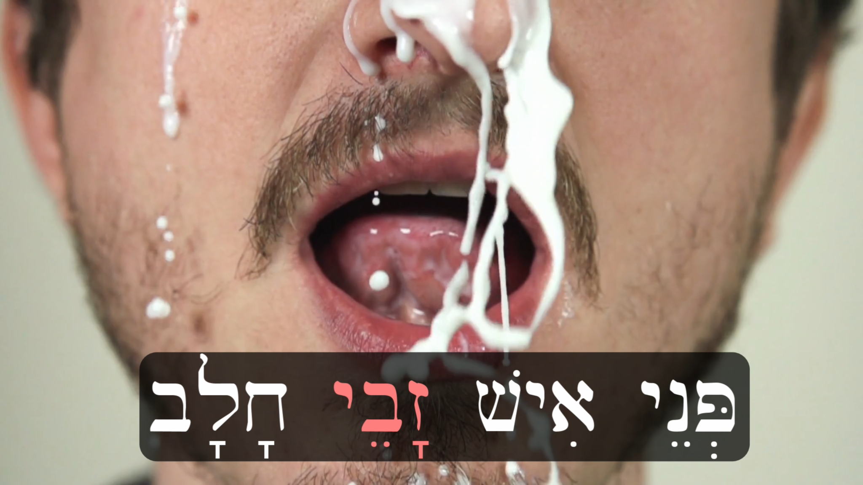
Again, we see: הַמַּיִם הָאֵלֶּה זָבִים מֵאֲבָנִים׃ which means “These waters are flowing from stones.” Notice that this time זָבִים is not in construct form. The masculine plural construct ending is י ֵ . For example, the sentence פְּנֵי אִישׁ זָבֵי חָלָב׃ means, “A man’s face flowing with milk.” Finally, the masculine singular participle form is זָב. As in:
יַיִן זָב - “wine flowing”
דְּבַשׁ זָב - “honey flowing”
דָּם זָב - “blood flowing”

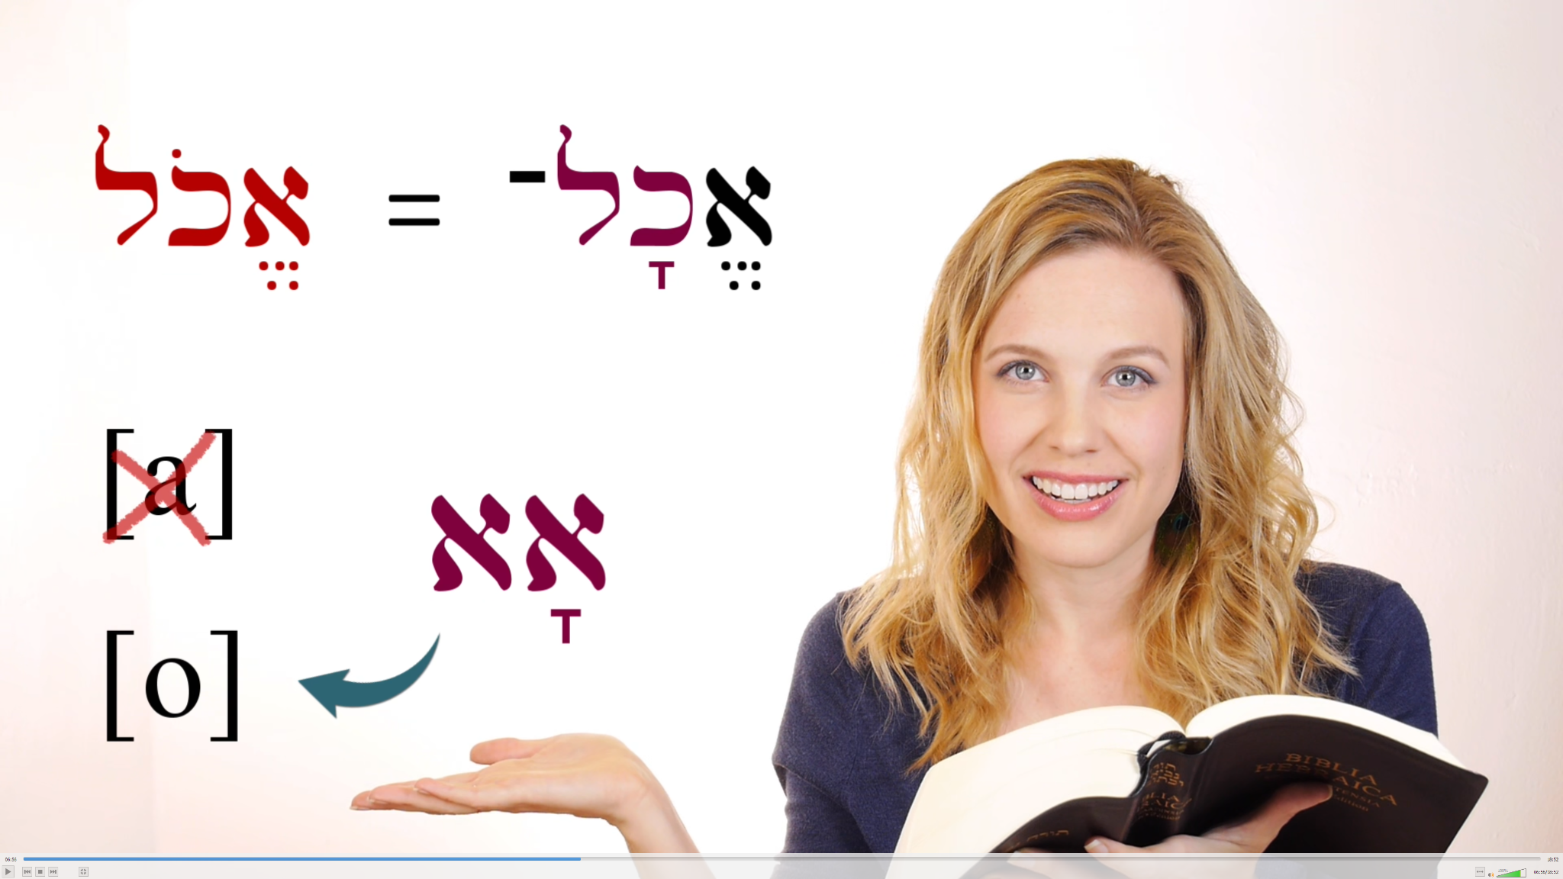
48.2 Qamets hatuf review
It may be good to review section 45.2 at this point to understand what’s going on when Beth reads the following verse: אֱכָל־בְּנִי דְבַשׁ כִּי־טוֹב

48.3 More Vayyiqtol Forms
וַיֹּאכַל - “and he ate”
וַתֹּאכַל - “and she ate”
וַיַּעַשׂ - “and he made”
וַיֵּשְׁתְּ - “and he drank”
וַתֵּשְׁתְּ - “and she drank”

48.4 Singular nouns with plural numbers
The phrase “forty days and forty nights” may seem strange to you, because “days” and “nights” are singular in Hebrew: אַרְבָּעִם יוֹם וְאַרְבָּעִם לַיְלָה. Usually nouns are plural when counting more than one, but there are some exceptions with words like לַיְלָה and יוֹם. This is what some grammars call the “collective use” of nouns, using the singular to communicate a group. Other words that behave this way with numbers in Hebrew are אִישׁ ,נֶפֶשׁ ,שָׁנָה ,חֹדֶשׁ ,עִיר ,שֶׁקֶל ,אַמָּה. Sometimes you might find different uses of these nouns within the same passage. For example, notice how עִיר is plural first, and then a number of verses later is singular (collective):
Joshua 21:19 שְׁלֹשׁ־עֶשְׂרֵה עָרִים “thirteen cities”
Joshua 21:33 שְׁלֹשׁ־עֶשְׂרֵה עִיר “thirteen cities”
Some nouns do this more than others. Keep in mind that there are nouns that are collective by default, and have no plural form, like זָהָב and בָּקָר.

Lesson 49 - Return & Fear

49.1 New Vocabulary
שָׁב - he returned
יָרֵא - he feared

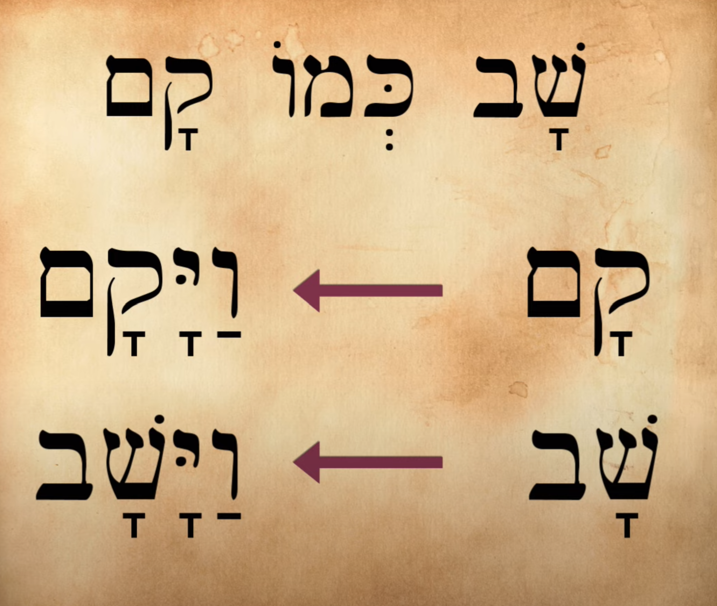
49.2 שָׁב and Hollow Verbs
In section 21.3 we discussed weak and strong verbs. שָׁב and קָם are both a certain kind of weak verb that grammarians call “hollow verbs” or “II-vav” (also II-waw) verbs. These verbs are called “hollow” because their root contains a weak letter in the middle that can completely disappear when conjugated. Verbs that have the letter yod in the middle of their root also are called “hollow verbs” because yod and vav are both considered to be semivowels rather than pure, solid consonants. The actual roots/lexical forms of these two verbs are שׁוב and קום. Notice that the vav is the second letter of each root, which is where we get the term “II-vav.” In this chart comparing the two verbs, we see that they conjugate the same way in the vayyiqtol, with a qamets hatuf [o] as the last vowel.
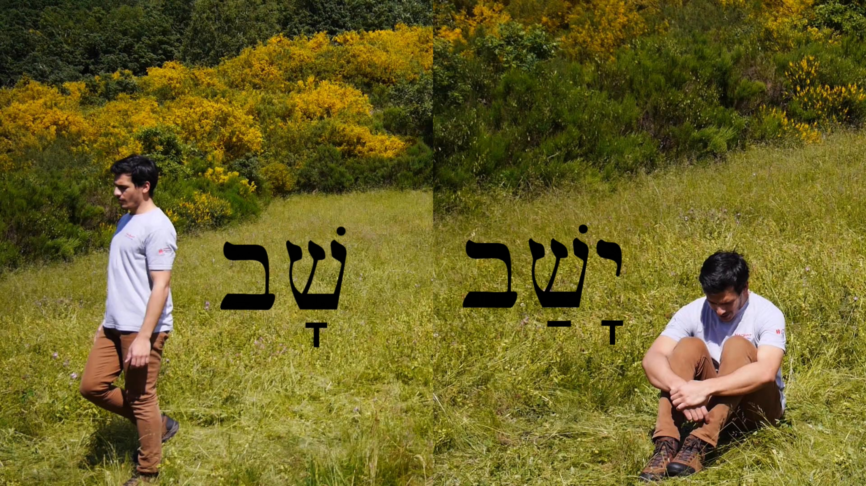
It’s also important to recognize the difference between שָׁב and יָשַׁב (“he sat”). When they are conjugated as vayyiqtol they have identical consonants but are different in their vowels. וַיָּשָׁב is the form for “and he returned” and וַיֵּשֶׁב is the form for “and he sat.” Most of the time the difference should be obvious from context.

Lesson 50 - Places: Here & There

50.1 New Vocabulary
מָקוֹם - place
שָׁם - there
פֹּה - here
כֹּה - thus
הַר צִיּוֹן - mount Zion
אִשָּׁה זוֹנָה - prostitute

50.2 The Imperative שֵׁב
To review imperatives, you can look back at sections 22.2 and 34.3.
Sit! (2MS - to one man) | שֵׁב
Sit! (2FS - to one woman) | שְׁבִי
Sit! (2MP - to more than one man, or a mixed group) | שְׁבוּ

Lesson 51 - The Twelve Spies

51.1 New Vocabulary
מְעַט - a little, few, a few
רָפֶה - weak
תָּרִים - spies
יָרֵא מִפְּנֵי - he was afraid of (literally, “he feared from the faces of…”)
מִמֶּנּוּ - from us

Lesson 52 - Vayyiqtol Forms 2: First Person

52.1 First Person Vayyiqtol Forms
If you need to, go back and review section 22.3 that introduces vayyiqtol, also known as vav-consecutive-imperfect.
Here are the vayyiqtol forms we demonstrate in this lesson that talk about what “I” did and what “we” did within a narrative framework:
וָאֶקַּח - and I took
וָאֶתֵּ֫ן - and I gave
וָאֶשְׁלַח - and I sent
וָאֵ֫רֶא - and I saw
וָאֵלֵ֫ךְ - and I went/walked
וָאֵשְׁתְּ - and I drank
וָאֹכַ֫ל - and I ate
וָאֵשֵׁ֫ב - and I sat
וָאָשֻׁ֫ב - and I returned
וָאָקֻ֫ם - and I got up
וָאֹמַ֫ר - and I said
וַנֵּלֶךְ - and we went/walked
וַנָּשָׁב - and we returned
וַנֵּשֶׁב - and we sat
וַנָּקָם - and we got up
וַנִּקְרָא - and we called out
וַנֹּאמֶר - and we said

Lesson 53 - Going Up & Down

53.1 New Vocabulary
יָרַד - he went down
עָלָה - he went up
מַעֲלוֹת - stairs
גָּג - roof
רָעָה - adjective: evil, bad; noun: evil, disaster

Lesson 53b - King Josiah reads the Book of the Covenant
No grammar points for this lesson.

Lesson 54 - David’s Dilemma

54.1 New Vocabulary
שָׁכַב - he lay down
מִטָּה - bed, couch
מִשְׁכָּב - bed, lodging place
הָרָה - pregnant
וַתַּהַר - and she became pregnant/conceived (from the root verb הָרָה)
פֶּתַח - opening, door


54.2 שָׁכַב - lie down
שָׁכַב is also used to describe someone’s death. For example: “When I lie down with my fathers (וְשָׁכַבְתִּי עִם־אֲבֹתַי), you shall carry me out of Egypt…” (Genesis 47:30). This verb is also used to refer to a sexual act, such as Genesis 34:2: “And he took her and lay with her….” וַיִּקַּח אֹתָהּ וַיִּשְׁכַּב אֹתָהּ.


Lesson 55 - Cross Over to the Other Side

55.1 New Vocabulary
עֵבֶר - other side
עָבַר - he crossed, passed over, through, by
וַיַּעֲבֹר - and he crossed, passed over/through
שֻׁלְחָן - table

55.2 Infinitive Construct
At the end of the video we see Avram telling a joke:
לָמָה עָבַר הָעוֹף אֶת־הַדֶּרֶךְ?
לָבֹא אֶל־הָעֵבֶר!
This translates as: “Why did the bird cross the road? To get to the other side!” Notice the word לָבֹא “to come.” This is an infinitive construct just like לֵאמֹר “to say” which we’ve seen many times by now. You can review what we’ve learned already about infinitive constructs in section 29.2. One of the easy ways to recognize that a word is appearing in the infinitive is by the ל prefix, which is often attached.

Lesson 56 - Weapons & Warfare

56.1 New Vocabulary
קֶשֶׁת - bow
מָגֵן - shield
חֲנִית - spear
מִלְחָמָה - battle, war
אִישׁ מִלְחָמָה - man of war, warrior
צָבָא - army
כְּלִי - vessel, piece of equipment, tool, ornament, weapon/armor
כְּלֵי מִלְחָמָה - weapons/armor

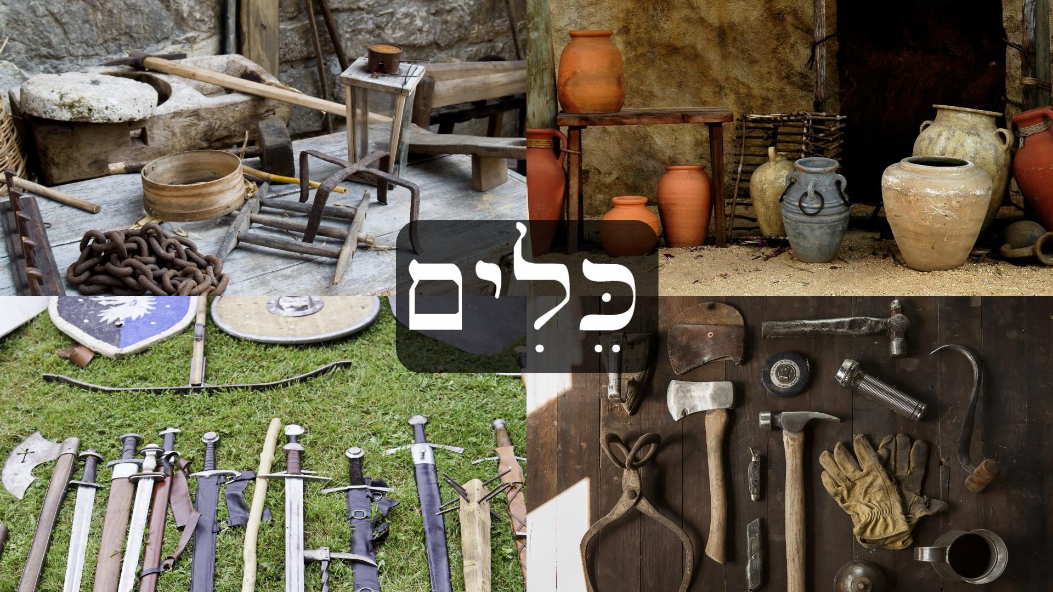
56.2 כְּלִי
As you can see in the gloss above, כְּלִי has a very wide range of meaning, and no single English word can translate it in all of its contexts. In a very general sense כְּלִי is a man-made object, usually of value. In the plural it could be as general as the cargo of a ship or the baggage you take on a journey. In English we often use the word “stuff” or simply “things.” It is also sometimes used for utensils or furniture, and even musical instruments.

56.3 צָבָא
צָבָא usually refers to an army, but it’s also used for the armies of Yahweh in heaven, as well as the sun, moon, and stars in the sky. In English this word has a long tradition of being translated as “host,” which is a very old way to refer to an army, so many modern readers misunderstand it. The common name יהוה צְבָאוֹת simply means “Yahweh of armies,” but is usually translated as “The LORD of hosts.” Whether this refers to God as commander of Israel’s armies, his own armies of angels, the stars of heaven, or all three, has been debated for a long time.

Lesson 57 - Strike & Fall

57.1 New Vocabulary
עָלֶה - leaf
נָפַל - he fell
הִכָּה - he hit, struck

57.2 First Nun Verbs or Pe Nun Verbs
Let’s talk about the morphology that’s going on with the two new verbs in this lesson: הִכָּה and נָפַל. Both of these are weak verbs (sometimes called irregular verbs) because of the letter nun. Back in sections 21.3 and 27.1 we began discussing strong and weak verbs, but there’s more to say. It’s important to understand that knowing the technical morphology of how verbs change when they are conjugated is not the same as knowing the language and being able to read or speak with some fluency. What we present in this section is not something a native speaker of biblical Hebrew would know unless they took a class, even if they had perfect mastery of the language as their mother tongue. That said, we share these details for those who are interested in going deeper and interacting with other textbooks and Hebrew scholars.
Verb roots that begin with a weak letter are called first-nun verbs or pe-nun verbs. The term pe nun comes from a very old paradigm based on the verb פָּעַל which means “he did.” The three letters of this root represent the positions of each radical (letter) in the weak verbs. So פ (pe) is the first radical, ע (‘ayin) is the second, and ל (lamed) is the third. Following this pattern we can call the verb נָפַל a pe-nun verb. In the same way the verb גָלָה would be a lamed-he verb because the weak letter he is the third letter of the root, in the same place as the lamed in פָּעַל. Since it is much simpler to say third-he or first-nun, we will use numbers from now on as our main way of talking about weak/irregular verbs.
The [n] sound has a tendency in some languages to get assimilated. Assimilation is a sound change in which some phonemes (typically consonants or vowels) change to become more similar to other nearby sounds. It can occur either within a word or between words. This means that assimilated letters sometimes disappear because of their position in a word or phrase. In Hebrew this happens often with נ when it occurs at the beginning of a word root. For example, when you add prefixes to the verb נָפַל, the nun is assimilated (disappears) and is represented by a dagesh forte in the letter after it, which would be pe in this case. So when we add the prefix וַיּ to נָפַל then we get וַיִּפֹּל.
The same kind of thing is happening in the verb הִכָּה “he struck.” The verb root is actually the first nun root נָכָה (which never occurs as נָכָה in the Bible). By adding a prefix to the verb, the nun assimilated and became represented by a dagesh forte in the kaf. We haven’t explained this prefix yet, but we want to avoid making things too complicated at this point, so we’ll introduce it later.
Once again, we don’t explain all of this morphology in the video for the same reason your mother didn’t explain irregular verb morphology to you when you were a child barely learning to speak! It simply isn’t necessary to know in order to become a fluent reader or speaker.

Lesson 58 - Directional Words

58.1 New Vocabulary
אָ֫נָה - to where?
מֵאַיִן - from where?

58.2 Directional Questions
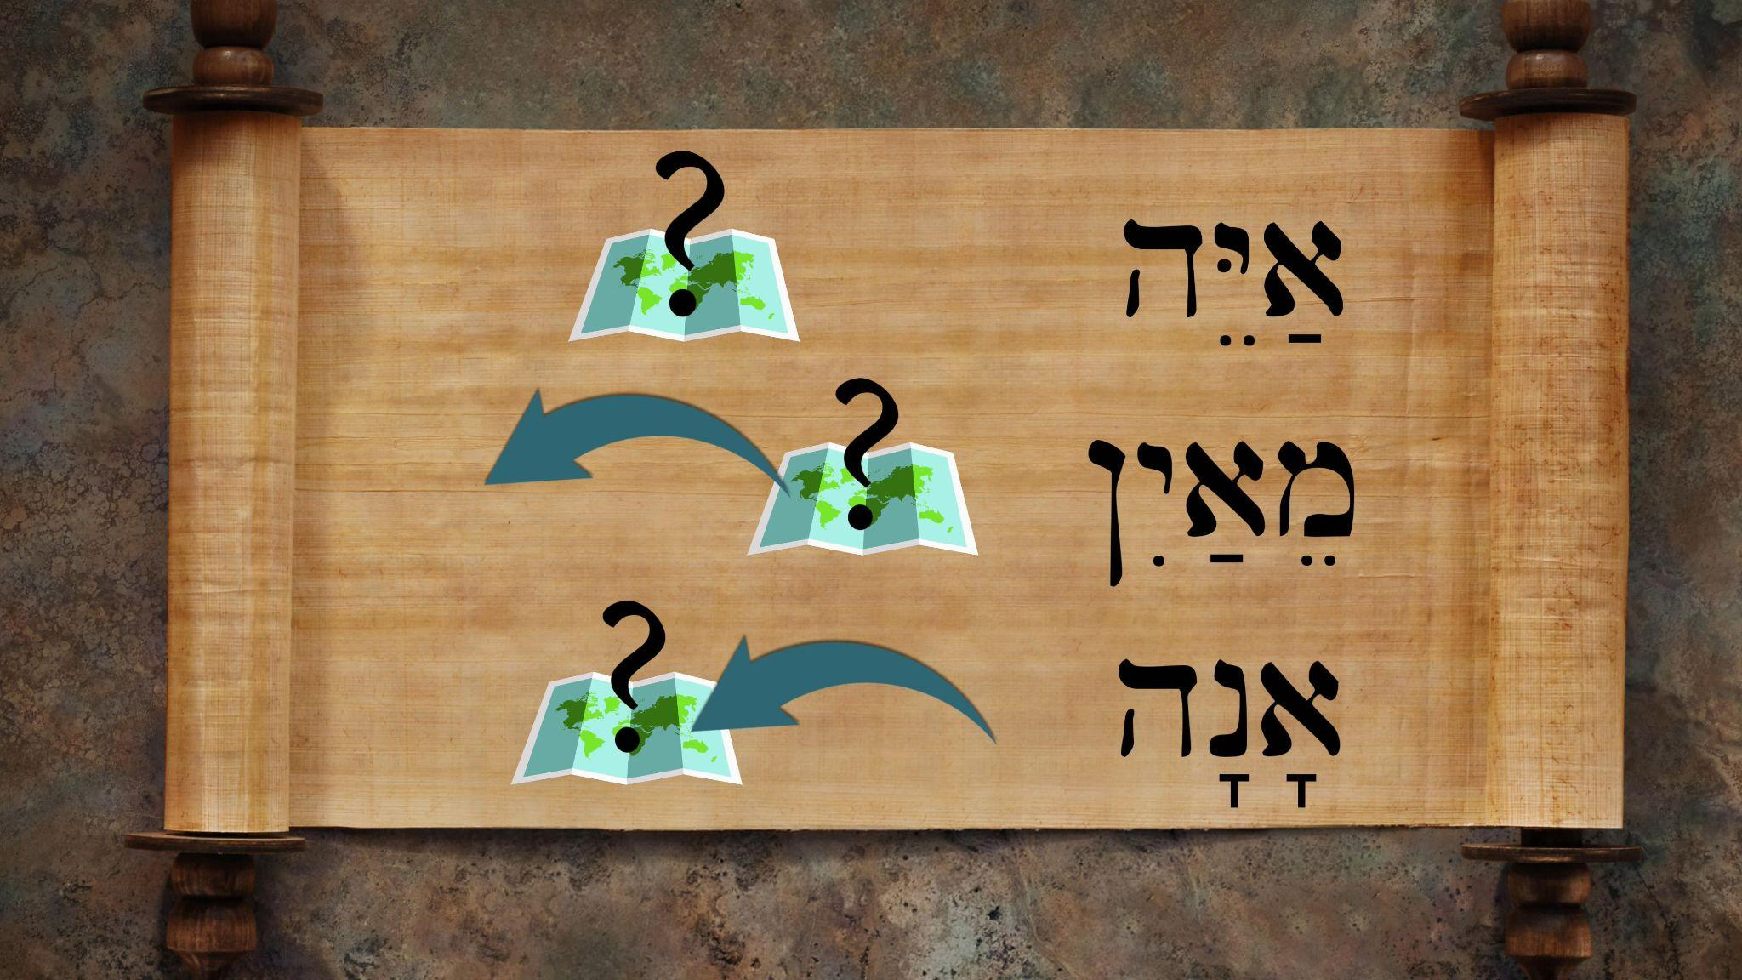
מֵאַיִן is a question asking “from where” someone or something is departing on its way to a new destination. Similarly, the word אָ֫נָה is asking “to where” someone or something is going.

50.3 Directional Ending Qamets He ה ָ
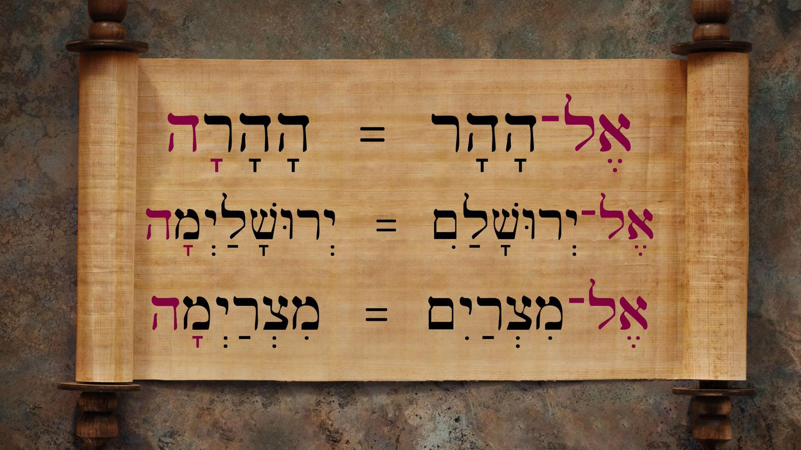
When the directional ending qamets he is added to the end of a word, it expresses movement towards the object. This is basically another way of saying “to/toward” something without using the preposition אֶל־. In the examples on the left we have two ways of saying each of the following phrases: 1) “to the mountain” 2) “to Jerusalem” 3) “to Egypt.”

The qamets he directional ending is quite frequent in the Hebrew Bible, occurring over a thousand times. Be careful, because the ה ָ ending can easily be confused with other constructions that also use ה ָ . For example, the feminine singular nouns and adjectives regularly end in ה ָ (for example, תּוֹרָה “law”). But the context will usually make it clear.

Lesson 59 - Run to Meet & Bow Down

59.1 New Vocabulary
רָץ - he ran
הִשְׁתַּחֲוָה - he bowed down
לִקְרַאת - to meet

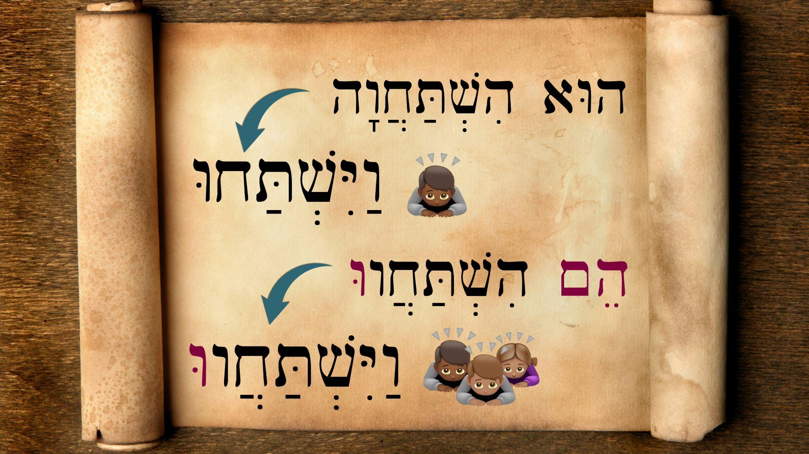
59.2 הִשְׁתַּחֲוָה
We’ve said in the past that Hebrew verbs all come from three letter roots, but you’ll notice that the verbs in this lesson aren’t listed like that. הִשְׁתַּחֲוָה technically comes from the three letter root חוה, but if you were required to learn that it would be useless, since you’ll never seen that form in the Hebrew Bible. Just as other languages have old forms of words that are no longer used, Hebrew has the same. What’s important is that you learn the form that you’ll see most often, which is הִשְׁתַּחֲוָה (along with other conjugations you saw in the video). Later on we will begin introducing and explaining the different Hebrew stems (called בִּנְיָנִים “constructions” in Hebrew) which cause conjugations like הִשְׁתַּחֲוָה. Our goal is to keep you from getting overwhelmed with too much detail all at once. For those who are too curious to wait, we recommend watching this helpful video. If you’re reading a print version of this grammar, use to following QR code to get to the video:


Lesson 60 - A Tense Reunion

60.1 New Vocabulary
מֵאָה - hundred
רִאשׁוֹן - first
אַחַרוֹן - next, last
פַּ֫עַם - occurrance, instance, time
נָשַׁק - to kiss

60.2 Counting by Hundreds
Although we heard the term מֵאָה for the first time in Lesson 49, we discuss it here as new vocabulary since it’s a lot more prominent in this video. Contrary to many Hebrew numbers, which are adjectives, this word is a noun. Adjectives have to match the gender of the noun they modify, but nouns generally maintain their gender. So since מֵאָה is a feminine noun you will always find it in its feminine form.
To express “one hundred” מֵאָה simply stands alone, similar to how we say “a hundred.” This term is most often placed before the noun which is being counted.
“Two hundred” is expressed with the dual form of מֵאָה, which is מָאתַיִם. There’s no need to use the number “two” שְׁתַּיִם in this construction.
In order to express a multiple of hundred beyond 200 Hebrew adds another cardinal number in its construct form typically placed before מֵאוֹת, the plural form of מֵאָה. This is why the servants say to Jacob, וְאַרְבַּע־מֵאוֹת אִישׁ עִמּוֹ. Here the number four needs to be in its feminine form in order to agree with the gender of the word it’s modifying: “hundreds” מֵאוֹת. Note in the table below that this is true whether the noun being counted is feminine or masculine.

Hebrew Number | Literal translation | Natural English
מֵאָה עִזִּים | Hundred goats | One hundred goats
מָאתַיִם עִזִּים | A pair of hundreds goats | Two hundred goats
שְׁלֹשׁ מֵאוֹת עִזִּים | Three hundreds goats | Three hundred goats
אַרְבַּע מֵאוֹת עִזִּים | Four hundreds goats | Four hundred goats
חֲמֵשׁ מֵאוֹת עִזִּים | Five hundreds goats | Five hundred goats
שֵׁשׁ מֵאוֹת סוּסִים | Six hundreds horses | Six hundred horses
שְׁבַע מֵאוֹת סוּסִים | Seven hundreds horses | Seven hundred horses
שְׁמֹנֶה מֵאוֹת סוּסִים | Eight hundreds horses | Eight hundred horses
תְּשַׁע מֵאוֹת סוּסִים | Nine hundreds horses | Nine hundred horses

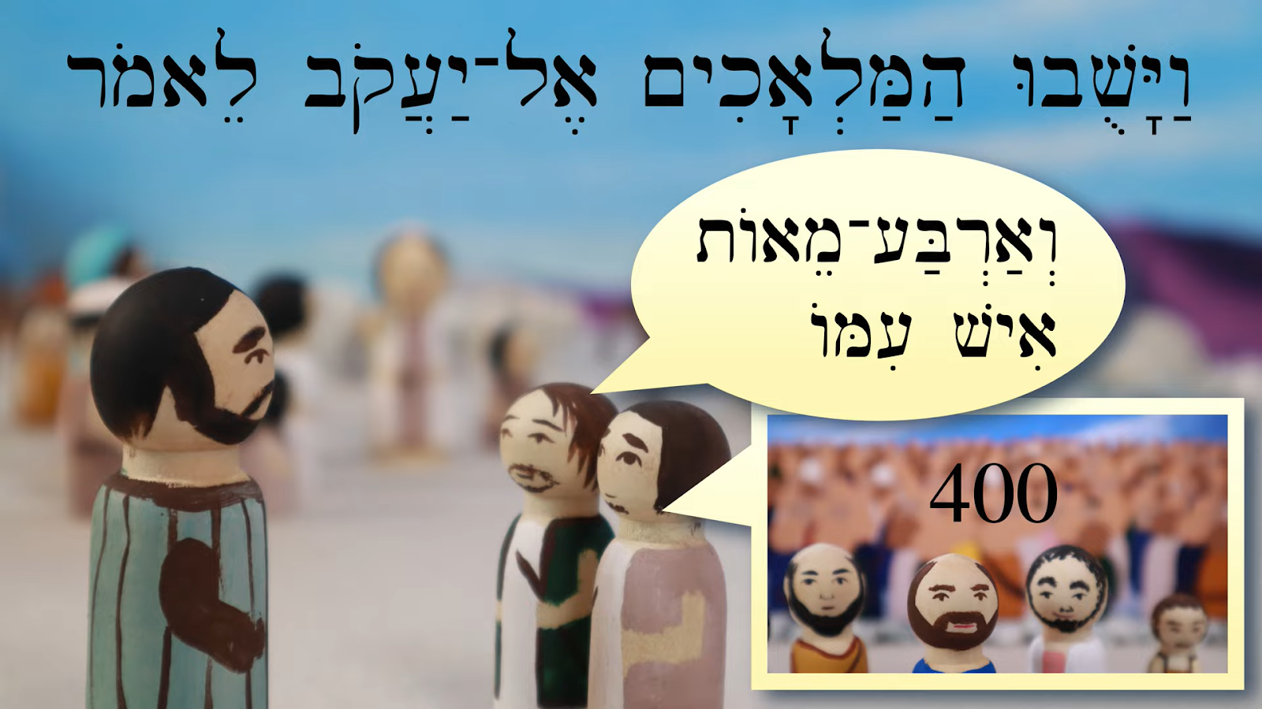
60.3 Collective Use of אִישׁ
You might have noticed an unexpected mix of plural and singular in this video. For example, when the messengers refer to 400 men who are accompanying Esau, the Hebrew says:
וְאַרְבַּע־מֵאוֹת אִישׁ עִמּוֹ׃
Literally: “And four hundreds man (are) with him.”
Here אִישׁ is used in a collective sense, which we talked about back in section 48.4.

60.4 Describing Order
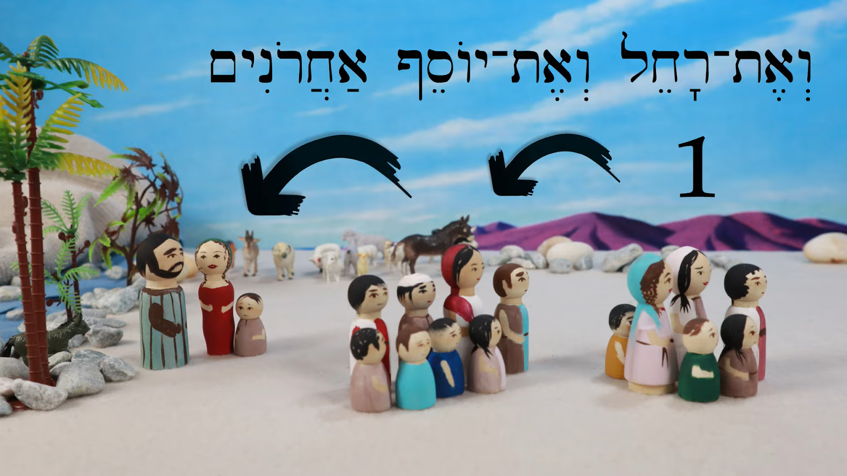
The words רִאשׁוֹן and אַחַרוֹן introduced in this lesson are an example of words which help to refer to position or order. רִאשׁוֹן comes from רֹאשׁ (“head”) and means “first.” This is what grammars call an ordinal number. This kind of number is used to describe positions in time or space, but not to count. When we want to count, we use what grammarians call cardinal numbers, which also can be used to describe quantity. In the future we’ll learn other ordinal numbers like second, third, etc. Keep in mind that רִאשׁוֹן will act like other adjectives, which means it must agree in number and gender with the noun it’s describing. For example, רִאשׁוֹנָה is the form that describes a feminine singular noun.
Another significant word in this regard is אַחַרוֹן which means “next” or “last.” It is also an adjective that is obviously related to the preposition we have already learned, אַחֲרֵי. Both senses (next and last) are used in this story with the masculine plural form, אַחֲרֹנִים.

60.5 Dual Form for פַּעַם
We first heard פַּ֫עַם in Lesson 38, but in this video its meaning becomes more clear. This word is used to count the number of occurrences of an event. For example, in the story of Jacob’s tense reunion we are told the following:
וַיִּשְׁתַּ֫חוּ אַ֫רְצָה שֶׁ֫בַע פְּעָמִים׃
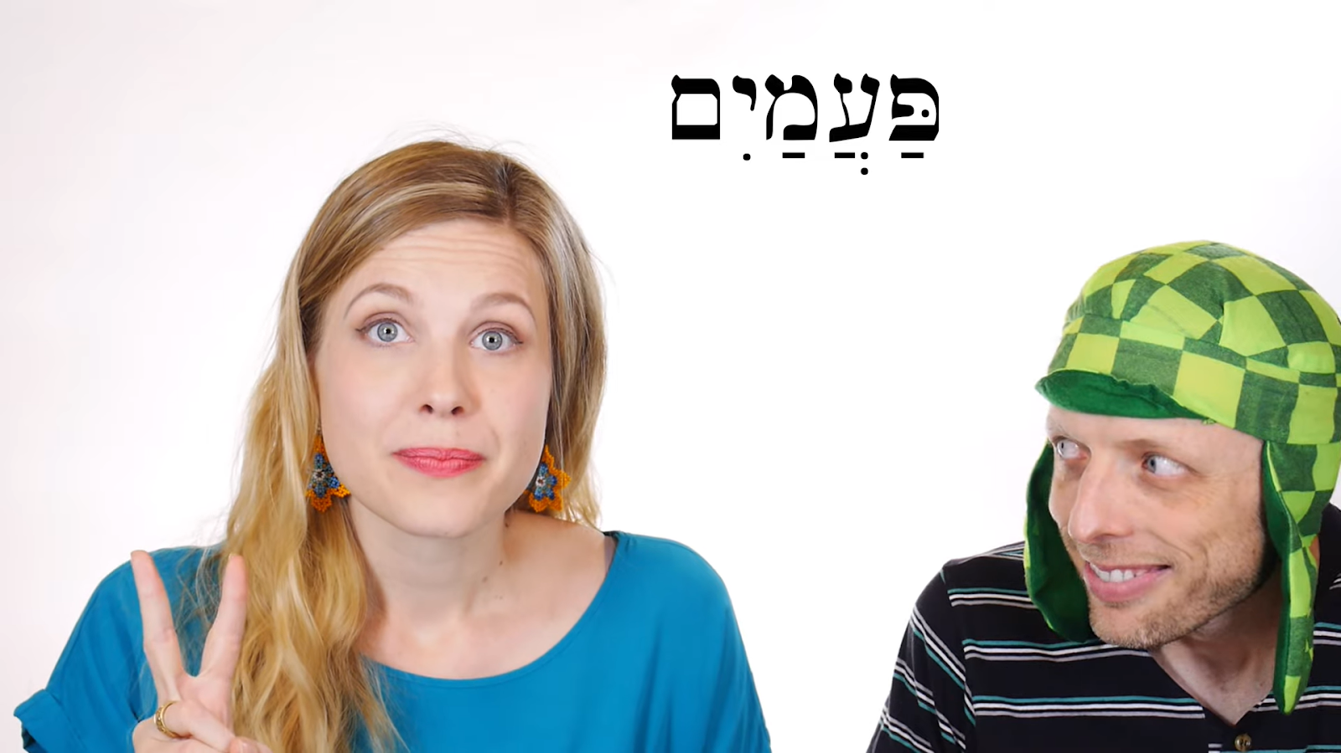
And he bowed down to the ground seven times.
When Beth explained the meaning of this word you probably noticed it was generally accompanied by a number to indicate how many times were in view. We saw an exception to this in the case of “two times” פַּעֲמַיִם. Again, this is due to the use of the dual form which already includes the sense of “two.”

Lesson 61 - Flee & Chase

61.1 New Vocabulary
נָס - he fled, escaped
רָדַף - he chased, pursued
תּוֹךְ - midst, middle
סוּף - reeds, rushes (collective)
יַם־סוּף - the Red Sea, the Sea of Reeds

61.2 Hollow Verb Patterns
For a quick review of weak verbs, please refer to sections 21.3 and 27.1 and 57.2. The verb נָס comes from the hollow root נוס, just like these other verbs we’ve seen before:
קָם ← וַיָּ֫קָם (root קום)
שָׁב ← וַיָּ֫שָׁב (root שׁוב)
רָץ ← וַיָּ֫רָץ (root רוץ)
נָס ← וַיָּ֫נָס
These are also known as second-vav or ‘ayin-vav verbs. Technically, the ו in these roots is not considered a consonant, which makes these roots unique. It’s treated as a vowel, which we usually consider to be וּ in this case. Before Hebrew was written with vowel markings, you would have seen these words as קום and שוב. It may seem strange that a sound like ו could stand in for a vowel, because in our pronunciation system the letter ו doesn’t sound even close to a vowel phonologically. But the most ancient sound of ו was probably a voiced labial-velar approximant [w], which we have in English as the w sound. This sound is weaker than other letters, and you can hear how it sounds more related to a vowel than a hard [v] sound. When the verb is conjugated, the ו typically drops out, and you are left with forms like נָס and וַיָּ֫נָס and others we see in the list above. The purpose of this list is to point out the consistent vowel pattern when conjugating these kinds of verbs.

Keep in mind that although the root of a hollow verb like נָס is נוס, you’ll never see the form נוס in the Bible, but rather a conjugated form of it with vowels. For example, you’ll see נוּס, which is the imperative form, but not the plain נוס form that you’ll see in many lexicons when you look it up. Our favorite lexicon, BDB, will list hollow verbs with וּ as the vowel, so you’ll find נוּס instead of נוס. This is one of the exceptions to the rule that we explained earlier about looking up verbs in lexicons: typically you’ll find the verb listed as its 3MS qatal form. But the 3MS qatal form of נוס is actually נָס.

Remember also that in the vayyiqtol conjugations of hollow verbs use the qamets hatuf vowel. You can review the rule of qamets hatuf in section 45.2.

Lesson 62 - David & Goliath

62.1 New Vocabulary
מַקֵּל - rod, staff
קֶ֫לַע - sling
וַיְקַלַּע - he slung, hurled
כָּרַת - he cut
Otherwise, no new grammar points in this video! Enjoy the story and use it to review the grammar you’ve already internalized.

Lesson 63 - Vayyiqtol Forms 3: Second Person

63.1 New Vocabulary
זָכַר - he remembered

63.2 More Vayyiqtol
If you need to review, in section 22.3 we discussed how vayyiqtol verbs work.
We show a lot of verb forms in this video, so here’s a handy chart to see everything together:
 | 👤 |  | 👥
 | ♂ | ♀ | ♂ | ♀
1 | וָאֵלֵךְ - I went |  | וַנֵּ֫לֶךְ - we went
2 | וַתֵּ֫לֶךְ - you went  וַתֹּ֫אמֶר - you said  וַתֵּ֫רֶא - you saw  וַתָּ֫קָם - you got up  וַתִּקְרָא - you called  וַתִּקַּח - you took  וַתָּ֫שֶׂם - you put  וַתֹּ֫אכַל - you ate  וַתִּירָא - you feared  וַתִּרְדֹּף - you pursued  וַתִּפֹּל - you fell | וַתֵּלְכִי - you went  וַתֹּאמְרִי - you said  וַתִּקְחִי - you took  וַתֹּאכְלִי - you ate  וַתִּרְדְפִי - you pursued  וַתִּשְׁתִּי - you drank  וַתִּשְׁלְחִי - you sent  וַתִּכְרְתִי - you cut | וַתֵּלְכוּ - y’all went  וַתֹּאמְרוּ - y’all said  וַתָּקֻ֫מוּ - y’all got up  וַתִּקְרְוּ - y’all called  וַתִּקְחוּ - y’all took  וַתִּרְדְּפוּ - y’all pursued  וַתִּכְרְתוּ - y’all cut  וַתָּבֹ֫אוּ - y’all came  וַתִּשְׁתַּחֲווּ - y’all bowed
3 | וַיֵּ֫לֶךְ - he went | וַתֵּ֫לֶךְ - she went  וַתֹּ֫אמֶר - she said  וַתֵּ֫רֶא - she saw  וַתָּ֫קָם - she got up | וַיֵּלְכוּ - they went

Lesson 63b - Sihon & Og

63b.1 New Vocabulary
עוֹג - Og (the king of Bashan)
חֶשְׁבּוֹן - Heshbon
סִחֹן - Sihon (king of the Amorites)
הַבָּשָׁן - Bashan

63b.2 וַנַּכֵּם
Although וַנַּכֵּם is explained briefly in the video, you might feel the need for a bit more help with the morphology. The root is a verb we’ve already talked about back in section 57.2: נָכָה, which mainly occurs in the hiphil stem in the Bible: הִכָּה, “to strike.” Since the verb is doubly weak, it tends to lose its two weak letters (נ and ה) when conjugated. So when we make this a first person plural (we) vayyiqtol verb and then add a suffix to communicate the object of the verb (them), we get וַנַּכֵּם “and we struck them.”
וַנַּכֵּם = וַנַּךְ אֹתָם

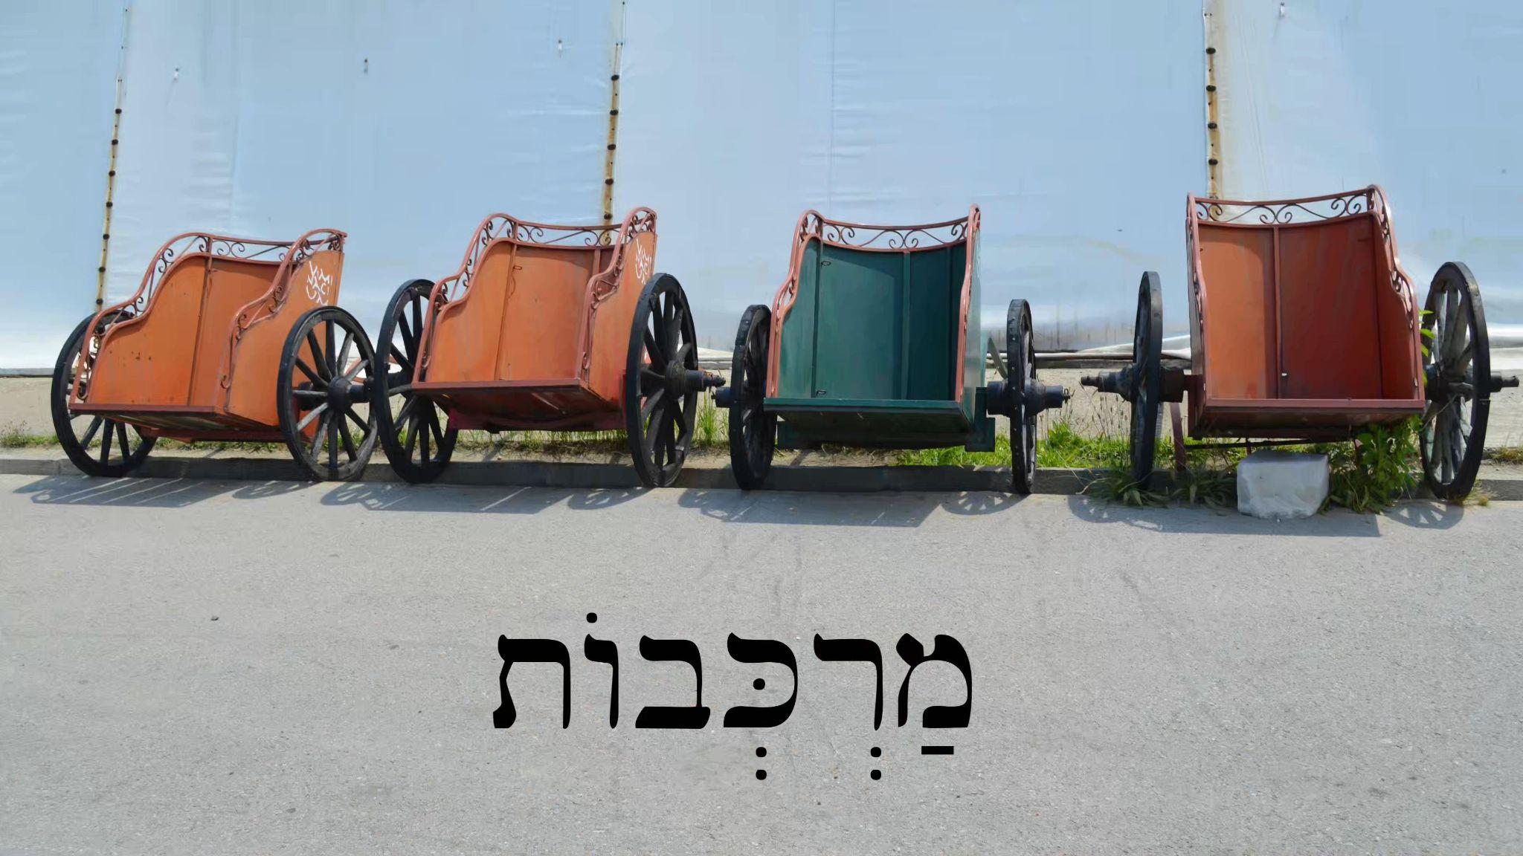
Lesson 64 - Chariots & Horsemen

64.1 New Vocabulary
רֶ֫כֶב - chariotry, chariots (collective)
מֶרְכָּבָה - chariot
פָּרָשׁ - horseman

64.2 Review of We and Y’all Verbs
Back in section 52.1 we introduced first-person vayyiqtol forms, which we review in this lesson. Notice how the vayyiqtol forms are used to describe a chain of events that the two dolls did. Beth asks them what they did, and they answer:
הָיִינוּ בְּבֵיתֵנוּ וַנֵּצֵא׃ וַנִּשָּׂא אֶת־הַכַּד וַנָּשֶׂם אֹתוֹ פֶּתַח הַבַּיִת׃ וַנַּעַל עַל־הַגָּג וַנִּשְׁכַּב שָׁם׃ וַנָּקָם וַנֵּרֶד מֵעַל הַגָּג וַנָּבֹא אֶל־הַבַּיִת׃
“We were in our house and we went out. And we carried the pot and we put it in the doorway of the house. And we went up onto the roof and we lay down there. And we got up and we went down from on the roof and we went into the house.” Beth then repeats to them what they did: “Y’all were in your house and y’all went out from the house….”

64.3 רֶ֫כֶב
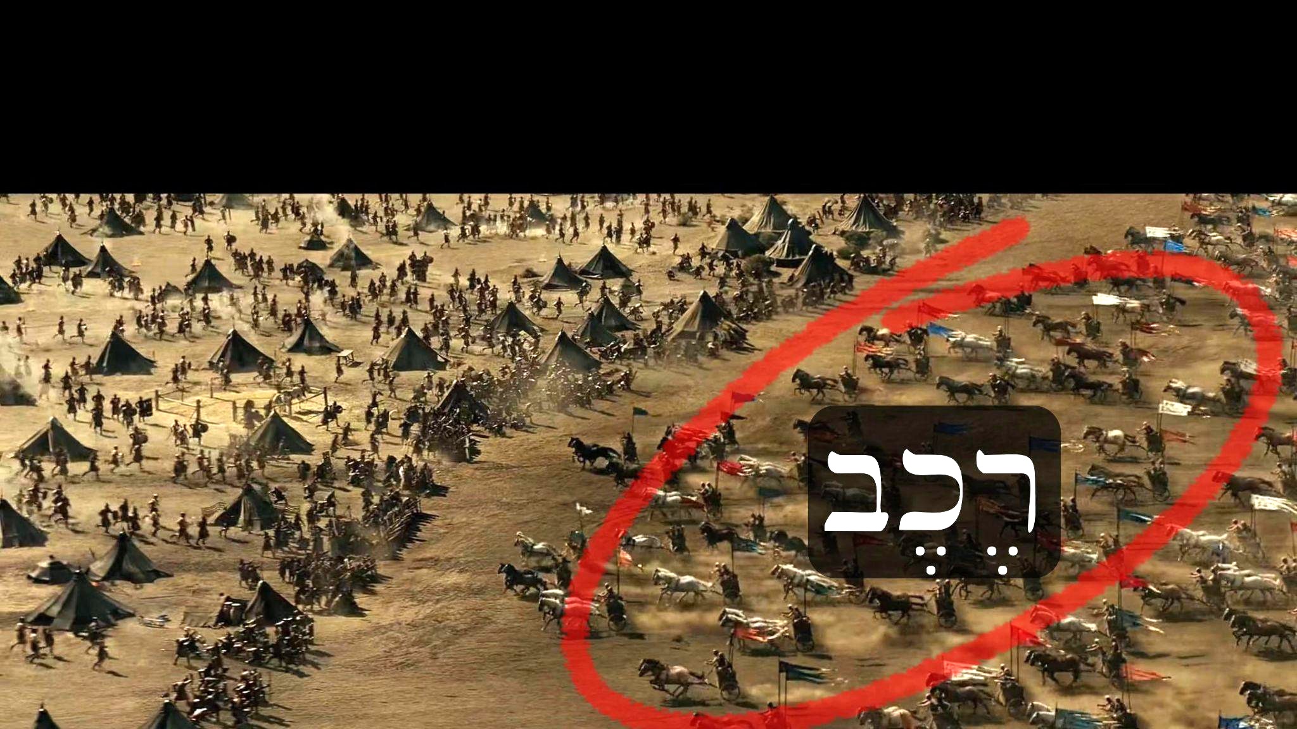
רֶ֫כֶב can be difficult to comprehend at first. It usually describes a large group of chariots, but can also be used to talk about a single chariot. So even though מַרְכְּבוֹת is another word for “chariots”, רֶ֫כֶב is the most common, and often used in contexts of big battles.

Lesson 65 - Thus says יהוה - a brief history of Israel

65.1 New Vocabulary
כֹּה - thus, so
נְהַר־פְּרָת - the river Euphrates
יָמִים - days
עוֺלָם - ancient past

65.2 עוֺלָם
עוֺלָם is a difficult word to grasp at first because it has many different uses. We would recommend reading through the different ways it’s used in the Brown-Driver-Briggs (BDB) lexicon on this page. In the context of Joshua 24:2a it carries the connotation of “ancient times” or “distant past.” But in many other contexts it will be used to talk about “forever/eternity/all time/future.”

Lesson 66 - Captains & Enemies

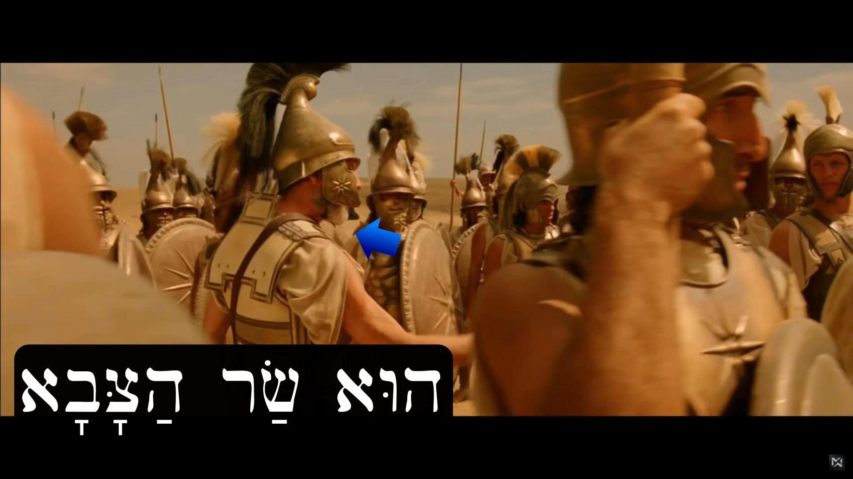
66.1 New Vocabulary
שַׂר - captain, chief, official, ruler
אוֹיֵב - enemy
צַר - enemy, adversary, foe

66.2 צַר
צַר is a word that may be confusing if you look it up in a lexicon. You need to watch out for the fact that there are several homonyms of צַר which mean very different things. A homonym is a word that is spelled or pronounced the same as another. For example, in English we have the “bat” which you use to hit a baseball, and the “bat” that lives in caves. They are spelled and sound exactly the same, but are not the same word. So be careful when you look up צַר in a lexicon and make sure to find צַר III (the third homonym of צַר). First you’ll find צַר I and צַר II, but they won’t be the ones you’re looking for.

Lesson 67 - Between Eglon & Zedekiah


67.1 New Vocabulary
כָּנָף - wing
זָנָב - tail
צִדְקִיָּ֫הוּ - Zedekiah
שָׁלוֹם - peace
בֵּין - between

67.2 בֵּין
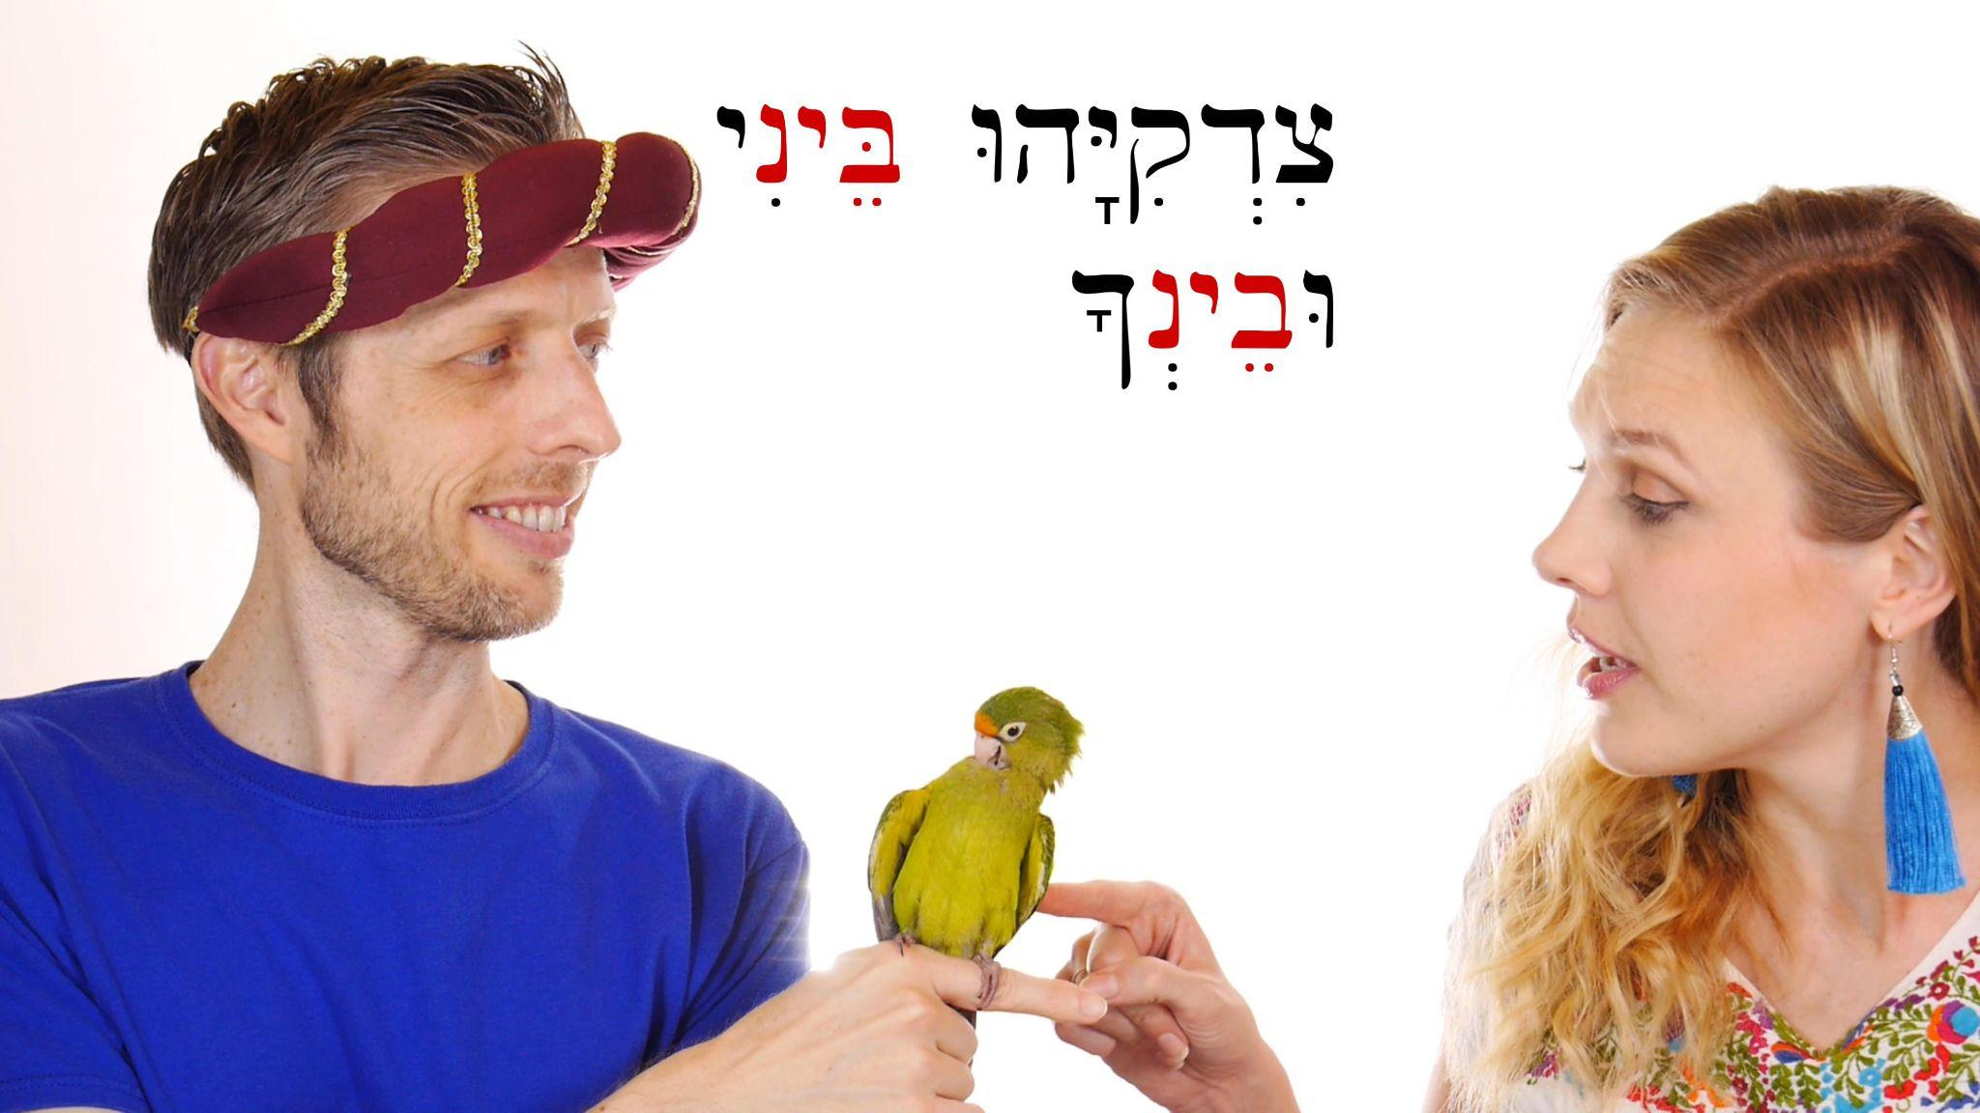
The use of בֵּין in your language may be different from how it’s used in Hebrew. In English we use the preposition “between” only once when we want to say something like, “The bull is between the pomegranate and the fish.” But in Hebrew you’ll hear the preposition twice: הַפָּר בֵּין הָרִמּוֹן וּבֵין הַדָּג “The bull is between the pomegranate and between the fish.” Like other Hebrew prepositions, pronominal suffixes can be added to בֵּין to say things like: בֵּינֵיהֶם or בֵּינֹתָם, both of which mean “between them.” Why are there two different ways of writing/saying “between them?” We’d encourage you to look at an in-depth grammar if you’re curious. But for our purposes, we simply want you to be aware that there are two forms, and that’s all you need to know to build fluency!

Lesson 67b - Peace & War in the Land

67b.1 New Vocabulary
שְׁלֹ֫שֶׁת - three
גּוֹי - nation, people (many times used to refer to non-Hebrew people)
כִּי אִם - but rather

Lesson 68 - Killing in the Camp

68.1 New Vocabulary
מֵת - he died
וַיָּ֫מָת - and he died
מַחֲנֶה - encampment, camp
הָרַג - kill

Lesson 69 - The woman who killed Sisera

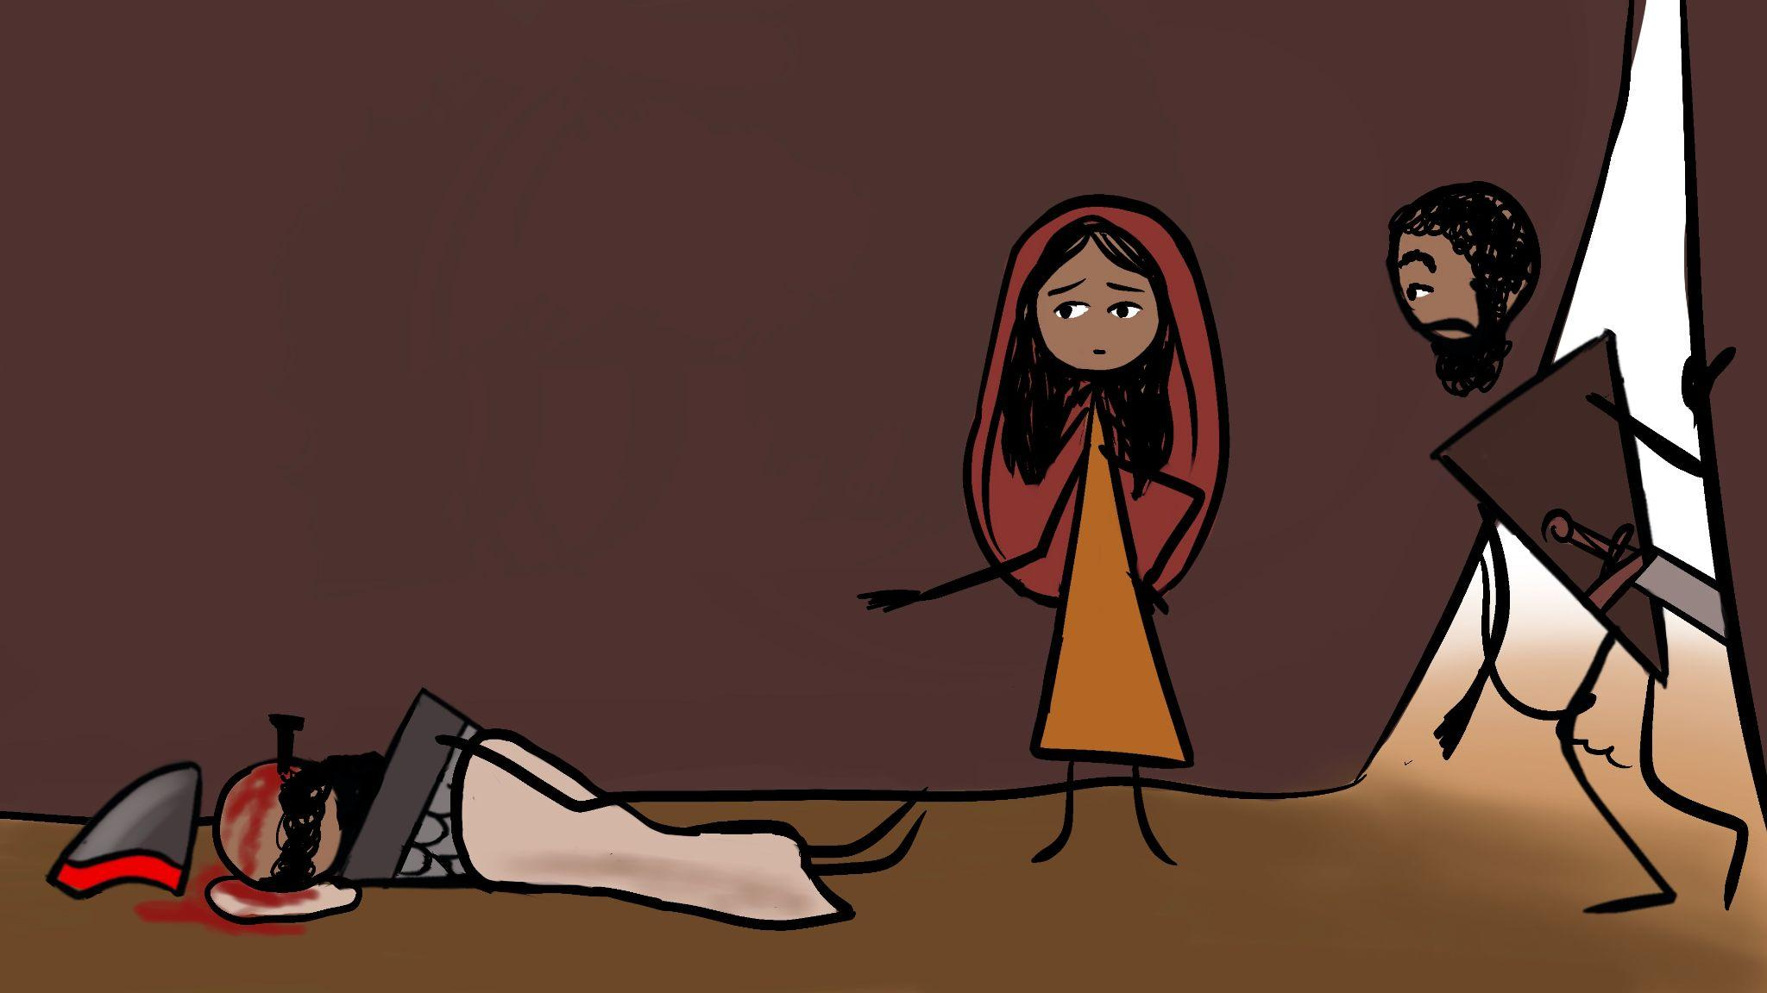
69.1 New Vocabulary
צָעַק - he cried out, called
יָתֵד - wooden peg, ten peg
מַקֶּבֶת - hammer
קֵינִי - Kenite
נְבִיאָה - prophetess
אֲדֹנִי - my lord, master
בַּלָּאט - secretly

Lesson 70 - Covenant & Seed

70.1 New Vocabulary
זֶ֫רַע - seed, offspring/descendants
בְּרִית - covenant, alliance
כָּרַת בְּרִית - he made (cut) a covenant

Lesson 71 - Vayyiqtol forms 4: feminine plural

71.1 New Vocabulary
בָּכָה - he wept

71.2 More Vayyiqtol Forms and Morphology
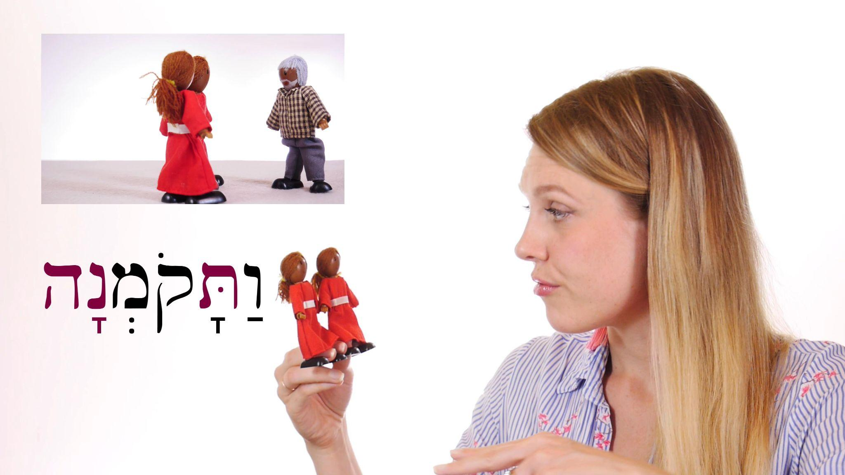
Back in sections 21.3 and 27.1 and 57.2 we began discussing strong and weak verbs, so we’d encourage you to review those sections. In this video we encounter several different kinds of weak verbs and see how they’re conjugated as vayyiqtol (vav-consecutive-imperfect, introduced back in section 22.3). We focus particularly on feminine forms to prepare you to read/listen to the Ruth story in lesson 72. Let’s look at some of these forms and discuss the morphology. Also, be reminded that the technicalities we’ll discuss below are not necessary to become a fluent reader/speaker.
הוּא בָּכָה ← וַיֵּבְךְּ When we want to say “And he wept” in vayyiqtol, בָּכָה loses the final ה. As we’ve discussed before, ה is a weak letter that disappears as the accent/stress moves towards the beginning of the word when it is conjugated as vayyiqtol. That’s why we’re left with וַיֵּ֫בְךְּ (notice that the accent is no longer on the last syllable like it is in בָּכָה). Since ה is weak, it will also be replaced by suffixes used to conjugate the verb. We see this in the following example:
הֵם בָּכוּ ← וַיִּבְכּוּ. In both the qatal and vayyiqtol forms the וּ suffix swallows the ה. In other grammars you’ll usually see בָּכָה referred to either as a third-he verb or as a lamed-he verb.

In this lesson we also see the hollow verbs from the roots קום and שׁוב:
קֹמְנָה - arise! (feminine plural)
שֹׁבְנָה - return! (fp)
וַתָּקֹ֫מְנָה - and you arose (fp)
וַתָּשֹׁ֫בְנָה - and you returned (fp)

You may be wondering what’s going on with this feminine plural form: וַתֵּשַׁ֫בְנָה “and you sat/dwelled.” This is a conjugation of the root ישׁב which is a first-yod or pe-yod weak verb. י, like ו, is an approximant (a voiced palatal-approximant [j]), which means it’s phonetically similar. That’s just a fancy, technical way of saying that it’s also a weak letter prone to getting swallowed up by others during conjugation. So in the vayyiqtol form וַתֵּשַׁ֫בְנָה the י is replaced by the prefix ת.

Lesson 71b - Verb Forms Summary: Qatal & Vayyiqtol

71b.1 Verbal Patterns
This video is designed to help you recognize patterns in different kinds of verbs and review what we’ve learned. If you would like to see full charts of all the conjugations shown in the video, please refer to the lesson transcript.
The first verb we see is רדף, which serves to give us an overview of how a strong or regular verb is conjugated in both qatal and vayyiqtol (both of which usually communicate past actions in a narrative).
Next we’re given the example of a third-he (3-ה) verb עשׂה, which you should recognize by now as a weak or irregular verb. If you compare the charts between this verb and רדף you’ll see that the main difference is the disappearance of the final ה when conjugated. Often the ה is replaced by a י (such as in עָשִׂ֫ית “you (f) made”). This is because in more ancient Hebrew, third-he verbs were actually third-yod verbs, and the conjugations preserved the ancient spelling.
Next we see an example of a second-vav (2-ו) verb קום. Again, since קום is a weak verb, the ו is usually lost in the conjugations. These kinds of verbs are also called “hollow verbs.” You can review our more detailed description of hollow verbs in section 61.2.
Next we review the conjugation of a first-nun (1-נ) verb נפל. Back in section 57.2 we discussed these kinds of verbs. Notice that when you add prefixes to נָפַל, the nun is assimilated (disappears) and is represented by a dagesh forte in the letter after it, which would be פ in this case (e.g. וַיִּפֹּ֫ל “and he fell”).
Next comes a first-yod (1-י) verb ישׁב. Just like first-nun verbs, the י disappears when conjugated in vayyiqtol. But unlike first-nun verbs, the י is not represented by a dagesh forte in the letter after it.

In section 32.2 we introduced the concept of פִּעֵל “piel” with the root דבר. We’re still not ready to talk about the piel and binyanim (stems) in detail, but just know that this part of the video is helping you get more familiar with the different forms of דבר in the piel stem. We’re forced to mention piel with דבר simply because it doesn’t ever occur in the qal stem. All of this will become more clear later on. For those nerds who are eager to learn more about binyanim now, we recommend this excellent video.
Remember that what matters with all of these verbs and charts is not rote memorization, but rather practice and growing familiarity with the sounds and patterns as you continue to hear and read them.

Lesson 72 - Naomi & Ruth

72.1 New Vocabulary
רָעָב - famine, hunger
כַּלָּה - daughter-in-law
מְא֫וּמָה - anything

Lesson 73 - More Parts of the Body

73.1 New Vocabulary
לָשׁוֹן - tongue
שֵׁן - tooth
זְרוֹעַ - arm, strength
לֵב - heart
לֵבָב - heart
שְׁכֶם - shoulder, shoulders
עֶ֫צֶם - bone
עוֹר - skin
קֶ֫רֶב - inward parts, entrails, midst

Lesson 74 - Lev: mind, will, emotions

74.1 New Vocabulary
שָׂם לֵב - he paid attention, considered, studied (lit. “he put heart”)
לָשׁוֹן - language
אָמַר בְּלִבּוֹ - he thought (lit. “he said in his heart”)
הִכָּה לִבּוֹ אֹתוֹ - his heart struck him, his conscience bothered him
נָבָל - fool

74.2 לֵב
לֵב / לֵבָב “heart” has a broad range of uses in different Hebrew idioms. The best place to read more about all the ways it’s used is in The Anthropology of the Old Testament by Wolff (pgs 40-58). It occurs 858 times in the Hebrew Bible, which makes it the most common term for a part of what makes us human. It’s important to recognize that the modern understanding of “heart” in English and other languages often clashes with the Bible’s use of the word. In Hebrew the לֵב is the center of who you are: your mind, will, desires, and emotions. In our modern way of thinking we often separate the mind (thinking) from the heart (feelings) as though they were completely different, but in Hebrew the לֵב is where you think and feel. Very rarely does לֵב refer strictly to anatomy or an organ. The main activities of the לֵב are mental and spiritual. So, if you don’t have a לֵב that means that you have no understanding, discernment, or wisdom (a fool) (e.g. Hosea 4:11).

Lesson 75 - Participles 1: singular

75.1 New Vocabulary
סַל - basket

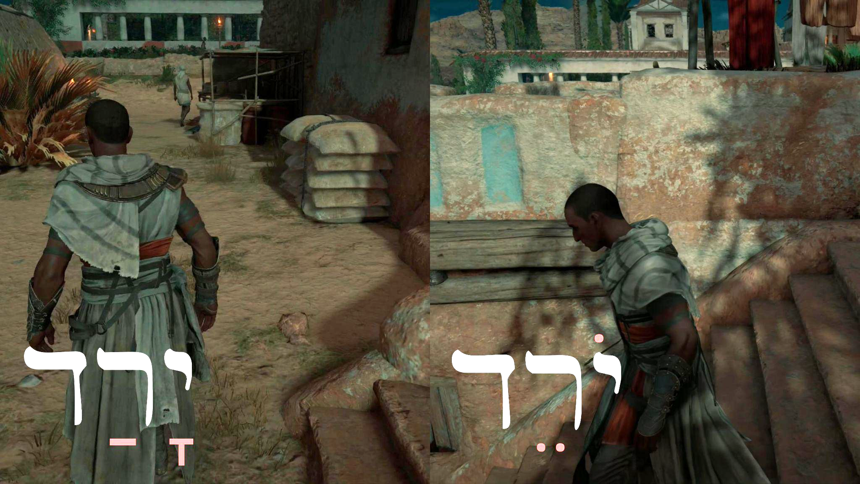
75.2 Participles
It’s important to recognize that up until now we have not formally introduced a way to talk about the present in Hebrew, even though we briefly mentioned participles in section 48.1. This lesson introduces the active participle (the passive participle will come later). Examples of active participles in English are verbs ending in -ing like judging, eating, listening.
In Hebrew the default vowel pattern for an active participle is “o-e” or holem-tsere, as you can see in the picture above. A participle is a verbal adjective, which means it can function as both a verb or an adjective. In this lesson we want to focus first on the verbal function of the participle. Just like other verbs, participles in Hebrew must agree with the gender (and number) of their subject.
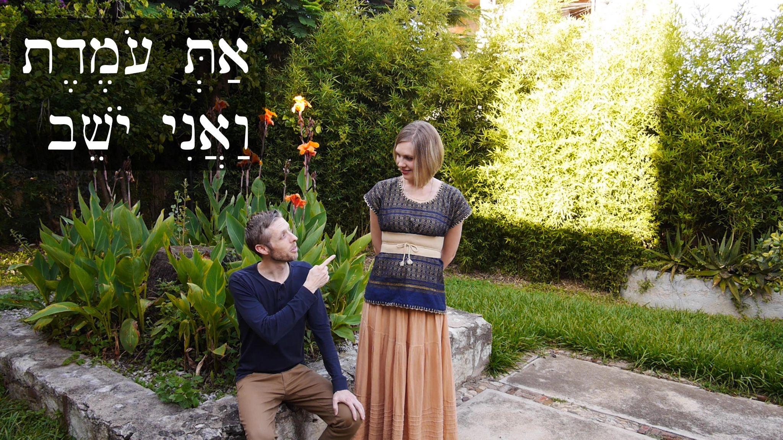
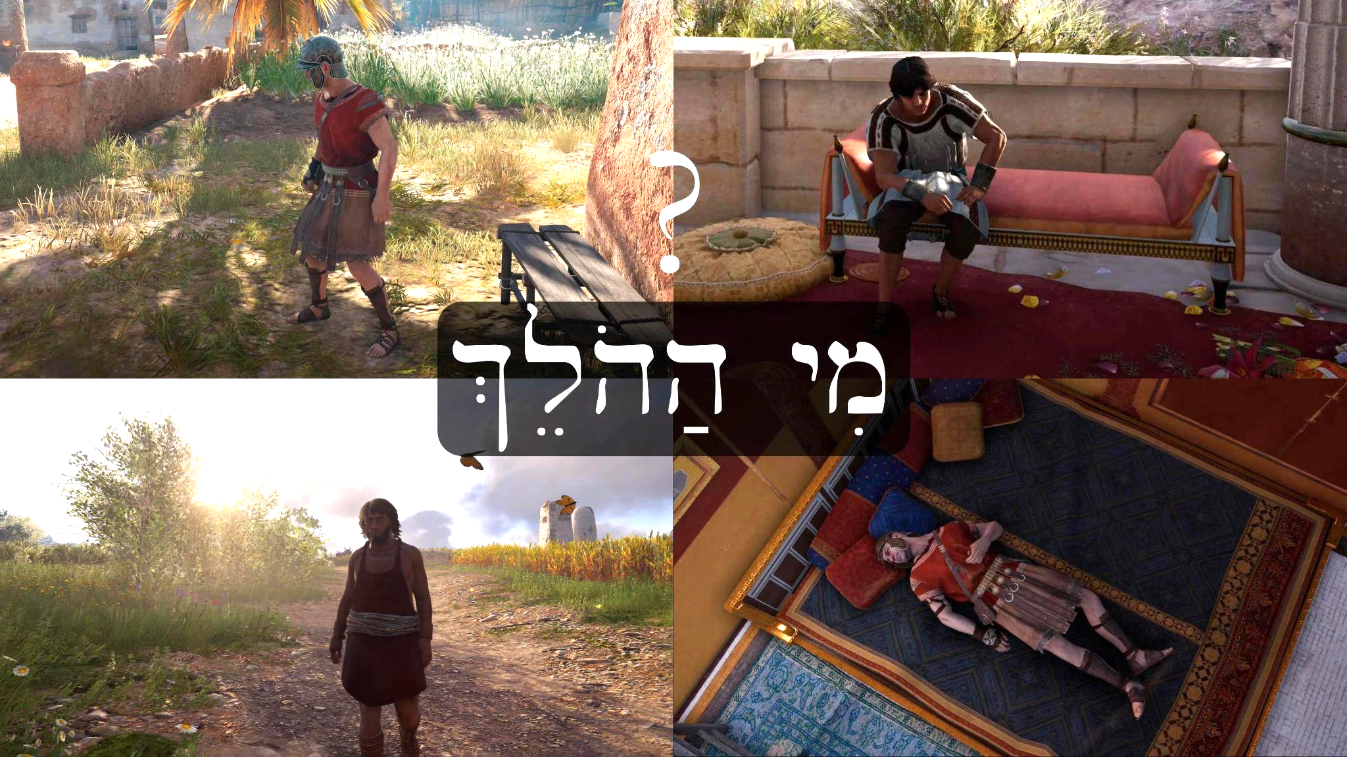
In the sentence אַבְרָם עֹמֵד “Avram is standing” עֹמֵד is the masculine singular form of the active participle from the root עמד. But if we want to say that “Beth is standing” בֵּת עֹמֶ֫דֶת we must have the feminine singular form of the active participle from עמד. The same applies to a woman if she is speaking about herself: “I am standing” אֲנִי עֹמֶדֶת.
Just like an adjective, participles can be definite, that is, you can attach the definite article to them. For example, we see the following two phrases in the video: מִי הַהֹלֵךְ? הוּא הַהֹלֵךְ׃ “Who [is] the [one/man] walking? He [is] the [one] walking.” The participle with the article may also be translated as a relative clause: “Who is the man who is walking? He is the man who is walking” or “Who is the man who walks? He is the man who walks.”
Below is a summary example of singular active participles. Plural active participles will come in lesson 77.
🧑🏾 👩🏾
אִישׁ אֶחָד אִשָּׁה אַחַת
🧑🏽 הוּא יֹשֵׁב הִיא יֹשֶׁבֶת 👩🏽
🧑🏽👉🏽 אַתָּה יֹשֵׁב אַתְּ יֹשֶׁבֶת 👩🏽👉🏽
🙋🏽‍♂️ אֲנִי יֹשֵׁב אֲנִי יֹשֶׁבֶת🙋🏽

Lesson 76 - Participles 2: in context

76.1 New Vocabulary
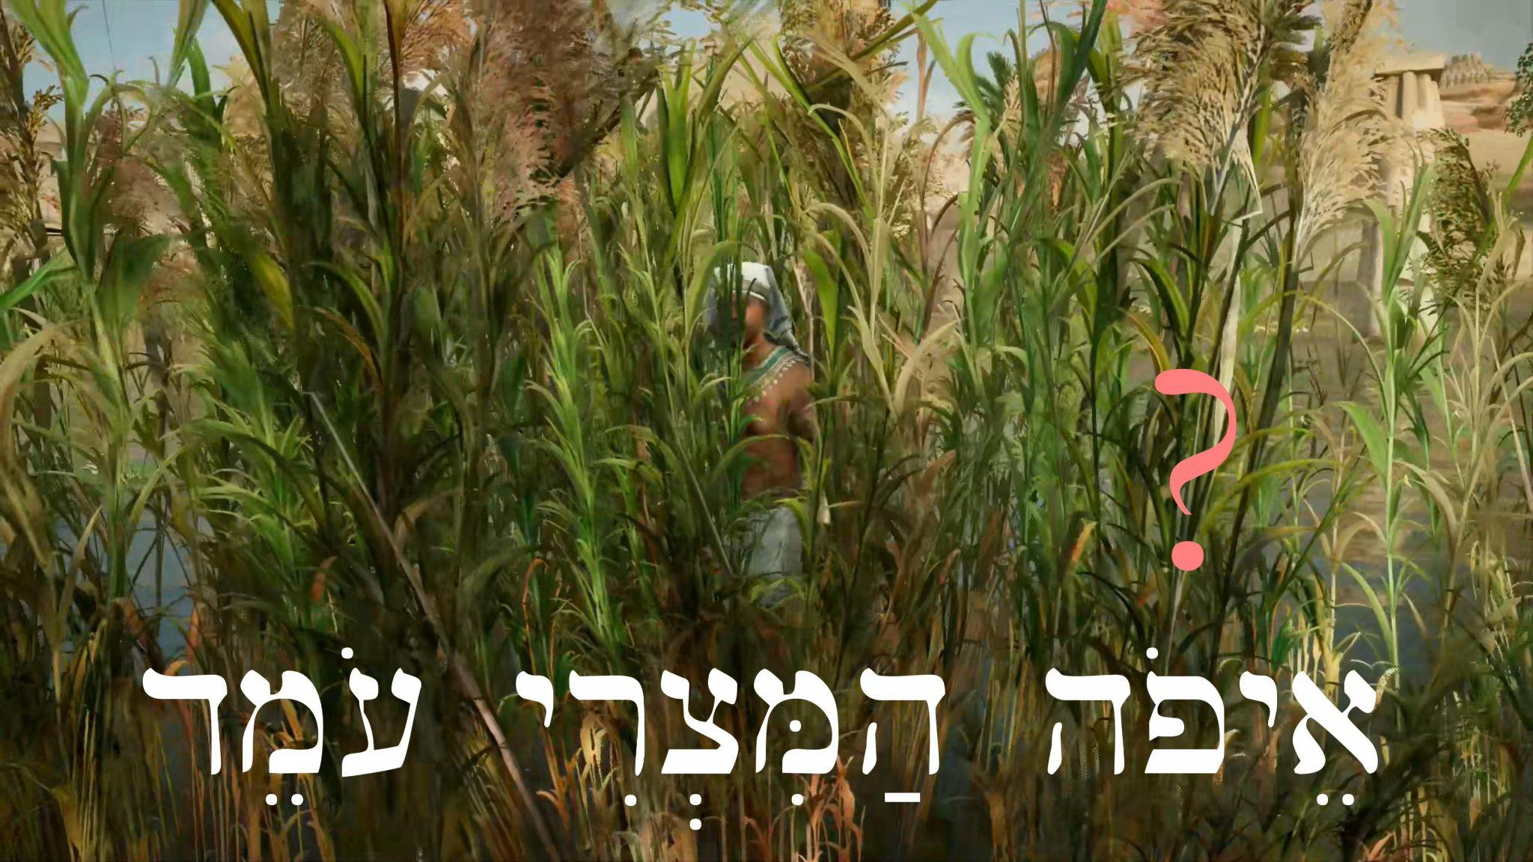
אֵיפֹה - where?
You may be thinking that we already have a word for “where…?” which is אַיֵּה. Although אֵיפֹה and אַיֵּה can be used interchangeably when asking where people and objects are located, אַיֵּה cannot be used to ask where an action is taking place. אֵיפֹה can be used for both: asking the location of people/objects and the location of actions.
For example: אֵיפֹה הָאִשָּׁה עֹמֶדֶת, “Where is the man standing?”

Lesson 77 - Participles 3: Plural

77.1 New Vocabulary
גַּיְא - valley
עֵמֶק - valley, plain between mountains
תּוֹדָה - thank-you (from modern Hebrew, not biblical Hebrew, but useful)

77.2 Plural Participles
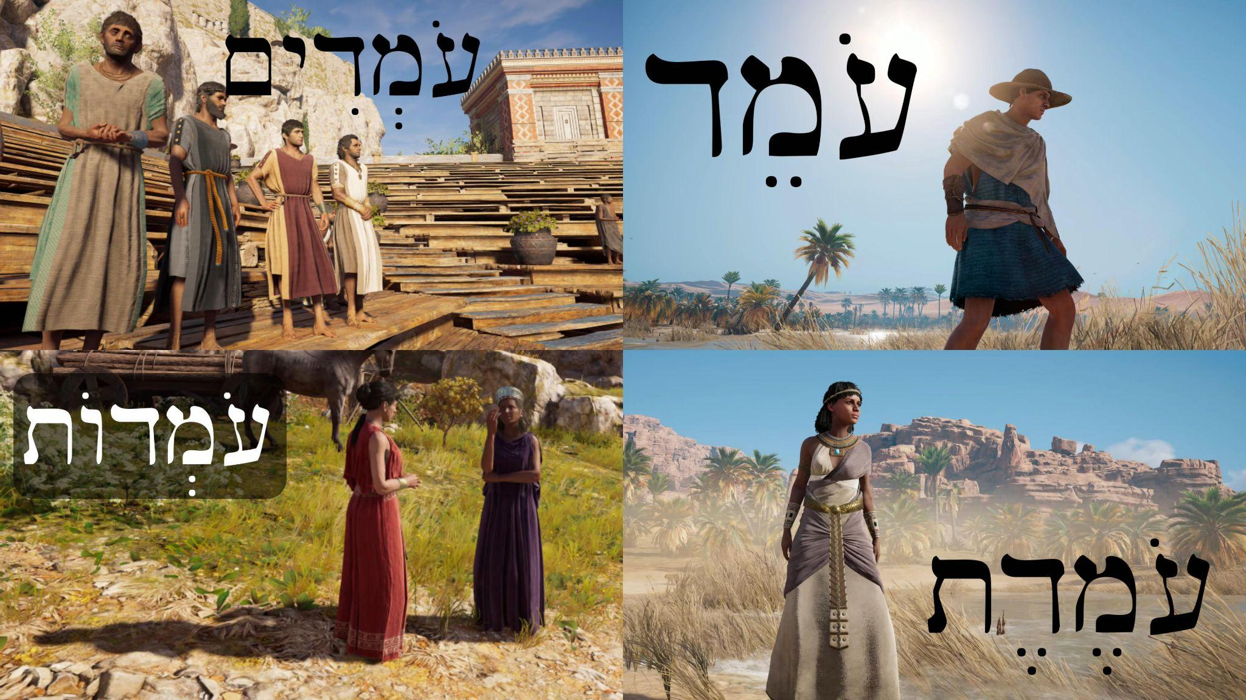
The active participle in Hebrew has the same plural endings as nouns. As you can see in examples like the one on the right, when these plural endings are added to active participles, there is a reduction of the second vowel to shewa.
Participles often function as nouns in a sentence, which means that they may be in the construct state and also may have pronominal suffixes. For example, יֹשְׁבִים becomes יֹשְׁבֵי in the construct relationship of the phrase יֹשְׁבֵי הָאָרֶץ, “The inhabitants of the land [lit. the dwellers of the land].”
Below are some more examples of how participles take masculine and feminine plural endings:
👤 |  | 👥
♂ | ♀ | ♂ | ♀
עֹמֵד  יֹשֵׁב  שֹׁכֵב  נֹשֵׂא | עֹמֶ֫דֶת  יֹשֶׁ֫בֶת  שֹׁכֶ֫בֶת  נֹשֵׂאת | עֹמְדִים  יֹשְׁבִים  שֹׁכְבִים  נֹשְׂאִים | עֹמְדוֹת  יֹשְׁבוֹת  שֹׁכְבוֹת  נֹשְׂאוֹת

Lesson 78 - Stand, Pillars & Gifts

78.1 New Vocabulary
עָמַד - he stood
עַמּוּד - pillar, column
מִנְחָה - gift, present

78.2 More Practice with Participles
In this lesson we introduce more active participle forms of verbs we already know, for both plural and singular, masculine and feminine. Here’s a quick reference chart:
 | 👤 |  | 👥
Root | ♂ | ♀ | ♂ | ♀
אכל  עבר  שׁתה | אֹכֵל  עֹבֵר | אֹכֶ֫לֶת  עֹבֶ֫רֶת | אֹכְלִים  עֹבְרִים  שֹׁתִים | אֹכְלוֹת

Lesson 79 - Participles 4: 3-ה verbs & 2-ו verbs

79.1 Participles Ending with ה
As we’ve discussed before, verbs ending in ה are classified as weak verbs or “irregular.” So far we’ve seen participle forms from verbs which end in ת in the feminine singular (e.g. “sitting” יֹשֶׁבֶת). But when we are dealing with a 3-ה root, the feminine singular participle no longer ends in ת. Instead, you have a new vowel pattern (o-a), as we see in the chart below:
singular participle 👤 |  | 👥 plural participle
masculine ♂ | ♀ feminine | masculine ♂ | ♀ feminine
עֹלֶה  רֹאֶה  עֹשֶׂה  בֹּנֶה  בֹּכֶה | עֹלָה  רֹאָה  עֹשָׂה  בֹּנָה  בֹּכָה | עֹלִים  רֹאִים  עֹשִׂים  בֹּנִים  בֹּכִים | עֹלוֹת  רֹאוֹת  עֹשׂוֹת  בֹּנוֹת  בֹּכוֹת

You’ll also notice that the ה disappears in the plural forms. Since ה is a weak letter, when plural endings are added, they knock the ה out. A final difference appears in the vowel pattern of the masculine singular forms: the vowel shortens from ֵ to ֶ , that is, tsere to segol. This doesn’t change the pronunciation according to our pronunciation system; it only changes the spelling.
עָשָׂה ← עֹשֶׂה
שָׁתָה ← שֹׁתֶה
עָלָה ← עֹלֶה

79.2 Second-Vav Participles

In sections 49.2 and 61.2 we discussed hollow verbs, which is what many people call 2-ו verbs. In many conjugations of these kinds of verbs the ו will drop out completely, which is what happens with participles as well. It’s important to be aware that the masculine singular participle of 2-ו verbs will look and sound exactly the same as the third masculine singular qal perfect conjugation. So the phrase הוּא רָץ could mean “he’s running” or “he ran.” However, the third feminine singular qal perfect does not sound the same as the feminine singular participle of 2-ו verbs. It’s spelled the same, but the accent/stress falls on a different syllable. For example, הָאִשָּׁה בָּ֫אָה means “the woman came,” while הָאִשָּׁה בָּאָ֫ה means “the woman is coming.” So the feminine singular participle of 2-ו verbs distinguishes itself by placing the accent on the last syllable. Here’s a chart of the 2-ו participle forms we see in the lesson:
 | singular participle 👤 |  | 👥 plural participle
root | masculine ♂ | ♀ feminine | masculine ♂ | ♀ feminine
רוץ  בוא  נוס | רָץ  בָּא  נָס | רָצָ֫ה  בָּאָ֫ה  נָסָ֫ה | רָצִים  בָּאִים  נָסִים | רָצוֹת  בָּאוֹת  נָסוֹת

Lesson 80 - אַבְרָם וְהַלֶּחֶם - Avram & the Bread

80.1 Practice What You’ve Learned
This lesson is designed to help you practice understanding the participles we’ve talked about so far, as well as review other vocabulary and some vayyiqtol forms.

Appendix 1 - The Hebrew Names of the Books of the Bible
In our videos we introduce biblical passages with the Hebrew name of the book. The chart below should help you become familiar with these names, which often have nothing to do with the English name. This is because the English names come largely from the ancient Greek translation of the Hebrew Bible, which is called the Septuagint. The names are sometimes different from the Hebrew, and the order is different. Notice that the names of some books derive from the first word or phrase in that book (for example, Genesis). In cases where there is a division of a book into two, such as 1st & 2nd Kings, the 1 and 2 will be designated by א and ב. For example, 1st Kings would be מְלָכִים א.
English | Hebrew
Genesis | בְּרֵאשִׁית‎
Exodus | שְׁמוֹת‎
Leviticus | וַיִּקְרָא‎‎‎
Numbers | בְּמִדְבַּר‎
Deuteronomy | דְּבָרִים‎‎‎
Joshua | יְהוֹשֻׁעַ
Judges | שֹׁפְטִים
Samuel | שְׁמוּאֵל
Kings | מְלָכִים
Isaiah | יְשַׁעְיָהוּ
Jeremiah | יִרְמְיָהוּ
Ezekiel | יְחֶזְקֵאל
Hosea | הֹוֺשֵׁעַ
Joel | יֹוֺאֵל
Amos | עָמוֹס
Obadiah | עֹבַדְיָה
Jonah | יוֹנָה
Micah | מִיכָה
Nahum | נַחוּם
Habakkuk | חֲבַקּוּק
Zephaniah | צְפַנְיָה
Haggai | חַגַּי
Zechariah | זְכַרְיָה
Malachi | מַלְאָכִי
Psalms | תְּהִלִּים
Proverbs | מִשְׁלֵי
Job | אִיּוֹב
Song of Songs | שִׁיר הַשִּׁירִים
Ruth | רוּת
Lamentations | אֵיכָה
Ecclesiastes | קֹהֶלֶת
Esther | אֶסְתֵּר
Daniel | דָּנִיֵּאל
Ezra | עֶזְרָא
Nehemiah | נְחֶמְיָה
Chronicles | דִּבְרֵי הַיָּמִים

Appendix 2 - Grammatical and Other Terms Used in Hebrew
Many terms in Hebrew have been developed to describe modern grammatical features. A subset of these are used to describe ancient Hebrew. The table below gives a rough correspondence between terms used in the different “dialects” of Hebrew (ancient and modern, where ‘ancient’ here includes Mishnaic Hebrew) and also the common English terms used. There are differences between modern and ancient Hebrew grammar, so I find it helpful to avoid the modern Hebrew terms for past, present and future tenses (עבר, הווה, עתיד), and use names that describe their forms (קָטַל יִקְטֹל).
Modern Hebrew  עברית מודרנית | Ancient Hebrew  עִבְרִית מִקְרָאִית יְהוּדִית | English  אנגלית
תנ"ך | מִקְרָא | Hebrew Bible
פרק | פֶּרֶק | chapter
פסוק | פָּסוּק | verse
משפט | מִשְׁפָּט | sentence
מילה | דָּבָר | word
שם עצם | שֵׁם עֶצֶם | noun
פועל | פּוֹעַל | verb
שם תואר | שֵׁם תֹּאַר | adjective
תואר הפועל | תֹּאַר הַפּוֹעַל | adverb
שם פועל | מָקוֹר | infinitive
מקור נטוי | מָקוֹר נָטוּי | infinitive construct
מקור מוחלט | מָקוֹר מוּחְלָט | infinitive absolute
עתיד | יִקְטֹל | yiqtol/imperfect/imperfective/prefix conjugation
עבר | קָטַל | qatal/perfect/perfective/suffix conjugation
זרוז | אֶקְטְלָה | cohortative (wish/desire – 1st person)
צווי | צִוּוּי | imperative (direct command – 2nd person)
פיקוד (יוסיבי) | יַקְטֵל | jussive (indirect wish/desire – 3rd person)
שורש | שֹׁרֶשׁ | root
בניין | בִּנְיָן | verbal stem
גיזרה | גִּזְרָה | weak pattern
גרוני | גְּרוֹנִי | guttural
צורת הפסק | צוּרַת הֶפְסֵק  צוּרַת מְנֻחָה | pausal form
הווה | בֵּינוֹנִי | participle
יחיד | יָחִיד | singular
רבים | רַבִּים | plural
זכר | זָכָר | masculine
נקבה | נְקֵבָה | feminine
ה" הידיעה | הֵא-הַיְדִיעָה | article
סמיכות | סְמִיכוּת | construct
מילת יחס | מִילַת יַחַס | preposition
פשר | פֵּשֶׁר | meaning

Common question words used to ask comprehension questions:
מַה | what?
בַּמֶּה בַּמָּה | with what/by what means?
מִי | who?
לְמִי | to/for whom?
מָתַי | when?
עַד מָתַי | until when?
לַמָּה מַדּוּעַ | why?
אֵיפֹה אַיֶּה אֵי | where / what location?
מֵאַיִן | from where?
אָנָה | to where?
אֵיךְ אֵיְכָה | how?
כַּמָּה | how many?

See section 7.3 for why the article has different spellings.
The full set of begadkefat letters include bgdkpt: בגדכפת. In some classical pronunciation systems these are all fricativized, so when they have no dagesh: b → v, g → ɣ, d → ð, k → χ, p → f, t → θ. However, in Modern Hebrew and the Sephardic pronunciation we are using in our videos, the only letters that undergo this process are ב ,פ ,כ.
As in Romance languages like Spanish or French, the gender of inanimate nouns is purely grammatical, and is therefore arbitrary and unpredictableː for example, the word for ‘jar’ is grammatically masculine, while the word for ‘cup’ is grammatically feminine even though both are inherently neuter by nature.
The letter he marked with a dot (called a mappiq) הּ- -ahh distinguishes it from a qamets he ending ה ָ -a. הּ ָ - is pronounced with an h sound at the end instead of a pure a vowel like ה ָ .
The plural form of אָחוֹת ‘sister’ is not attested in its free absolute form in the Hebrew Bible, but it may be אֲחָיוֹת ‘sisters.’
The form שִׂים is masculine singular, so it is only used when addressing a single male (like Avram in the video). For addressing a single female, it would be שִׂמִי.
Some classical pronunciations will pronounce tav without a dagesh ת as th [θ]. Under this system, the name of the letter ב sounds like the name Beth.
Historically, vav was pronounced like a w, so you may hear it pronounced like that in classical pronunciations of Hebrew, or hear the letter called waw.
These belong to the group of letters ר ע א ה and ח, that cannot take a dagesh and therefore cause many other vowel changes throughout the language. In future lessons you will also see the definite article take the form -הֶ before some of these letters.
For body parts that come in pairs, the dual form may sometimes be used to refer to more than two: אַרְבַּע רַגְלַיִם ‘four feet.’
Qamets ָ that appears in a closed unaccented syllable is a qamets hatuf and is pronounced [o] instead of [a], so this word is correctly pronounced ‘oznayim.’
In a later lesson, we will cover the vowel rule that reads a qamets hatuf ָ in a closed unaccented syllable and a ḥaṭef qamets ֳ both as [o] sounds. Because of this rule, the name Naomi נָעֳמִי is correctly pronounced in Biblical Hebrew No’omi [noʕoˈmi]. This same rule about qamets ָ in a closed unaccented syllable is also why גָּלְיָת is pronounced Goliat [ɡolˈjat].
Some pronunciation systems will consistently pronounce tsere as [e], distinguishing it from tsere + yod י ֵ , which is then pronounced as a diphthong [ej]. In our videos, we follow Modern Hebrew, which does not distinguish between ֵ and י ֵ and in which tsere can vary between [e] and [ɛ] depending on context.
Modern Hebrew speakers will often not pronounce vocal shewas, so for example, you may hear שְׁמִי pronounced as 1-syllable [ʃmi] instead of 2-syllable [ʃəmi]. Don’t let small differences of pronunciation throw you off, just focus on understanding what you hear!
The rule that reads a qamets hatuf ָ in a closed unaccented syllable and a ḥaṭef qamets ֳ both as [o] sounds means the word אָהֳלֵי is correctly pronounced ‘oholey [ʔohoˈle], just like the name Naomi נָעֳמִי is pronounced no’omi [noʕoˈmi]. This can be a complicated issue that even a lot of Hebrew experts struggle with, so don’t worry if you don’t understand it right away!
The form קַח is masculine singular, so it is only used when addressing a single male (like Avram in the video). For addressing a single female, it would be קְחִי.
This is pronounced [kol] because of the rule about qamets hatuf pronounced [o] in a closed unaccented syllable.
Some pronunciation systems will consistently pronounce segol ֶ as [ɛ], distinguishing it from tsere ֵ [e]. In our videos, we follow Modern Hebrew, which pronounces segol and tsere both as either [ɛ] or [e], depending on context. For example both בֵּן and its construct form בֶּן are pronounced [bɛn] with an [ɛ] vowel, while the words שָׂדֶה and its construct form שְׂדֵה both end in an [e] vowel.
Occasionally consonantal vav appears with a dagesh וּ, and thus looks exactly the same as shureq וּ. You can distinguish consonantal vav with dagesh (pronounced [v]) from shureq (pronounced [u]) because vav with dagesh will have another vowel with it, such as: וֶּ וַּ וֵּ.
Very few basic vocabulary words are spelled with qibbuts. It usually occurs in morphologically complex words: When a suffix is added to a verb ending in shureq וּ, that shureq that is now in the middle of the word is frequently changed into a qibbuts ֻ .
In the Hebrew Bible, the sof pasuq marks the end of a verse instead of the end of a sentence. A single verse may contain more than one sentence, but the sof pasuq will only occur at the end of the verse.
The patterns for begadkefat letters losing the dagesh across word boundaries are general tendencies more than strict rules. It is not hard to find exceptions in the Hebrew Bible.
Very rarely kaf sofit may take a dagesh ךּ and be pronounced k at the end of a word.
The letter he marked with a mappiq (מַפִּיק‎ = the dot in the he) הּ- -ahh distinguishes it from a qamets he ending ה ָ -a. הּ ָ - is pronounced with an h sound with rough breathing at the end instead of a pure a vowel like ה ָ .
In Modern Hebrew, ‘ayin is usually pronounced the same as aleph - the pharyngeal fricative pronunciation is more historical, though still preserved in some dialects of Hebrew today.
In Modern Hebrew, ħet is usually pronounced the same as kaf with no dagesh, [χ]. The pharyngeal fricative pronunciation is more historical, though still preserved in some dialects of Hebrew today.
Historically it was pronounced further back in the throat than k, so it is usually transliterated as q, which represents a voiceless uvular stop.
Shewa is pronounced as shva in Modern Hebrew, and in the field of Linguistics is written as schwa (Hebrew: שְׁוָא‎).
Compiled by Cameron Hamm, 2021

